Welcome to the LSIRC Notebook, a newsletter for all adult students of Literacy Services of Indian River County, Florida. We hope you like this newsletter.

1. Word Ladder: Change the starting word into the ending word. Change the highlighted letter to make a new word. Change the highlighted letter in this new word to make another new word. Repeat until you have made the ending word.

When a kitten grows up, it can be a mouser, a cat that catches mice! Help this KITTEN grow up to become MOUSER.

- K I T T E N
- __ __ __ __ __ __ If you have a mosquito bite, you were _____ by a mosquito.
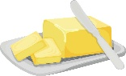
- __ __ __ __ __ __ Lemons are sour; dark chocolate and coffee are ____.

- __ __ __ __ __ __ Tastes good on bread, potatoes and many other foods.

- __ __ __ __ __ __ Lambs playfully ____ each other.
- __ __ __ __ __ __ The dirt road is badly ____
- __ __ __ __ __ __ After being forgotten in the refrigerator for a month, the leftovers

had ____
- __ __ __ __ __ __ Because of bad weather in Atlanta, Georgia,
airplanes were ____ to Orlando, Florida
- __ __ __ __ __ __ He was sleeping happily when the neighbor’s loud music ___ him.
- __ __ __ __ __ __ The detective ____ out the details of the scandal.
- M O U S E R

2. Word Picture Puzzle: A word picture puzzle uses two or more pictures to suggest a word:
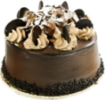
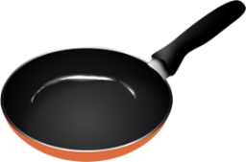
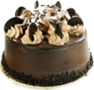
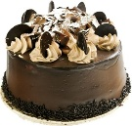
+ = _____________

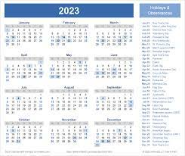
3. Brainteasers are questions that you need to think about carefully to figure out the answers. Riddle jokes are similar to brainteasers. Try to answer this riddle joke:
You are waiting for a friend. You are getting hungry. You can’t leave and you have no snacks with you, but you do have your calendar. What can you eat while you wait?
(Clue: one word can have two meanings.)

4. Crypto-Quiz Mystery quote from Winnie the Pooh
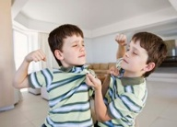
Instructions: Look at the picture clues. Write the letters of the word in the blanks.

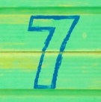
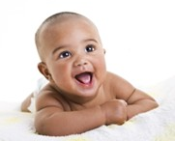
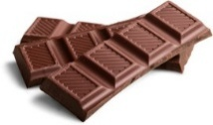
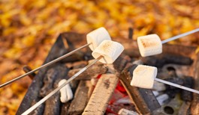

1. 2. 3. 4. 5. 6.
1. _______ is my favorte candy.
2. Roasting ___________ over a campfire is a lot of fun.
3. What a cute ________!
4. Brothers shouldn’t ________, but sometimes they do.
5. After it rains, kids like to splash in a ________ of water.
6. Number _________
1. 17___ 22___ 3 ___ 17___ 3 ___ 26___ 5___ 8___ 19___
2. 1___ 15___ 6___ 7___ 22___ 1___ 15___ 16____ 16___ 3___ 11___ 7___
3. 16___ 15___ 16___ 13___
4. 20___ 23___ 21___ 22___ 8___
5. 4 ___ 9 ___ 18___ 18___ 26___ 19___
6. 7___ 19___ 10___ 19___ 2___

Write the letters in the blanks to see the quote.

“23____ 8____’ 7____ 8____ 22____ 19____ 20____ 23____ 6____ 7____ 8____ 18____ 5____ 13____
3____ 20____ 15____ 9____ 8____ 9____ 1____ 2____! 15____ 8____ 23____ 1____ 19____
3____ 20____ 22____ 3____ 8____
17 ____ 22____ 3____ 17____ 3____ 26____ 15 ____ 8____ 19____ 13____
1____ 3____ 6____ 2____ 23____ 2____ 21____ 7___, 15____ 2____ 18____
8____ 3____ 15____ 7____ 8____ 13____
1____ 15____ 6____ 7____ 22____ 1____ 15____ 26____ 26____ 3____ 11____
19____ 10____ 19____ 2____ 23____ 21____ 7____, 15____ 2____ 18____,
16____ 19____ 7____ 8____ 3____ 20____ 15____ 26____ 26____,
29____ 19____ 15____ 4____ 23____ 2____ 21____ 23____ 2____ 8____ 3____
26____ 19____ 15____ 10____ 19____ 7____!”


5. Captain Comprehension and Busy Words. Captain Comprehension is a new Super Hero! Captain Comprehension conquers Busy Words. Busy Words are words that sound the same but are spelled differently, have different meanings, and some can’t decide if they are nouns, verbs, or adjectives.
Art by Carlos Millan
Today’s Words: chew / chews / choose / chooses

chew / chews – verb. To break up food with your teeth before swallowing it
Please chew your food with your mouth closed.
He chews his food quietly.
choose / chooses – verb. To pick or select something
You can choose which book you want to read.
She chooses to go grocery shopping on Saturdays.
Practice One
When we eat, it is important to ______ our food well. ______ helps break food into small pieces, so it is easier to swallow and digest. Some people ______ very quickly, while others ______ more slowly. A child often ______ slowly because the food may feel new or different.
Eating also gives us many choices. At home, you can ______ what to cook for dinner. At the store, you might ______ between apples or oranges. Each person ______ food based on taste, health, or even price. For example, one friend ______ a sandwich, and another ______ soup.
After everyone ______ their meal, the ______ing begins. One person ______ crunchy chips, while another ______ soft bread. No matter what food you ______, ______ing well is always important. It keeps you safe from choking and helps your body use the food for energy.

Practice Two
At school, students often eat lunch together. One student ______ a sandwich, and another ______ pizza. After each person ______ their food, they sit down to eat. A hungry student ______ quickly, while another student ______ more slowly.
Sometimes students talk about healthy eating. A teacher says, “When you ______ what to eat, try to think about good nutrition.” The teacher often ______ fruit because it is sweet but still healthy. Another student ______ salad instead of fries.
After class, students may go to the store. They can ______ a snack for the walk home. One person ______ an apple, and another ______ cookies. When they get home, everyone ______ their snack. No matter what you ______, it is smart to ______ carefully and enjoy the taste.

Idiomatic expressions with chew and choose

chew over – to think deeply about something
We'll need to chew over the proposal for a few days before we can make a decision.
chew out – to scold someone angrily
The manager chewed out the employee for being late to work
chew on – to ponder or think about something, often to make a decision
I need some time to chew on this complicated problem before I can offer a solution
chew something up – phrasal verb: to damage something by chewing it
Be careful with that new toy; the puppy will probably chew it up in no time.
chew the fat – idiom: to talk with friends casually
We spent the evening chewing the fat at the local pub

choose among: To select one from a larger group of more than two things.
You must choose among the desserts on the menu.
choose between: To select one of only two available options.
I had to choose between the red shirt and the blue one.
choose from: To make a selection from a variety of options.
You can choose from all the items displayed on the table.



1. Word Ladder: 1. kitten, 2. bitten, 3. bitter, 4. butter, 5. butted, 6. rutted, 7. rotted,
8. routed, 9. roused, 10. moused, 11. mouser
2. Word Picture Puzzle: pancakes
3. Brainteaser: Dates
4. Crypto-Quiz: 1. chocolate, 2. marshmallows, 3. baby, 4. fight, 5. puddle, 6. Seven
“It’s the first day of autumn! A time of hot chocolatey mornings, and toasty marshmallow evenings, and, best of all, leaping into leaves!” – Winnie the Pooh

Answer Key
Practice One
When we eat, it is important to chew our food well. Chewing helps break food into small pieces, so it is easier to swallow and digest. Some people chew very quickly, while others chew more slowly. A child often chews slowly because the food may feel new or different.
Eating also gives us many choices. At home, you can choose what to cook for dinner. At the store, you might choose between apples or oranges. Each person chooses food based on taste, health, or even price. For example, one friend chooses a sandwich, and another chooses soup.
After everyone chooses their meal, the chewing begins. One person chews crunchy chips, while another chews soft bread. No matter what food you choose, chewing well is always important. It keeps you safe from choking and helps your body use the food for energy.
Practice Two
At school, students often eat lunch together. One student chooses a sandwich, and another chooses pizza. After each person chooses their food, they sit down to eat. A hungry student chews quickly, while another student chews more slowly.
Sometimes students talk about healthy eating. A teacher says, “When you choose what to eat, try to think about good nutrition.” The teacher often chooses fruit because it is sweet but still healthy. Another student chooses salad instead of fries.
After class, students may go to the store. They can choose a snack for the walk home. One person chooses an apple, and another chooses cookies. When they get home, everyone chews their snack. No matter what you choose, chew carefully and enjoy the taste.

