Welcome to the LSIRC Notebook, a newsletter for all adult students of Literacy Services of Indian River County, Florida. We hope you like this newsletter.

1. Word Search Every March seventeenth, people around the world celebrate St. Patrick's Day. This holiday honors Saint Patrick, the patron saint of Ireland. According to legend, Patrick was not originally from Ireland; he was taken there as a slave when he was young. After he managed to escape, he returned as a missionary to teach the people. One famous story says he chased all the snakes out of the country!
In parades today in many cities you might see a leprechaun with a pot of gold at the end of a rainbow and decorations of shamrocks.
Families often gather for a big meal of corned beef and cabbage and delicious Irish soda bread. While adults might have a glass of beer, everyone enjoys the music and fun. It is a wonderful day to celebrate Irish history and have a great time!
Find the bold words in this month’s St. Patrick’s Day Word Search:
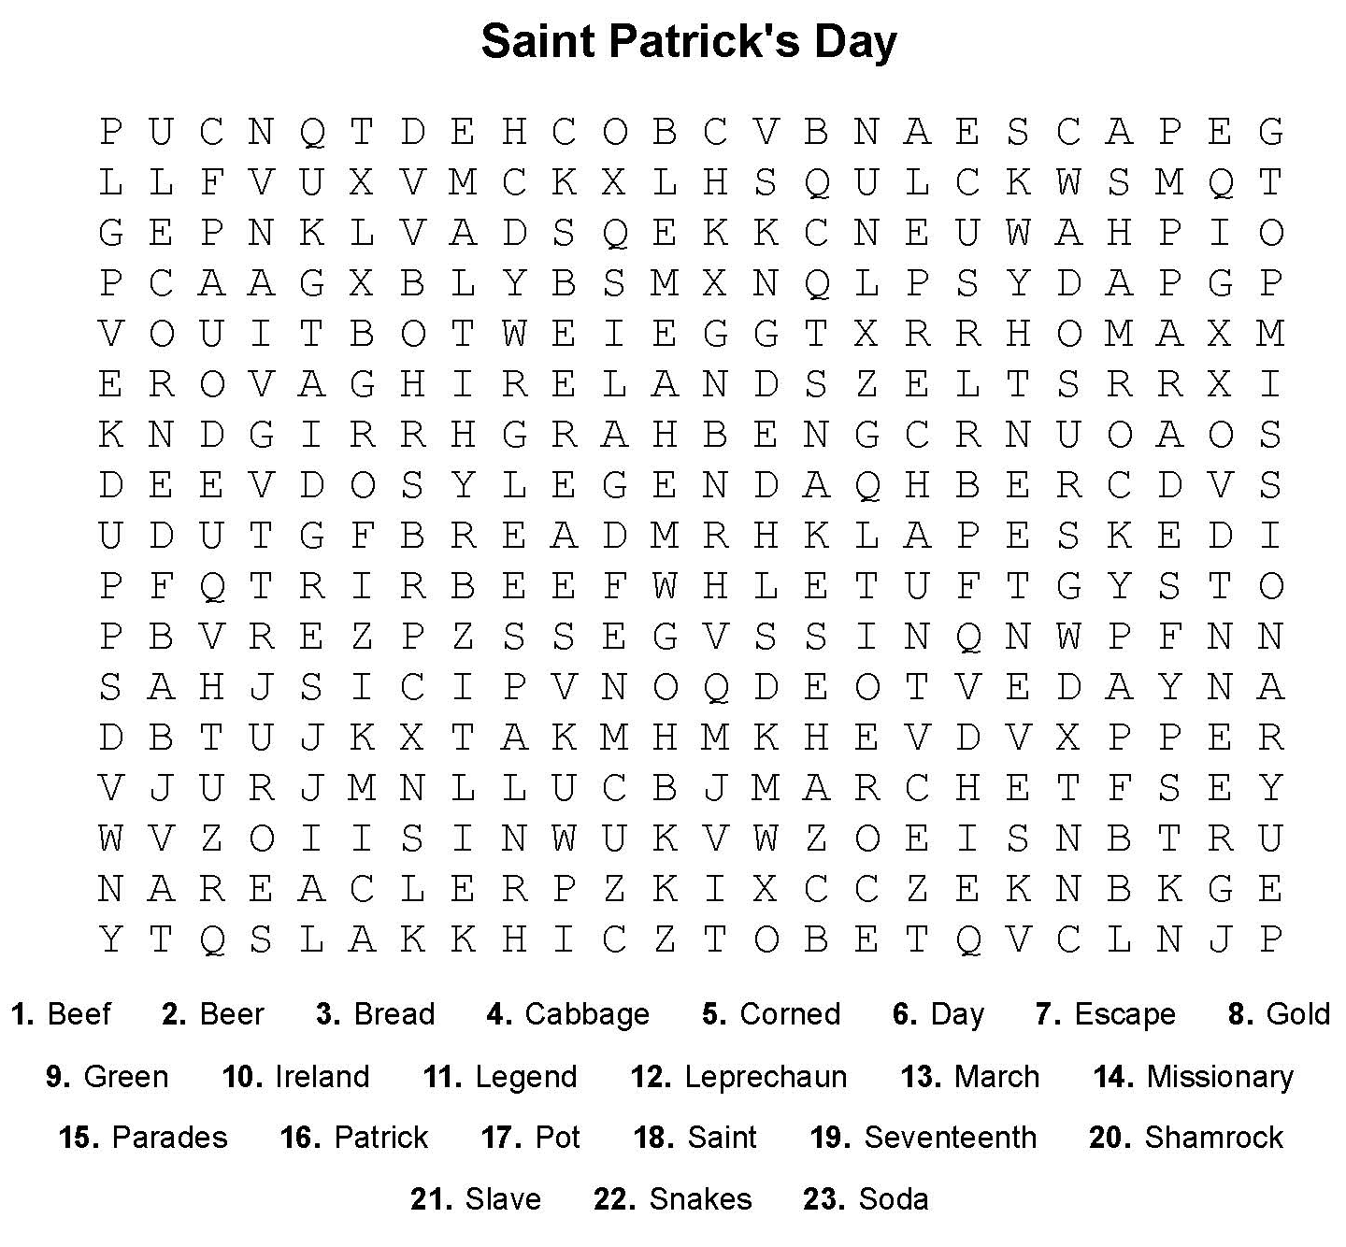

2. Word Math Puzzle: Solve the equation:
said -d = _________
+pint -pi = _________
+path -h = _________
+rich -h =_________
+king -ing =
Total = ______________________
3. Picture Talk: How many sentences can you write from these pictures?




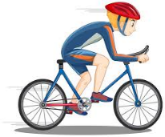

_____________________________________ _____________________________________
_____________________________________ _____________________________________
_____________________________________ _____________________________________

4. Silly Jokes and Riddles

Which hand is best to use to stir the sugar in your coffee or tea?


The one holding the spoon!
Or
Neither Hand! A spoon is better than either hand!
5. Crypto-Quiz Irish Blessing [oral tradition]
Instructions: Look at the picture clues. Write the letters of the word in the blanks.

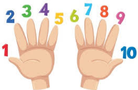





1. 2. 3. 4. 5. 6.

1. 7_D__ 8_____ 22_____ 14_____

2. 2__Y__ 8_____ 15_____ 15_____ 18_____ 26_____

3. 19_P_ 15_____ 4_____ 17_____ 23_____

4. 9__F_ 12_____ 17_____ 10_____ 8_____ 21_____ 22_____

5. 5__B_ 24_____ 6_____ 14_____ 8_____ 23_____

6. 11_H__ 18_____ 16_____ 8_____

Write the letters in the blanks to see a traditional Irish Blessing
4_____ 15_____ 26_____ 4_____ 2_____ 22_____ 21_____ 8_____ 16_____ 8_____ 16_____ 5_____ 8_____ 21_____

23_____ 18_____ 9_____ 18_____ 21_____ 10_____ 8_____ 23_____

23_____ 11_____ 8_____ 23_____ 21_____ 18_____ 24_____ 5_____ 15_____ 8_____ 22_____

23_____ 11_____ 4_____ 23_____ 19_____ 4_____ 22_____ 22_____ 6_____ 7_____ 4_____ 26_____ 4_____ 2_____

5____ 24_____ 23_____ 17_____ 6_____ 25_V__ 8_____ 21_____ 9_____ 18_____ 21_____ 10_____ 8_____ 23_____

23_____ 18_____ 21_____ 8_____ 16_____ 8_____ 16_____ 5_____ 8_____ 21_____

23_____ 11_____ 8_____ 5_____ 15_____ 8_____ 22_____ 22_____ 12_____ 17_____ 10_____ 22_____

23_____ 11_____ 4_____ 23_____ 6_____ 18_____ 16_____ 6_____ 8_____ 4_____ 6_____ 11_____

7_____ 4_____ 2_____

_____________________________________________________________________________________

______________________________________________________________________________________________________

6. Captain Comprehension and Busy Words. Captain Comprehension is a new Super Hero! Captain Comprehension conquers Busy Words. Busy Words are words that sound the same but are spelled differently, have different meanings, and some can’t decide if they are nouns, verbs, or adjectives. Other words are easy to confuse because they sound only slightly different from each other. Other words can
Art by Carlos Millan
be verbs or nouns without chaning their sounds!

Today’s Words: higher / hire

higher [adjective – high, higher, highest]: above something else, or at a greater quantity
- The blue balloon is higher than the yellow balloon.
- After sunrise, the sun moves higher in the sky until noon.
- Prices are higher this year than they were last year.
- She jumped higher than her brother.

hire/hires, hiring, hired [verb] to give someone a job or to pay to use something.
- The store will hire a new worker.
- I want to hire a driver for the day.
- They hire people in the summer.
- The company will hire two new cooks.

higher hired hires hiring

Passage 1: The New Job
Carlos wants a new job. He hopes the pay will be higher than his old job. Last week, he went to a store that is hiring. The manager hires people every spring. Carlos filled out an application. Two days later, the store hired him. He feels happy. He is proud of his new job.
high higher hiring hired hires

Passage 2: The Tall Building
A new office building is going up in town. Each day it gets __________ and __________. It will be the tallest building in the city. Many workers were__________ to build it. The company __________ skilled workers for this job. When the building is finished, people will work in offices __________ above the street.
hire higher hiring

Passage 3: A Better Position
Maria works in an office. She wants a better position with __________ pay. She studies hard to improve her skills. Her boss plans on __________ one person for a new position. Maria hopes they will promote her instead and __________ someone to replace her.



!. Word Search Puzzle Solution
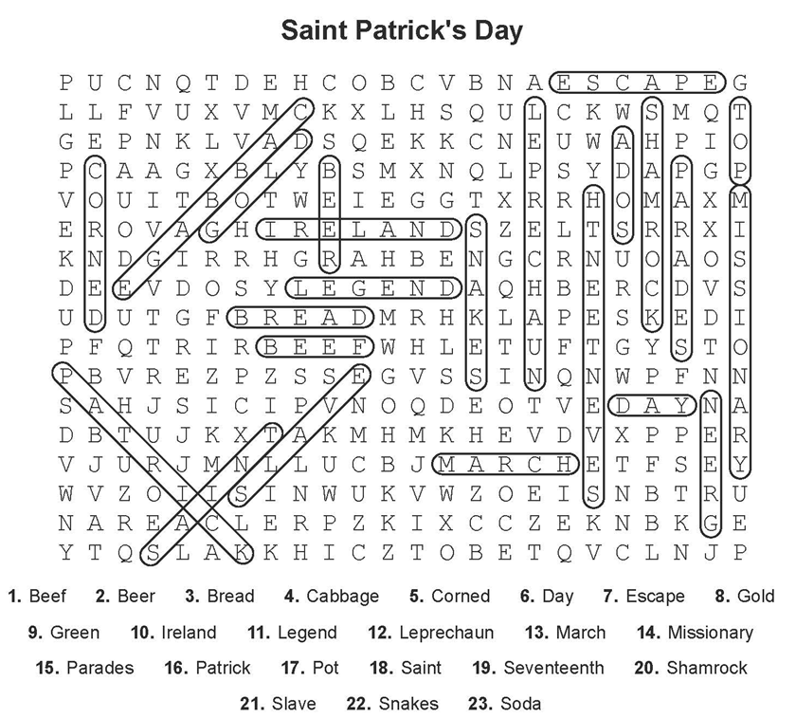

2. Word Math Puzzle: Saint Patrick
3. Many answers are possible. Check with your tutor. I walk to the store. I am walking to the store. I go to the store. I am going to the store. He rides his bike to the park. He rides his bike on the path. He is riding his bike to the park. He is riding his bike on the path.

5. Crypto-Quiz: Always remember to forget the troubles that passed away. But never forget to remember the blessings that come each day.
Answer Key 1. desk 2. yellow 3. plant 4. fingers 5. bucket 6. home

Passage 1: The New Job
Carlos wants a new job. He hopes the pay will be higher than his old job. Last week, he went to a store that is hiring. The manager hires people every spring. Carlos filled out an application. Two days later, the store hired him. He feels happy. He is proud of his new job.
Passage 2: The Tall Building
A new office building is going up in town. Each day it gets higher and higher. It will be the tallest building in the city. Many workers were hired to build it. The company hires skilled workers for this job. When the building is finished, people will work in offices high above the street.
Passage 3: A Better Position
Maria works in an office. She wants a better position with higher pay. She studies hard to improve her skills. Her boss plans on hiring one person for a new position. Maria hopes they will promote her instead and hire someone to replace her.

