Welcome to the LSIRC Notebook, a newsletter for all adult students of Literacy Services of Indian River County, Florida. We hope you like this newsletter.

1. Word Search

On New Year’s Day, people make resolutions or promises to improve their lives. Some people promise to save money or eat better food. In Spain, people eat twelve grapes at midnight for good luck. In the southern United States, families eat black-eyed peas, collard greens, and cornbread. The peas stand for fortune, the greens look like money, and the cornbread is the color of gold. At midnight, people drink champagne and make a toast. People watch parades, and football games. These traditions help people welcome the new year with hope and happiness.

Find these words in this month’s Happy New Year Word Search:

1. New, 2. Year, 3. Day, 4, resolutions, 5. Promises, 6. Improve, 7. Good, 8. Luck,
9. Twelve, 10. Grapes, 11. Blackeye, 12. Peas, 13. Collard, 14. Greens, 15. Cornbread,
16. midnight, 17. Champagne, 18. Drink, 19. Toast, 20. Fortune, 21. Gold, 22, money, 23. Parades, 24. Football, 25. Celebrate
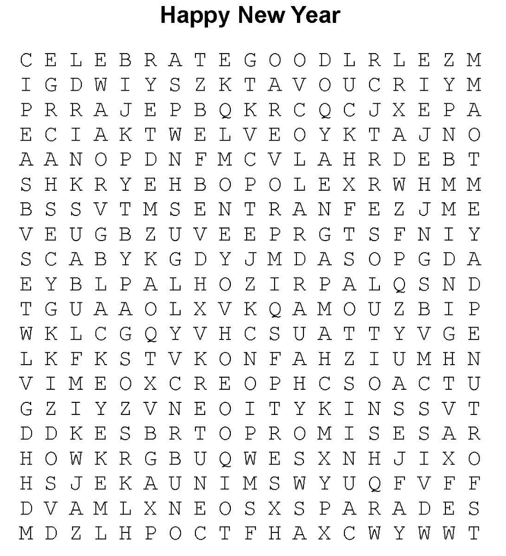

2. Word Picture Puzzle: A word picture puzzle uses two or more pictures to suggest a word:


+ = M_____B____

3. Silly Riddles are questions that have funny answers because words have more than one meaning. Do you understand why this riddle/joke is funny?
Why iare the corners the warmest places in every room?
Because it’s always 90 degrees!
One more silly riddle:
What did one wall say to the other wall?
Meet you at the corner!

4. Crypto-Quiz Unknown
Instructions: Look at the picture clues. Write the letters of the word in the blanks.







1. 2. 3. 4. 5. 6.

1. 2_____ 21_____ 10_____ 10_____ 19_____
2. 22_____ 25_____ 24_____
3. 12_____ 15_____ 8_____ 8_____ 3_____ 8_____ 1____
4. 17_____ 2_____ 3_____ 13_____ 14_____ 6_____ 25_____
5. 13_____ 14_____ 21_____ 12_____
6. 9_____ 8_____ 25____
Write the letters in the blanks to see the words.

14____ 2____ 25____ 9____ 8____ 6____ 19____ 10____ 25____ 12____ 13____ 9____ 8____
19____ 9____ 15____ 13____ 2____ 9____ 15____ 6____ 24____ 14____ 12____ 19____
14____ 9____ 22____ 25____ 22____ 25____ 14____ 14____ 25____ 12____
14____ 2____ 21____ 8____ 3____ 13____ 14____ 2____ 25____
10____ 25____ 12____ 13____ 9____ 8____ 19____ 9____ 15____ 17____ 25____ 12____ 25____
19____ 25____ 13____ 14____ 25____ 12____ 24____ 21____ 19____


5. Captain Comprehension and Busy Words. Captain Comprehension is a new Super Hero! Captain Comprehension conquers Busy Words. Busy Words are words that sound the same but are spelled differently, have different meanings, and some can’t decide if they are nouns, verbs, or adjectives. Other words are easy to confuse because they sound only slightly different from each other.
Art by Carlos Millan

Today’s Words: promise / premise

1. Promise [verb] To say that you will do something..

Present Simple
- I promise to call you tonight.
- She promises to help her sister.

Present Continuous
- He is promising to finish the work today.
- They are promising better service.
Past Simple
- I promised to be on time.
- She promised him an answer.

Future (will)
- I will promise to tell the truth.
- He will promise his support.

Present Perfect
- I have promised to help my neighbor.
- She has promised to return the book.

2. Promise [noun] A statement that someone will do something or that something will happen.
- She kept her promise.
- His words were a promise of change.

3. Promising [gerund as a noun] The act of making a promise.
- Promising to help is easy, but doing it is harder.
- He regrets promising too much.

4. Promising [gerund as an adjective]
- She has a promising future in music, She is a good musician.

Premise is a more formal or academic word. Basis [noun] and Base [verb] are a good synonyms for premise.

5. Premise [verb] To base something on an idea or assumption.
Present Simple
- The story premises its plot on a mistake.
- We premise our plan on trust.

Present Continuous
- The author is premising the argument on false data.
- They are premising the decision on cost.

Past Simple
- The theory was premised on incomplete evidence.
- He premised his claim on rumors.

Future (will)
- The report will premise its conclusions on research.
- She will premise her argument on facts.

Present Perfect
- The study has premised its findings on surveys.
- The case has been premised on witness statements.

6. Premise [noun] An idea or statement that is used as the basis for a reason, argument, or story.
- The basic premise of the movie is simple.
- Her argument is based on a false premise.

7. Premising [gerund noun] The act of basing an idea or argument on a premise.
- Premising an argument on facts is important.
- He made a mistake by premising his theory on guesses.

Practice One
premised, premising, promise, promise, promises, promising,

Ms. Green made a __________ to her class. She __________ o help them build a garden. The plan was __________ on teamwork. Each student had a job. Tom was __________ to water the plants every day. Maria kept her __________ to pull weeds. The class was building the garden by __________ their work on helping each other. Because everyone kept their __________, the garden grew well, and the project was a success.

Practice Two
premise, premising, premising, promise, promises, promised, promised, promising,

The story’s __________ was simple. The team would build a treehouse together. Dad __________ to help after work. He had __________ before, and this time he kept his __________. The children were __________ their plan on clear rules and safety. By __________ o listen and by __________ each step on the last one, the treehouse slowly took shape. Everyone learned that keeping __________ makes building easier.

Practice Three
premise, premised, premised, premising, promise, promise, promising,

The club __________ its project on trust and careful planning. Each member made a __________ to complete a task on time. By __________ their work on shared goals, the group avoided confusion. One member regretted __________ too much, but the others helped. The final report was __________ on accurate information, not guesses. In the end, the club learned that a strong __________ and an honest __________ are both necessary for success.



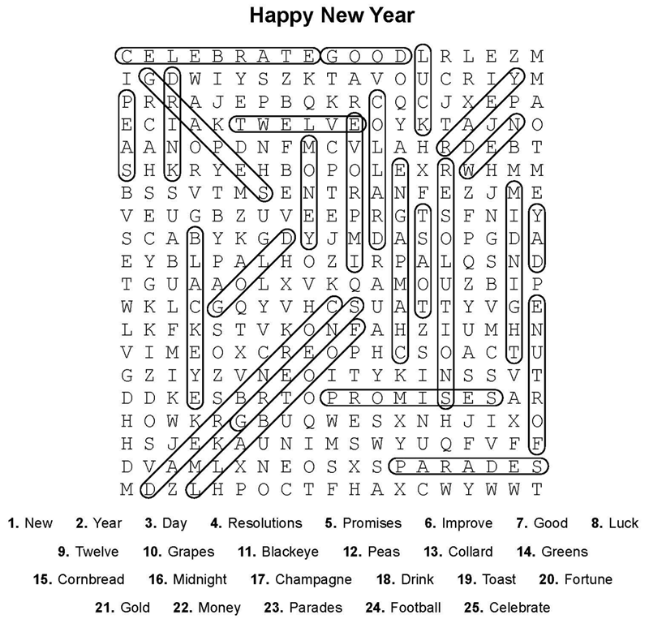
!. Word Search Puzzle Solution
2. Word Picture Puzzle: mailbox
3. Brainteaser/Silly Riddle 90 degrees Fahrenheit means the temperature. While 90 degrees can also mean a right angle and the angle made by two walls at the corner is 90 degrees.
4. Crypto-Quiz: The only person you should try to be better than is the person you were yesterday.
Answer Key 1. happy, 2. bed, 3. running, 4. whistle, 5. star, 6. one

Practice One
Ms. Green made a promise to her class. She promised to help them build a garden. The plan was premised on teamwork. Each student had a job. Tom was promising to water the plants every day. Maria kept her promise to pull weeds. The class was building the garden by premising their work on helping each other. Because everyone kept their promises, the garden grew well, and the project was a success.

Practice Two
The story’s premise was simple. The team would build a treehouse together. Dad promised to help after work. He had promised before, and this time he kept his promise. The children were premising their plan on clear rules and safety. By promising to listen and by premising each step on the last one, the treehouse slowly took shape. Everyone learned that keeping promises makes building easier.

Practice Three
The club premised its project on trust and careful planning. Each member made a promise to complete a task on time. By premising their work on shared goals, the group avoided confusion. One member regretted promising too much, but the others helped. The final report was premised on accurate information, not guesses. In the end, the club learned that a strong premise and an honest promise are both necessary for success.

