Welcome to the LSIRC Notebook, a newsletter for all adult students of Literacy Services of Indian River County, Florida. We hope you like this newsletter.

1. Word Search
Find the BOLD words from the reading in the Puzzle.

Cinco de Mayo is often celebrated more in the United States than in Mexico. The holiday remembers the Battle of Puebla in 1862. In that battle, a smaller Mexican army defeated a larger French army. Cinco de Mayo is not Mexico’s Independence Day. Mexico’s Independence Day is September 16th. In Mexico, Cinco de Mayo is mainly celebrated in the state of Puebla.

Memorial Day was first called Decoration Day. It was a day to decorate the graves of soldiers. Today, Memorial Day is a solemn federal holiday, a day of mourning in the United States. It honors soldiers who died while serving their country. Many people have barbecues and enjoy time with family, but the main purpose is to remember and honor those who died. Memorial Day is also considered to be the unofficial start of summer.

Mother's Day is celebrated on the second Sunday in May. It is the busiest day of the year for restaurants. Because we have mothers, we have grandmothers and grandfathers, sisters and brothers, aunts and uncles and cousins.
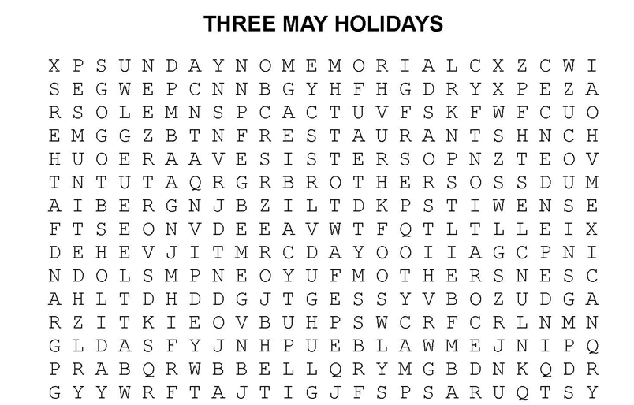

1. Aunts 2. Barbecues 3. Battle 4. Brothers 5. Cousins 6. Day 7. Decoration
8. Federal 9. Grandfathers 10. Grandmothers 11. Holiday 12. Independence
13. Memorial 14. Mexican 15. Mothers 16. Mourning 17. Puebla 18. Restaurants
19. Sisters 20. Solemn 21. States 22. Sunday 23. Uncles 24. United

2. Word Math Puzzle: Solve the equation:
Barbara -bara = _________
+Ben -n = _________
+Curtis -rtis = _________
+Esther -ther =_________
Total = _________________ ___________
3. Picture Talk: Can you see the not very secret question and answer.
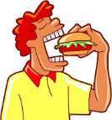

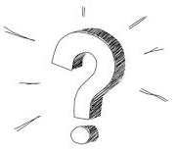


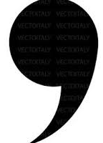



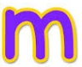
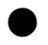

____________________________________________________________________________________
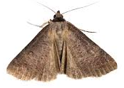
____________________________________________________________________________________

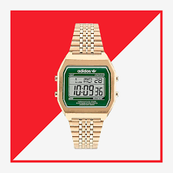
4. Silly Jokes and Riddles

1. What holiday do moths like most?
2. What did the digital watch say to its mother?
3. Jimmy’s mother has four children The first child is named Monday, The second child is named Tuesday. The third child is named Wednesday. What is the name of the fourth child?

1. Mother’s Day.
2. Look, Ma! No hands!
3. Jimmy, because Jimmy’s mother has four children.

5. Crypto-Quiz Betty White (as Rose Nylund in The Golden Girls TV show)
Instructions: Look at the picture clues. Write the letters of the word in the blanks.


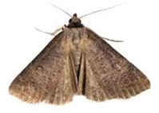

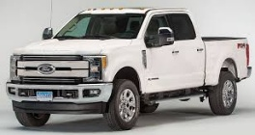


1. 2. 3. 4. 5. 6.

1. 16_____ 15_____ 2_____ 15_____ 2_____ 15_____ 7_____
2. 8_____ 6 _____ 9_____ 17_____ 25_____
3. 16_____ 3_____ 8_____ 8_____ 26_____ 19_____
4. 1_M_ 3 _____ 8_____ 22_____
5. 18_____ 3 _____ 21_____
6. 13_____ 19_____ 26_____ 26 _____ 3_____ 11_____
Write the letters in the blanks to see a quote from Betty White.
“1_____ 13_____ 1_____ 3_____ 8_____ 22_____ 19_____ 6_____ 9_____ 7_____ 19_____ 18_____ 8_____ 3_____
7_____ 15_____ 13_____: 8_____ 22_____ 19_____ 3_____ 6_____ 18_____ 19_____ 6_____ 13_____ 3_____ 9_____
21_____ 19_____ 8_____, 8_____ 22_____ 19_____ 16_____ 19_____ 8_____ 8_____ 19_____ 6_____ 13 _____3_____ 9 _____ 21_____ 19_____ 8_____, 9_____ 2_____ 26_____ 19_____ 7_____ 7_____ 13_____ 3_____ 9_____’ 6_____ 19_____ 15_____ 16_____ 15_____ 2_____ 15_____ 2_____ 15_____.”

_____________________________________________________________________________________

______________________________________________________________________________________________________

6. Captain Comprehension and Busy Words. Captain Comprehension is a new Super Hero! Captain Comprehension conquers Busy Words. Busy Words are words that sound the same but are spelled differently, have different meanings, and some can’t decide if they are nouns, verbs, or adjectives. Other words are easy to confuse because they sound only slightly different from each other. Other words can
Art by Carlos Millan
be verbs or nouns without chaning their sounds!

Today’s Words: pass / passed / past
pass (verb) to go by something or someone; to give something to someone
- I pass the store on my way to work.
- Please pass the salt to me.
- The car will pass the bus on the road.

pass (noun) a success or permission; a way to go through a place
- She got a pass on her test.
- The teacher gave him a hall pass.
- The road went through the mountain pass.

passed (verb – past tense of “pass”) went by; moved past; gave something; finished or succeeded
- He passed my house yesterday.
- She passed the ball to her friend.
- They passed the exam last week.

past (noun) the time before now; things that already happened
- In the past, I lived in another city.
- We can learn from the past.
- That is a story from the past.

Passage 1
pass passed passes past

Maria walks to class every day. She ____________ a small park on her way. One day, her friend asked, “Can you ____________ me your notebook?” Maria smiled and gave it to her. Last week, Maria studied hard and ____________ her test. She was proud because, in the ____________, tests were hard for her. Now she feels more confident and happy about her learning.
Passage 2
pass pass passed passed past

On Saturday, Ben went hiking with his family. They walked through a narrow ____________ between two hills. As they climbed, cars ____________ them on the road below. Ben had to ____________ his water bottle to his sister when she got thirsty. Later, they talked about the ____________, when their grandparents lived in the same area. At the end of the day, Ben said it was his best trip. He felt strong because he had also ____________ his fitness test the day before.
Passage 3
pass pass pass passed passed past

Lena works in an office downtown. Every morning, she ____________ many people on the street. When she gets inside, she must show her work ____________ to enter the building. One day, her coworker forgot his ____________ and asked if he could borrow hers. Lena helped him quickly. Last month, Lena took a big exam and ____________ it after many weeks of study. Now she is eligible for a promotion. She thought about the ____________, when she was afraid of tests. Now, she feels proud of her progress. After work, she sometimes walks home and watches the cars that ____________ by her. She enjoys the quiet time and thinks about her goals.

Passage 4
pass pass pass passed past past

Carlos trained for a big foot race in his city. In the ____________, he did not like running, but now he practiced every day. On race day, he wore a special runner’s ____________ to enter the event area. At the starting line, he felt nervous but ready. When the race began, many runners ____________ him at first. Carlos did not give up. He kept a steady pace and began to ____________ other runners one by one. A teammate called out, “You can do it!” and Carlos felt stronger. As he ran, he thought about the ____________, when he could not run very far. Near the end, more runners tried to ____________ him, but Carlos stayed focused. He crossed the finish line tired but proud. Even though he did not win, he knew he had improved a lot.

Phrasal Verbs and Collocations with Pass
1. Useful Phrasal Verbs

- Pass out: To lose consciousness (faint).
  - Example: It was so hot in the office that he passed out.
- Pass away: The most common polite way to say someone died.
  - Example: My grandfather passed away last year.
- Pass on [something]: To give something to the next person (often information or an object).
  - Example: Please pass on this message to the manager.
- Pass up: To decline an opportunity or invitation.
  - Example: Don't pass up the chance to work in that department!
- Pass out [something]: To distribute items to a group.
  - Example: The teacher passed out the worksheets.

2. Common Collocations (Verb + Noun)

- Pass the time: Doing an activity while waiting.
  - Example: I played games on my phone to pass the time at the airport.
- Pass a test / exam: Successfully finishing a course or certification.
- Pass a law: Used in news or citizenship contexts when a government approves a bill.
- Pass judgment: To criticize someone (often used negatively).
  - Example: It’s not my place to pass judgment on her lifestyle.
- Pass the buck: An idiom meaning to shift responsibility or blame to someone else.
3. Professional & Travel (Noun) A "pass" is often a physical document or digital permit:

- Boarding pass: For flights.
- Bus / Rail pass: For commuting.
- Visitor pass / Security pass: For entering a workplace or office building.
- Parking pass: For a vehicle.



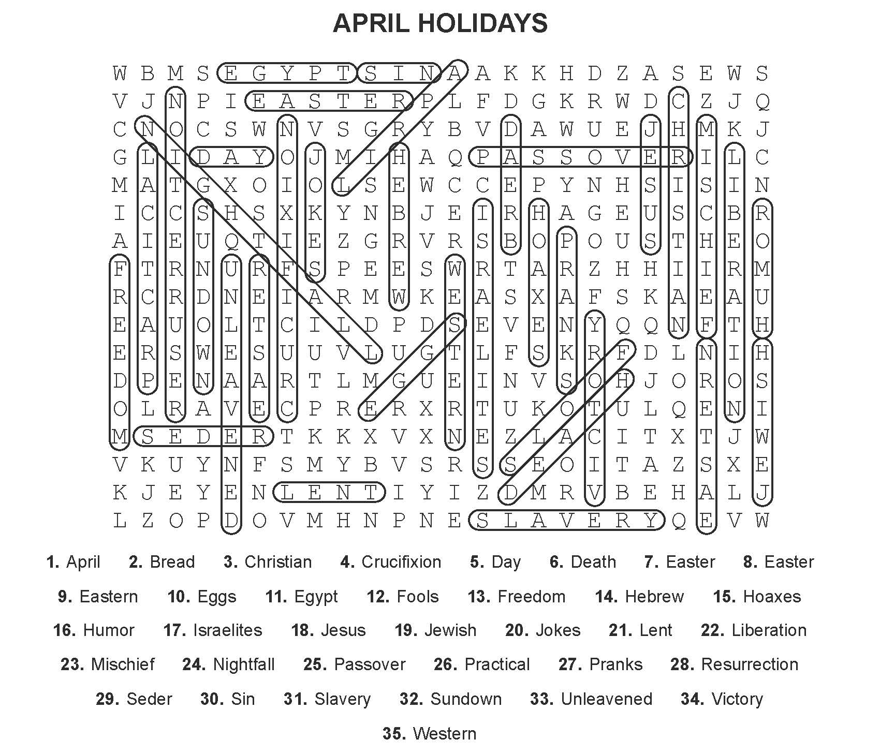
1. Word Search Puzzle Solution
2. Word Math Puzzle: barbecues
3. Word Picture Puzzle: What are you eating? I’m eating French fries.
5. Crypto-Quiz: “My mother used to say: the older you get, the better you get, unless you’re a banana.”
Answer Key 1. bananas 2. truck 3. bottle 4. moth 5. dog 6. yellow
Passage 1
Maria walks to class every day. She passes a small park on her way. One day, her friend asked, “Can you pass me your notebook?” Maria smiled and gave it to her. Last week, Maria studied hard and passed her test. She was proud because, in the past, tests were hard for her. Now she feels more confident and happy about her learning.
Passage 2
On Saturday, Ben went hiking with his family. They walked through a narrow pass between two hills. As they climbed, cars passed them on the road below. Ben had to pass his water bottle to his sister when she got thirsty. Later, they talked about the past, when their grandparents lived in the same area. At the end of the day, Ben said it was his best trip. He felt strong because he had also passed his fitness test the day before.

Passage 3
Lena works in an office downtown. Every morning, she passes many people on the street. When she gets inside, she must show her work pass to enter the building. One day, her coworker forgot his pass and asked if he could borrow hers. Lena helped him quickly. Last month, Lena took a big exam and passed it after many weeks of study. Now she is eligible for a promotion. She thought about the past, when she was afraid of tests. Now, she feels proud of her progress. After work, she sometimes walks home and watches the cars that pass by her. She enjoys the quiet time and thinks about her goals.
Passage 4
Carlos trained for a big foot race in his city. In the past, he did not like running, but now he practiced every day. On race day, he wore a special runner’s pass to enter the event area. At the starting line, he felt nervous but ready. When the race began, many runners passed him at first. Carlos did not give up. He kept a steady pace and began to pass other runners one by one. A teammate called out, “You can do it!” and Carlos felt stronger. As he ran, he thought about the past, when he could not run very far. Near the end, more runners tried to pass him, but Carlos stayed focused. He crossed the finish line tired but proud. Even though he did not win, he knew he had improved a lot.

