Welcome to the LSIRC Notebook, a newsletter for all adult students of Literacy Services of Indian River County, Florida. We hope you like this newsletter.

1. Word Ladder: Change the starting word into the ending word. Change one letter to make a new word. Change one letter in this new word to make another new word. Repeat until you have made the ending word.


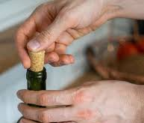
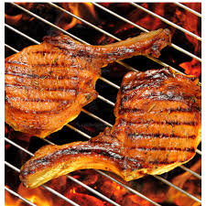
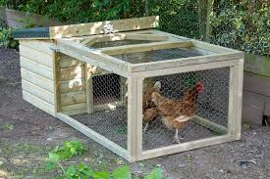

Pork to Chop

- P O R K
- _ _ _ _ It closes a wine bottle.
- _ _ _ _ She prepares food. She is a _____.
- _ _ _ _ Chickens live in a chicken _____.
- C H O P

2. Word Picture Puzzle: A word picture puzzle uses two or more pictures to suggest a word:
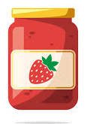

+ = _____________

3. Brainteasers are questions that you need to think about carefully to figure out the answers.

How many birthdays does the average man have?

4. Crypto-Quiz Mystery Sentence: Holiday Wisdom

1. ₈__ ₂₂__ ₁₅__ ₂ __ ₂₅__ ₇ __ ₂₁__ ₂₃__ ₁₀__ ₂₃__ ₂__ ₂₁__ [a November holiday]
2. ₂₆ __ ₂₃ __ ₈ __ ₈ __ ₂₆ __ ₁₉__ [not big]
3. ₂₂__ ₃__ ₂₆__ ₂₃__ ₁₈__ ₁₅__ ₁₃__ ₇__ [Thanksgiving, Christmas, New Year’s Day]
4. ₁₁__ ₂₃__ ₂__ ₈__ ₁₉__ ₆__ [the season between fall and spring]
5. ₂₀__ ₉__ ₂__ ₂__ ₁₃__ [You will laugh if the joke is _______.]
6. ₁ __ ₁₅__ ₁₃__ ₁₆__ ₁₉__ [Not yes or no, but ________.]

₈ __ ₂₂__ ₁₉ __ ₆__ ₁₉__ ₂₃__ ₇ __ ₁₅__ ₂₆ __ ₁₁ __ ₁₅ __ ₁₃__ ₇ __
₇__ ₃__ ₁__ ₁₉__ ₈__ ₂₂__ ₂₃__ ₂__ ₂₁__ ₈__ ₃__ ₁₆__ ₁₉__
₈__ ₂₂__ ₁₅__ ₂__ ₂₅__ ₂₀__ ₉__ ₂₆__ ₂₀ __ ₃__ ₆ __. Unknown

5. My Story. This space is reserved for you to send in something you have written. Your tutor can help you decide what to write. You can write a paragraph or more about you, your family, your vacation, your favorite food – anything you want. Articles for My Story should be short – between approximately 25 and 125 words.


- Captain Comprehension and Busy Words. Captain Comprehension is a new Super Hero! Captain Comprehension conquers Busy Words. Busy Words are words that sound the same but are spelled differently, have different meanings, and some can’t decide if they are nouns, verbs, or adjectives.

Today’s Word: cent/scent/sent and cents/scents/sense

cent [noun] = penny
The book costs $5.01.
The book costs five dollars and one cent.
dollar sign = $
cent sign = ¢

scent [noun]= the nice smell of something
Many people like the scent of roses.

sent = the past tense of send
He sent an email to his sister.

cents = plural of cent
There are five cents in a nickel and ten cents in a dime.


scents = plural of scent
The scents of lavender and lily of the valley are often found in perfumes.

sense [noun] = an ability to perceive something
sense of smell

A man’s sense of smell is not very good compared to a dog’s sense of smell.
The camera in my cell phone can sense a QR Code.

make sense = understand
Does this sentence make sense? Do you understand this sentence?

Pronunciation Alert! Sends – She sends many text messages every day.

You can ask Captain Comprehension to explain any words that give you trouble.

7. Cook’s Corner: This is the place for readers to share their favorite recipies. Your food is an important part of your culture. We would like to publish some recipes in every issue of this newsletter.

8. Questions and Suggestions Box: This is the place for readers to ask questions and make suggestions. We will try to answer your questions. Other readers may want to answer your questions, too. Suggestions are always welcome.

Send your Busy Words for Captian Comprehension, your Stories, your Recipes, your Questions and Suggestions to:

tuesdaytips@literacyservicesirc.org


1. Word Ladder: pork cork cook coop chop

2. Word Picture Puzzle: jelly + fish = jellyfish

3. Brainteaser: Kerri is a twin. Her family has two sets of twins! through the square hole. A round one cannot fall throught hole.

4. Crypto-Quiz: An apple a day keeps the doctor away.

