Welcome to the LSIRC Notebook, a newsletter for all adult students of Literacy Services of Indian River County, Florida. We hope you like this newsletter.

- Word Ladder: Change the starting word into the ending word. Change one letter to make a new word. Change one letter in this new word to make another new word. Repeat until you have made the ending word.

Change Word to Book
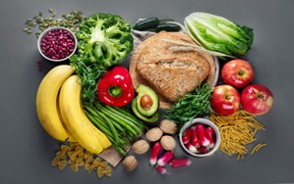
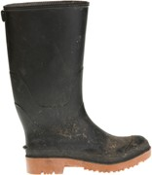
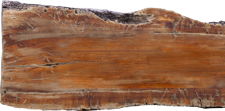
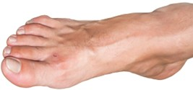

2. 3. 4. 5.
- W O R D
- ___ ___ ___ ___
- ___ ___ ___ ___
- ___ ___ ___ ___
- ___ ___ ___ ___
- B O O K

2. Word Picture Puzzle: A word picture puzzle uses two or more pictures to suggest a word:

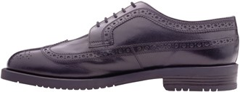
+ = __________

3. Brainteasers are questions that you need to think about carefully to figure out
the answers.
This is an old English nursery rhyme riddle.
As I was going to St. Ives, I met a man with seven wives,
Each wife had seven sacks, Each sack had seven cats,
Each cat had seven kits: Kits, cats, sacks, and wives,
How many were there going to St. Ives?

4. Crypto-Quiz Mystery quote from Robert M. Pirsig

Instructions: Look at the picture clues. Write the letters of the word in the blanks.

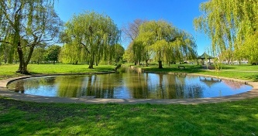
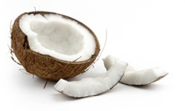

1. 2. 3.
1. 24___ 23___ 22___ 12___ (a small lake)
2. 5___ 9___ 2___ 13___ 26___ 14___ 9___ 20___ 20___
3. 11___ 23___ 11___ 23___ 22___ 3___ 2___
4. Winter, Spring, 1___ 3___ 21___ 21___ 13___ 26___, Fall
5. 16___ 17___ 15___ 16___ (not low)
6. 12___ 13___ 13___ 24___ (not shallow)

“2___ 16___ 13___ 24___ 20___ 9___ 11___ 13___ 2___ 23___
17___ 21___ 24___ 26___ 23___ _V_ 13___ 2___ 16___ 13___

5___ 23___ 26___ 20___ 2___ 17___ 1___ 14___ 17___ 26 ___ 1___ 2___
17___ 22___ 23___ 22___ 13___’ 1___ 23___ 5___ 22___
16___ 13___ 9___ 26___ 12___ 9___ 22___ 12___ 16___ 13___ 9___ 12___
9___ 22___ 12___ 16___ 9___ 22___ 12___ 1___ 9___ 22___ 12___
2___ 16___ 13___ 22___ 5___ 23___ 26___ _K_
23___ 3___ 2___ 5___ 9___ 26___ 12___ 14___ 26___ 23___ 21___

2___ 16___ 13___ 26___ 13___.”


5. Captain Comprehension and Busy Words. Captain Comprehension is a new Super Hero! Captain Comprehension conquers Busy Words. Busy Words are words that sound the same but are spelled differently, have different meanings, and some can’t decide if they are nouns, verbs, or adjectives.
Art by Carlos Millan

August brings us to the end of our first year of publication. Captain Comprehension has helped you conquer these Busy Words:

September 2024 right / write / write / rite
October 2024 by / buy / bye
November 2024 cent / scent / sent and cents / scents / sense
December 2024 Mary / merry / marry
January 2025 bored / board
February 2025 there / their / they’re
March 2025 flu / flew / flue
April 2025 eye / I / aye and nose / knows / noes
May 2025 row/roe and rows/roes/rose
June 2025 already / all ready and altogether / all together
July 2025 read / reed / Reid
Next month Captain Comprehension will begin to also look at easily confused word pairs such as excess/access and insure/ensure and other problem words whose meaning changes when pronounced differently such as present-to give something to someone/present-to be here or a gift. and content-what is inside/content – happy and satisfied.

You can ask Captain Comprehension to explain any words that give you trouble.

6. My Story. This space is reserved for you to send in something you have written.` Your tutor can help you decide what to write. You can write a paragraph or more about you, your family, your vacation, your favorite food – anything you want. Articles for My Story should be short – between approximately 25 and 125 words.

7. Cook’s Corner: This is the place for readers to share their favorite recipes. Your food is an important part of your culture. We would like to publish some recipes in every issue of this newsletter.

8. Questions and Suggestions Box: This is the place for readers to ask questions and make suggestions. We will try to answer your questions. Other readers may want to answer your questions, too. Suggestions are always welcome.

Send your Busy Words for Captian Comprehension, your Stories, your Recipes, your Questions and Suggestions to:

Editor fayejhts@comcast.net

1. Word Ladder: 1. word, 2. wood, 3. food, 4. foot, 5. boot, book
2. Word Picture Puzzle: shoelace
3. Brainteaser: One. The speaker was the only one going to St. Ives. The man and his wifes were leaving St. Ives.
4. Crypto-Quiz: 1. pond, 2. waterfall, 3. coconut, 4. summer, 5. high, 6. deep “The place to improve the world is first in one’s own heart and head and hands and then work outward from there.” Robert M. Pirsig

