Welcome to the LSIRC Notebook, a newsletter for all adult students of Literacy Services of Indian River County, Florida. We hope you like this newsletter.

1. Word Ladder: Change the starting word into the ending word. Change one letter to make a new word. Change one letter in this new word to make another new word. Repeat until you have made the ending word.

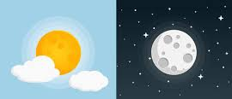
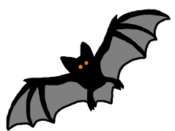


or

2. 3. 4. 5.

- D R Y
- __ __ __
- __ __ __
- __ __ __
- __ __ __
- W E T

2. Word Picture Puzzle: A word picture puzzle uses two or more pictures to suggest a word:
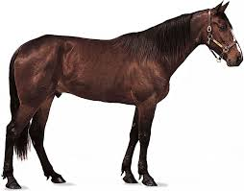
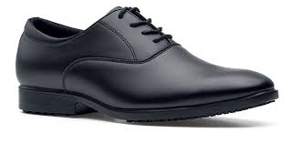
+ = _____________

3. Brainteasers are questions that you need to think about carefully to figure out the answers.

Some months have 31 days. How many months have 28? _______

4. Crypto-Quiz Mystery Sentence: Winter Words from Aristotle
- ₂₀__ ₂₅__ ₃ __ ₂₁__ ten cents
- ₂₂__ ₂₅__ ₁₂__ ₂₁__ 2 +3 = _______
- ₂__ ₂₁__ ₁₀__ ₁₀__ ₂₁__ ₈__ ₉__ The mailman brings them.
- ₃__ ₅__ ₄__ ₂₁__ ₁₅__ You can buy things if you have ________.
- ₆__ ₂₅__ ₄__ ₁__ Red + white = ____________.
- ₂₄__ ₅__ ₁₃__ Who, what, when, where, why and _______.
- ₁₅__ ₂₁__ ₁₇__ ₈__ Happy New _______.
Albert Einstein said:

”₂__ ₂₁__ ₁₇__ ₈__ ₄__ ₂₂__ ₈__ ₅__ ₃__ ₁₅ __ ₂₁__ ₉ __ ₁₀__ ₂₁__ ₈__ ₂₀__ ₁₇__ ₁₅__.

₂__ ₂₅__ ₁₂__ ₂₁__ ₂₂__ ₅__ ₈__ ₁₀__ ₅__ ₂₀__ ₁₇__ ₁₅__.

₂₄__ ₅__ ₆__ ₂₁__ ₂₂__ ₅__ ₈__ ₁₀__ ₅__ ₃__ ₅__ ₈__ ₈__ ₅__ ₁₃__.”

5. My Story. This space is reserved for you to send in something you have written. Your tutor can help you decide what to write. You can write a paragraph or more about you, your family, your vacation, your favorite food – anything you want. Articles for My Story should be short – between approximately 25 and 125 words.

My story is about my treasure and my greatest treasure is my daughter, Lauren Sophia. She changed my life becoming my engine, my reason for being, my first thought when I woke up and my greatest wish is to live together again, since she studies and works in Germany, so that is my greatest challenge and now with God's help we will achieve it. From Everilda C.


6.Captain Comprehension and Busy Words. Captain Comprehension is a new Super Hero! Captain Comprehension conquers Busy Words. Busy Words are words that sound the same but are spelled differently, have different meanings, and some can’t decide if they are nouns, verbs, or adjectives.
Art by Carlos Millan
Today’s Word: bored/board


bored [verb]– not interested in anything
bore/bores boring bored
bore [noun] – someone or something that is not interesting

I am so bored. This movie is a total bore. It’s so boring I will probably fall asleep before it’s over.

Tell me about your trip to France but please leave out the boring details.

He bores me so much I almost fall asleep listening to him.

board [noun] – a piece of wood
bulletin board, chess board, cutting board
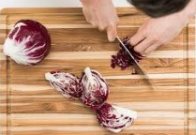
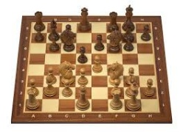
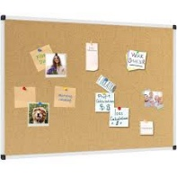

board [verb] – board/boards boarding boarded

It’s time to board the bus. Passengers are boarding the plane now.
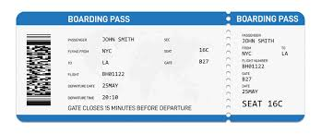
Families with small children should board first.

boarding [adjective] – Please have your boarding pass ready to show the flight attendant.

board [noun] – food or meals Rooms for rent, board included (three meals a day) The boarding house had rooms for rent. They served three meals every day.

You can ask Captain Comprehension to explain any words that give you trouble.

7. Cook’s Corner: This is the place for readers to share their favorite recipes. Your food is an important part of your culture. We would like to publish some recipes in every issue of this newsletter.

Bollo de Mazorca is a typical Colombian food, made with fresh ground corn wrapped in corn husks and boiled until it is consistent. This is served at breakfast accompanied with tropical cheese. From Everilda C.

8. Questions and Suggestions Box: This is the place for readers to ask questions and make suggestions. We will try to answer your questions. Other readers may want to answer your questions, too. Suggestions are always welcome.

Send your Busy Words for Captian Comprehension, your Stories, your Recipes, your Questions and Suggestions to:

tuesdaytips@literacyservicesirc.org
1. Word Ladder: dry, day, bay, bat, bet, wet

2. Word Picture Puzzle: horse + shoe = horseshoe

3. Brainteaser: twleve All months have 28 days!

4. Crypto-Quiz: 1. dime, 2. five, 3. letters, 4. money, 5. pink, 6. how, 7. year.
Albert Einstein: “Learn from yesterday, live for today, hope for tomorrow.”

