Welcome to the LSIRC Notebook, a newsletter for all adult students of Literacy Services of Indian River County, Florida. We hope you like this newsletter.

1. Word Search

One common Valentine’s Day tradition is giving cards called valentines. People give them to friends, parents, teachers, and classmates. Valentine cards often have hearts, flowers, and kind messages. Some cards say, “I like you” or “You are special.” Children bring valentines for everyone in the class so no one feels left out. Another tradition is giving candy and chocolate. Chocolate hearts and candy in red and pink wrappers are very popular. Cupid is a symbol of love on Valentine’s Day. Cupid is a small angel with wings. Cupid carries a bow and arrow. When Cupid shoots someone with his arrow, that person falls in love.
Find the bold words in this month’s Happy Valentine’s Day Word Search:
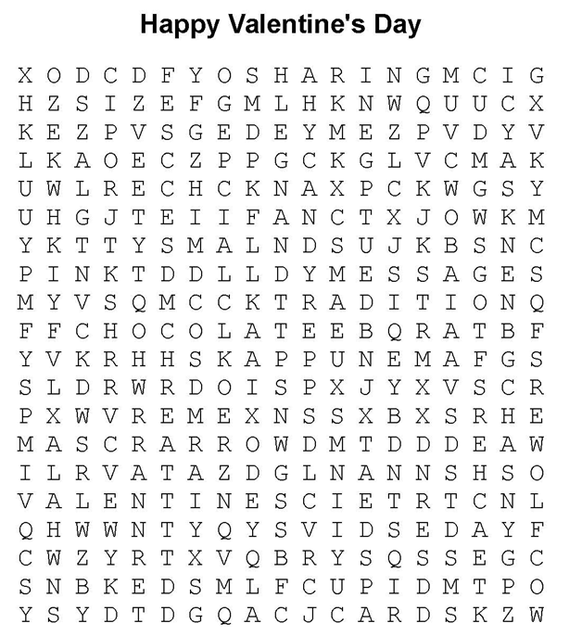

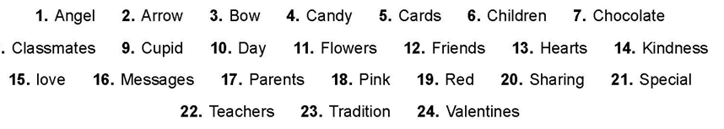

2. Word Math Puzzle: Solve the equation:
value -ue = _________
+enter -er = _________
+into -to = _________
+end -nd =_________
Total = ______________________

3. Picture Talk: Can you write sentences from these pictures?



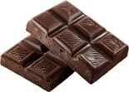



_____________________________________ __________________________________

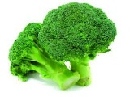





_____________________________________ _________________________________

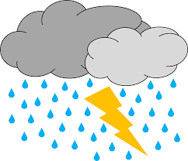




_____________________________________ _________________________________

4. Silly Jokes and Riddles
The psychiatrist was asking questions to test his patient.
Do you ever hear voices withoutknowing who is speaking or where the voices are coming from?
Yes, sir, I do.
And when does this occur?
When I answer the telephone.
5. Crypto-Quiz Quote from Mother Theresa
Instructions: Look at the picture clues. Write the letters of the word in the blanks.
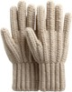


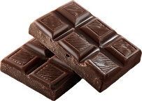
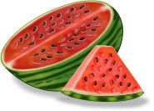

1. 2. 3. 4. 5. 6.

1. 26____ 25____ 26____ 23____
2. 1____ 6____ 13____ 1____ 13____ 10____ 25____ 18____ 3____
3. 5____ 10____ 13____ 20____ 3____ 17____
4. 21___ 25___ 18___ 3___ 16___ 11___ 3___ 10___ 13___ 12___
5. 19___ 11___ 26___ 16___ 3___ 10___ 10___ 25___
6. 4___ 7___ 17___ 6___

Write the letters in the blanks to see the quote from Mother Teresa.
“10____ 3____ 18____ 19____ 17____ 25____ 10____ 21____ 25____ 23____ 17____
11____ 3____ 3____ 18____ 3____ 25____ 1____ 6____ 21____ 7____ 18____ 6____
25____ 17____ 11____ 7____ 10____ 3____, 4____ 13____ 18____ 25____
17____ 11____ 7____ 10____ 3____ 7____ 17____ 18____ 6____ 3____
26____ 3____ 5____ 7____ 12____ 12____ 7____ 12____ 5____ 13____ 4____
10____ 13____ 20____ 3____.”


6. Captain Comprehension and Busy Words. Captain Comprehension is a new Super Hero! Captain Comprehension conquers Busy Words. Busy Words are words that sound the same but are spelled differently, have different meanings, and some can’t decide if they are nouns, verbs, or adjectives. Other words are easy to confuse because they sound only slightly different from each other.
Art by Carlos Millan

Today’s Words: quiet / quietly / quit / quite

quiet [rhymes with buy it] (adjective): making little or no noise
- The room is quiet during the test.
- The baby is quiet while sleeping.
- We sat in a quiet library.
- Please be quiet in the hallway.

quietly [rhymes with silently] (adverb): in a way that makes little or no noise
- She walked quietly into the room.
- The students worked quietly at their desks.
- He closed the door quietly so the baby would not wake up.
- The cat moved quietly across the floor.

quit [rhymes with bit, hit, sit] (verb): to stop doing something or to leave something
- I quit the game when I felt tired.
- She did not quit her job last year.
- He wants to quit eating candy every day.
- Please do not quit when work feels hard.

quite [rhymes with bite] (adverb): very or really
- The movie was quite funny.
- It is quite cold outside today.
- She is quite good at math.
- The dog is quite fast.

Practice

Passage 1
quiet quiet quietly quit quite

The classroom was __________ after lunch. The students sat at their desks and worked __________ on their math pages. Sam felt __________ proud because he finished his work on time. Yesterday, he wanted to __________ when the problems felt hard, but today he kept trying. The teacher walked around the room and smiled. She liked how __________ the class felt.

Passage 2
quiet quietly quietly quit quite

Lena went to the library after school. It was a __________ place with tall shelves and soft chairs. She walked __________ so she would not bother anyone. The book she chose was __________ interesting, and she did not want to stop reading. Last week, she almost __________ reading that story because it seemed boring at first. Now she was glad she kept going. The librarian nodded as Lena checked out her book and __________ left the building.

Passage 3
quiet quietly quit quit quite

The team practiced soccer after school. At first, it was __________ noisy on the field. When the coach blew the whistle, everyone grew __________ and listened. Max felt tired and wanted to __________, but he stayed. He ran __________ back to his spot and took a deep breath. Soon, the team worked together better. When practice ended, the players packed up and walked home. Max felt proud because he hadn’t given up. He hadn’t __________!

Passage 4

quiet quietly quietly quit quite

Early in the morning, the house was __________. Maya got out of bed and moved __________ so she would not wake her little sister. She felt __________ excited about the school trip later that day. While eating breakfast, she remembered yesterday’s homework. She almost wanted to __________ when it felt confusing, but she asked for help instead. Now she understood it better. Maya packed her bag and waited __________ by the door. She smiled, ready for a new day.



!. Word Search Puzzle Solution

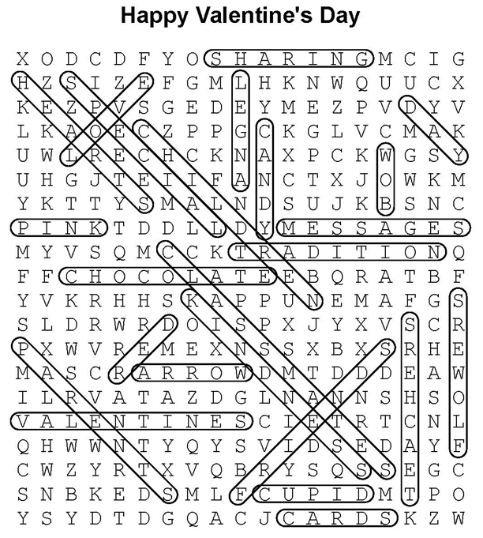

2. Word Math Puzzle: valentine
3. Many answers are possible. Check with your tutor. I like chocolate. I love chocolate. I don’t like snakes. He doesn’t like broccoli. She likes broccoli. They love ice cream They don’t like thunder storms. They don’t like bad weather.

5. Crypto-Quiz: “Let us always meet each other with a smile, for the smile is the beginning of love.” —Mother Teresa
Answer Key 1. baby 2. chocolate 3. gloves 4. watermelon 5. umbrella 6. fish

Passage 1

The classroom was quiet after lunch. The students sat at their desks and worked quietly on their math pages. Sam felt quite proud because he finished his work on time. Yesterday, he wanted to quit when the problems felt hard, but today he kept trying. The teacher walked around the room and smiled. She liked how quiet the class felt.

Passage 2

Lena went to the library after school. It was a quiet place with tall shelves and soft chairs. She walked quietly so she would not bother anyone. The book she chose was quite interesting, and she did not want to stop reading. Last week, she almost quit reading that story because it seemed boring at first. Now she was glad she kept going. The librarian nodded as Lena checked out her book and quietly left the building.

Passage 3

The team practiced soccer after school. At first, it was quite noisy on the field. When the coach blew the whistle, everyone grew quiet and listened. Max felt tired and wanted to quit, but he stayed. He ran quietly back to his spot and took a deep breath. Soon, the team worked together better. When practice ended, the players packed up and walked home. Max felt proud because he hadn’t given up. He hadn’t quit!

Passage 4

Early in the morning, the house was quiet. Maya got out of bed and moved quietly so she would not wake her little sister. She felt quite excited about the school trip later that day. While eating breakfast, she remembered yesterday’s homework. She almost wanted to quit when it felt confusing, but she asked for help instead. Now she understood it better. Maya packed her bag and waited quietly by the door. She smiled, ready for a new day.

