Welcome to the LSIRC Notebook, a newsletter for all adult students of Literacy Services of Indian River County, Florida. We hope you like this newsletter.

1. Word Ladder: Change the starting word into the ending word. Change one letter to make a new word. Change one letter in this new word to make another new word. Repeat until you have made the ending word.

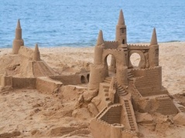
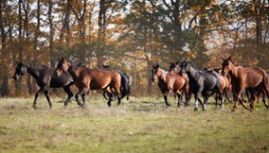
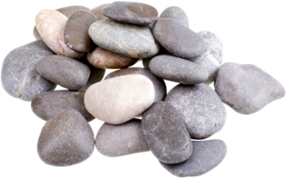
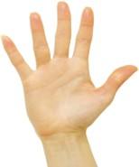
The hero saves people from danger. Change Hero to Save.
1. 2. 3. 4.

H E R 0
1. ___ ___ ___ ___ A flock of birds, a ______ of horses or cattle.
2. ___ ___ ___ ___ Rocks are ________. Difficult work is _______ work.
3. ___ ___ ___ ___ At the end of your arm. It has fingers and a thumb.
4. ___ ___ ___ ___ The beach has a lot of this. You can build castles with it.
5. ___ ___ ___ ___ The opposite of insane.
S A V E

2. Word Picture Puzzle: A word picture puzzle uses two or more pictures to suggest a word: lip stick

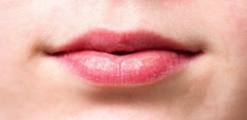
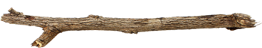
+ = _____________

3. Brainteasers are questions that you need to think about carefully to figure out the answers.

What can you hold in your right hand that you can never hold in your left hand?

4. Crypto-Quiz Mystery quote from Wilma Rudolph




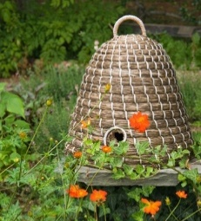
Instructions: Look at the picture clues. Write the letters of the word in the blanks.
1. 2. 3. 4.

1. 6___ 9___ 9___ 12___ 13___ 26___ 9___ A home for bees.

2. 5___ 11___ 16___ 5___ 23___ 23___ 19___ 10___ 1 ___ 5___ 24___ 9___ 22___

3. 7___ 5___ 18___ 8___ 3___ Something sweet to eat.

4. 25___ 17___ 6___ 22___ 9___ 16___ 16___ 5___ Helps to keep you dry in the rain.

Write the letters in the blanks to see the quote.

“1___ 12___ 9___ 18___ 24___ 12___ 9___ 23 ___ 25___ 18___ 13___ 23___

23___ 12___ 13___ 18___ 13 ___ 18___ 11___. 13___ 7___ 5___ 18___ 8___ 19___

5___ 18___ 3___ 24___ 12___ 13___ 18___ 11___; 18___ 19___

17___ 19___ 25___ 18___ 24___ 5___ 13___ 18___ 13__ 23__ 24___ 19___ 19___

12 ___ 13___ 11___ 12 ___, 18___ 19___ 24___ 22___ 19___ 25___ 6___ 16___ 9___

13___ 23___ 24___ 19___ 19___

8___ 13___ 10___ 10___ 13___ 7 ___ 25___ 16___ 24___ 24___ 19___

19___ 26___ 9___ 22___ 7 ___ 19___ 17___ 9___.”


5. Captain Comprehension and Busy Words. Captain Comprehension is a new Super Hero! Captain Comprehension conquers Busy Words. Busy Words are words that sound the same but are spelled differently, have different meanings, and some can’t decide if they are nouns, verbs, or adjectives.
Art by Carlos Millan
Today’s Words: read / reed / Reid

Reid: The name Reid, usually a man’s name, has British and Scottish origins and means "red" or "reed clearing". It's derived from a Scottish and English surname, originally a nickname for someone with red hair or a ruddy complexion

Reed:
- [noun] A type of grassy plant found growing is wet and marshy areas.
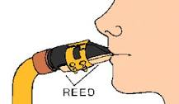
- [noun] Thin strip of reed used to make sound in the mouthpiece of reed instruments

- [adjective] Clarinet, oboe, and saxophone are reed instruments. The mouthpiece includs a reed.

Read: [verb] to look at letters that form words with understanding
I like to read romantic stories.
He likes to read stories about history.

Rede:
- archaic [noun] advice or counsel given by one person to another.
What is your rede? (What is your advice?)
- archaic [verb] to give advice to someone
Therefore, my son, I rede thee stay at home.

You can ask Captain Comprehension to explain any words that give you trouble.

6. My Story. This space is reserved for you to send in something you have written.` Your tutor can help you decide what to write. You can write a paragraph or more about you, your family, your vacation, your favorite food – anything you want. Articles for My Story should be short – between approximately 25 and 125 words.

7. Cook’s Corner: This is the place for readers to share their favorite recipes. Your food is an important part of your culture. We would like to publish some recipes in every issue of this newsletter.

8. Questions and Suggestions Box: This is the place for readers to ask questions and make suggestions. We will try to answer your questions. Other readers may want to answer your questions, too. Suggestions are always welcome.

Send your Busy Words for Captian Comprehension, your Stories, your Recipes, your Questions and Suggestions to:

tuesdaytips@literacyservicesirc.org
1. Word Ladder: hero 1. herd, 2. hard, 3. hand, 4. sand, 5. sane, save
2. Word Picture Puzzle: lipstick
3. Brainteaser: Your left hand or your left elbow
4. Crypto-Quiz: "When the sun is shining, I can do anything; no mountain is too high, no trouble is too difficult to overcome." Wilma Rudolph

