Welcome to the LSIRC Notebook, a newsletter for all adult students of Literacy Services of Indian River County, Florida. We hope you like this newsletter.

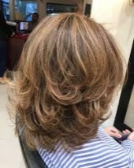
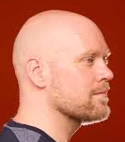

1. Word Ladder: Change the starting word into the ending word. Change one letter to make a new word. Change one letter in this new word to make another new word. Repeat until you have made the ending word.

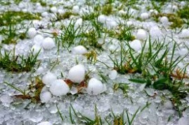
1. hair 2. 3. 4. 5. bald

Hair to Bald

- H A I R

- _ _ _ _ little pieces of frozen rain

- _ _ _ _ like an indoor street

- _ _ _ _ a sphere to play with

- B A L D

2. Word Picture Puzzle: A word picture puzzle uses two or more pictures to suggest a word:
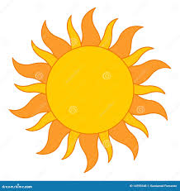

+ = _____________

3. Brainteasers are questions that you need to think about carefully to figure out the answers.

John is a butcher in a butcher shop? He is 5’ 10” tall. What does he weigh?

4. Crypto-Quiz Mystery Sentence: Winter Words from Aristotle
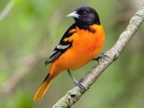
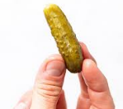
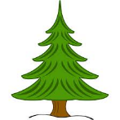

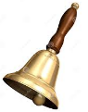

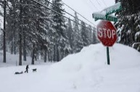

1. 2. 3. 4, 5. 6. 7.
1. ₁₂___ ₇___ ₈ __ ₁₆___ cold white stuff that falls from the sky
2. ₁₂___ ₁₃___ ₂₀___ ₁₁___ a point of light in the sky
3. ₁₃ ___ ₁₁___ ₂₄___ ₂₄___ apples grow on a __________
4. ₂₁___ ₂₄___ _{5_}__ ₅___ It rings, but it’s not a cell phone.
5. ₉___ ₂___ ₂₂___ ₄___ ₅___ ₂₄___ Do you like a sweet or a dill _______.
6. ₂₅___ _{2_}__ ₁₂___ ₁___ They swim in rivers, lakes, and streams.
7. ₁₈___ ₈___ ₁₄___ ₁₁___ ₁₂___ This book is not mine. It’s _______.
8. ₂₁___ ₂ ___ ₁₁___ ₂₃___ It lives in a nest and flies in the air.

”₁₃___ ₈___ ₂₀___ ₉ ___ ₉ ___ ₁₁___ ₂₄___ ₂₂ ___ ₂___ ₂₀___ ₁₃___ ₂₄ ___

₁₃___ ₁ ___ ₂₄___ ₂₁___ ₂₄___ ₂₀___ ₁₄___ ₁₃___ ₁₈___ ₈___ ₂₅___ ₂₀__

₁₂___ ₇ ___ ₈___ ₁₆ ___ ₂₅___ ₅___ ₂₀___ ₄___ ₂₄___, ₂___ ₁₃___ ₂ ___ ₁₂___

₇___ ₂₄___ ₂₂___ ₂₄___ ₁₂___ ₁₂___ ₂₀___ ₁₁___ ₁₈___ ₁₃___ ₈___

₁₂___ ₁₃___ _{20_}__ ₇___ ₂₃___ ₈___ ₁₄___ ₁₃___ ₂ ___ ₇___ ₁₃___ ₁ ___ ₂₄___

₂₂___ ₈___ ₅___ ₂₃__.”
5. My Story. This space is reserved for you to send in something you have written. Your tutor can help you decide what to write. You can write a paragraph or more about you, your family, your vacation, your favorite food – anything you want. Articles for My Story should be short – between approximately 25 and 125 words.

From Hilda S
I traveled on vacation to Rio de Janeiro in 2023, a city full of life and beauty. My first stop was the Christ the Redeemer statue, one of the most impressive sights I’ve ever seen. Standing at the top of Corcovado Mountain, I felt like I was on top of the world, looking out over the city and the ocean. Later, I went to the famous Carnival parade. The colors, music, and dancing was impressive! I also got to try delicious Brazilian food, like “feijoada” equal beans and “pão de queijo” equal cheese bread. Every moment was an amazing experience, and Rio is now one of my favorite places!

From Carlos M
María Lionza is a legendary figure in Venezuelan folklore, known as a powerful goddess of nature, love, and protection. According to the story, María Lionza was a beautiful indigenous woman born in the Yaracuy region. She was said to have mystical powers, and her spirit connected deeply with nature.
The legend tells that María Lionza grew up surrounded by mountains and rivers, protected by a giant anaconda. When her village was threatened, she became the protector of her people and the forest. After her death, her spirit was believed to have become part of the mountain.
Today, María Lionza is honored by thousands in Venezuela. People visit her mountain to pray for health, love, and strength.


6.Captain Comprehension and Busy Words. Captain Comprehension is a new Super Hero! Captain Comprehension conquers Busy Words. Busy Words are words that sound the same but are spelled differently, have different meanings, and some can’t decide if they are nouns, verbs, or adjectives.

Today’s Word: Mary/marry/merry
Art by Carlos Millan

Mary – noun a female name
My mother’s name is Mary.

marry – verb marry/marries marrying married
to become husband and wife
John and Martha will marry in June.
Antonio asked, “Will you marry me?” Josephine replied, “Yes, I will marry you.
They got married in August.

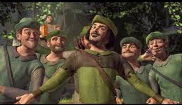
merry – adjective happy and cheerful
Merry Christmas! Let's eat, drink, and be merry! They sang a merry little song.
Robin Hood and his merry men.

You can ask Captain Comprehension to explain any words that give you trouble.

7. Cook’s Corner: This is the place for readers to share their favorite recipes. Your food is an important part of your culture. We would like to publish some recipes in every issue of this newsletter.

From Carlos M.
Arepa is a typical Venezuelan dish made with corn flour. Mix water, corn flour and a pinch of salt. Knead it into round balls and place it in a pan, cook it for 25 minutes to 30 minutes over low heat and turn it over so that it cooks on both sides. It can be filled with whatever you want or whatever you like most: cheese, meat, tuna, egg, chicken and avocado.
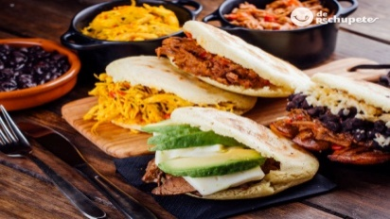
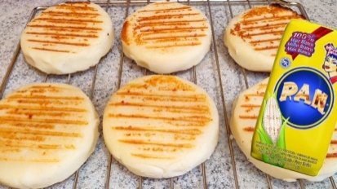

8. Questions and Suggestions Box: This is the place for readers to ask questions and make suggestions. We will try to answer your questions. Other readers may want to answer your questions, too. Suggestions are always welcome.

Send your Busy Words for Captian Comprehension, your Stories, your Recipes, your Questions and Suggestions to:

tuesdaytips@literacyservicesirc.org
1. Word Ladder: hair, hail, hall, ball, bald

2. Word Picture Puzzle: sun + glasses = sunglasses

3. Brainteaser: He is a butcher. He weighs meat!

4. Crypto-Quiz: “To appreciate the beauty of a snowflake, it is necessary to stand out in the cold.”

