Welcome to the LSIRC Notebook, a newsletter for all adult students of Literacy Services of Indian River County, Florida. We hope you like this newsletter.

1. Word Search
Winter holidays include Christmas Day, Christmas Eve, Boxing Day, New Year’s Eve and New Year’s Day as well as Hanukkah and the Lunar New Year. Find these holiday words in this month’s Holiday Word Search:
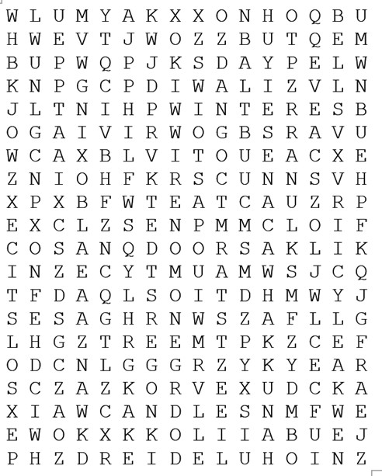
- Bells
- Boxing
- Candles
- Candy
- Canes
- Christmas
- Day
- Diwali
- Dreidel
- Eve
- Hanukkah
- Kwanzaa
- Lunar
- New
- Solstice
- Star
- Tree
- Winter
- Year

2. Word Picture Puzzle: A word picture puzzle uses two or more pictures to suggest a word:


+ = N______G______

3. Silly Riddles are questions that have funny answers because words have more than one meaning. Do you understand why this riddle/joke is funny?
Why is the Cook so mean? The Cook is so mean because she must beat the eggs and whip the cream.

4. Crypto-Quiz A Japanese Proverb
Instructions: Look at the picture clues. Write the letters of the word in the blanks.

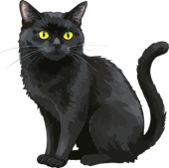

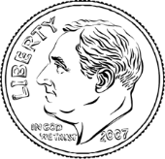

- 2. 3. 4.

1. 8____ 3____ 4____ 12____ 21____ 1____ 16____ 26____ 20____
2. 21____ 23____ 7____ 20____ 20____
3. 19____ 24____ 2____ 20____
4. 18____ 16____ 9____

Write the letters in the blanks to see the word letter values

4____ 3____ 20____ 26____ 24____ 3____ 19____ 12____ 4____ 7____ 19____
18____ 16____ 3____ 12____ 16____ 7____ 2____ 9____ 23____ 7____ 20____ 20____
12____ 24____ 3____ 9____ 20____ 7____ 2____ 4____ 3____ 9____ 23____ 8____


5. Captain Comprehension and Busy Words. Captain Comprehension is a new Super Hero! Captain Comprehension conquers Busy Words. Busy Words are words that sound the same but are spelled differently, have different meanings, and some can’t decide if they are nouns, verbs, or adjectives. Other words are easy to confuse because they sound only slightly different from each other.
Art by Carlos Millan
Today’s Words: missile /missal / mistle(toe)
and mist / missed


1-A. Missile: A missile is a weapon that is sent through the air to hit a target, often fired from far away.
- The news showed a missile being launched during a test.
- The soldiers watched the missile fly across the sky.
- A missile can travel a long distance very quickly.

1-B. Missile: A missile can also mean any object that is thrown or shot at a target, even if it is not a weapon.
- The pitcher threw the ball like a missile toward home plate.
- A snowball can feel like a missile when someone throws it hard.
- The rock became a missile when the boy tossed it at the tree.

2. Missal: A missal is a special book used during church services that has prayers, readings, and songs.
- The priest opened the missal and began the prayer.
- She placed the missal on the stand before the service started.
- The old missal had worn pages from many years of use.

3. Mistle: “Mistle” is an old word related to mistletoe. It is not used much today.
- The word “mistle” is found in some old stories.
- A teacher explained that “mistle” is part of the word “mistletoe.”
- Most people do not use the word “mistle” in daily life.
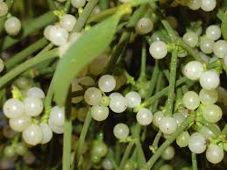

4. Mistletoe: Mistletoe is a green plant with white berries. People hang it during Christmas, and some people kiss under it for good luck.
- She hung mistletoe in the doorway for the holiday.
- Mistletoe stays green even in winter.
- They laughed when they met under the mistletoe.

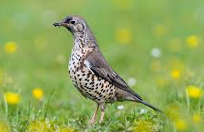
5. Mistle Thrush: A mistle thrush is a bird found in Europe. It likes to eat mistletoe berries and sings a loud, clear song.
- The mistle thrush sat high in the tree and sang.
- A mistle thrush often guards the trees where it feeds.
- We saw a mistle thrush eating berries on a cold morning.

6. Mist: Mist is a light cloud of tiny water drops that hangs close to the ground and makes it hard to see clearly. Mist is ‘wetter’ than fog.
- Early in the morning, a soft mist covered the field.
- The mist made the trees look far away.
- She walked slowly because the mist made the path slippery.

7. Missed: Missed is the past tense of miss. It means someone did not hit a target, did not catch something, or was not present for something.
- He threw the ball but missed the goal.
- She missed the bus and had to wait for the next one.
- I missed seeing my friend because I arrived late.

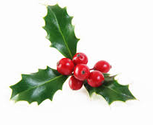
Note: Holly is sometime confused with mistletoe. The holly tree is an evergreen tree. The holly leaves are stiff and shiny green often with sharp needle-like spines. Holly is often seen at Christmas time.

Practice One
mistle missal mistle thrush mistle toe
At the park, Marta sat on a bench with her small ____________, reading a prayer before work. A ____________ sang from a high branch, guarding the berries it loved. She looked up and noticed ____________ growing in the tree. A boy nearby tossed a pinecone, and it flew like a ____________ toward a trash can but missed. Marta smiled. She remembered reading that the old word ____________ is part of “mistletoe,” and she enjoyed learning how words change over time.

Practice Two
missed mist mistletoe mistle thrush missal missile
Early one morning, a soft ____________ hung over the field behind the church. Rosa carried her old ____________ as she walked along the path. A ____________ called from a tall tree where ____________ grew in thick bunches. Just then, a student practicing for a game threw a ball. It shot through the air like a ____________, but it ____________ the target and rolled toward Rosa. She picked it up, laughed, and tossed it back to her.
Practice Three
missed mistle thrush missal mistletoe missile mist
There was a light ____________ in the air as Daniel opened the church door early in the morning. He carried a small ____________ to place on the front table before the service. Outside, a ____________ fluttered near a tree covered in ____________. In a field nearby, a child was practicing soccer, He kicked the ball hard, and it flew like a ____________across the field but ____________ the goal and landed near Daniel’s feet. Daniel picked up the ball and passed it back to the boy with a smile before heading inside.



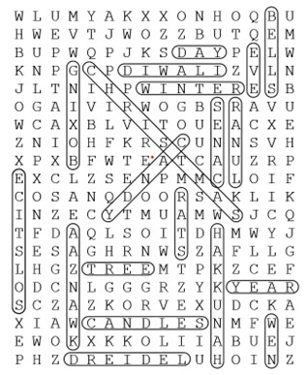
!. Word Search Puzzle Answers
2. Word Picture Puzzle: nightgown
3. Brainteaser/Silly Riddle To beat something can mean to hit it – Don’t beat the dog! It can also mean to stir or mix – You need to beat the eggs if you are making scrambled eggs. To whip something can mean to hit something with a whip. It can also mean to beat very fast – You need to whip the cream to make whipped cream.
4. Crypto-Quiz: One kind word can warm three winter months. Japanese proverb.
Answer Key 1. snowflake 2. three 3. dime 4, cat

Practice One
At the park, Marta sat on a bench with her small missal, reading a prayer before work. A mistle thrush sang from a high branch, guarding the berries it loved. She looked up and noticed mistletoe growing in the tree. A boy nearby tossed a pinecone, and it flew like a missile toward a trash can but missed. Marta smiled. She remembered reading that the old word mistle is part of “mistletoe,” and she enjoyed learning how words change over time.
Practice Two
Early one morning, a soft mist hung over the field behind the church. Rosa carried her old missal as she walked along the path. A mistle thrush called from a tall tree where mistletoe grew in thick bunches. Just then, a student practicing for a game threw a ball. It shot through the air like a missile, but it missed the target and rolled toward Rosa. She picked it up, laughed, and tossed it back to her.

Practice Three
There was a light mist in the air as Daniel opened the church door early in the morning. He carried a small missal to place on the front table before the service. Outside, a mistle thrush fluttered near a tree covered in mistletoe. In a field nearby, a child was practicing soccer, He kicked the ball hard, and it flew like a missile across the field but missed the goal and landed near Daniel’s feet. Daniel picked up the ball and passed it back to the boy with a smile before heading inside.

