Welcome to the LSIRC Notebook, a newsletter for all adult students of Literacy Services of Indian River County, Florida. We hope you like this newsletter.

1. Word Ladder: Change the starting word into the ending word. Change one letter to make a new word. Change one letter in this new word to make another new word. Repeat until you have made the ending word.

Example: story to short
s t o r y
s t o r e (a place to buy something)
s h o r e (where the ocean meets the land)
s h o r t
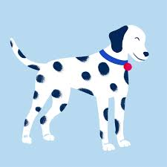

head to tail

- _ H E A D

- ___ ___ ___ ___ (to get better – A broken arm takes a long time to ______.)

- ___ ___ ___ ___ (a blue-green color)

- ___ ___ ___ ___ (to say a story – Please _____ me a story.)

- ___ ___ ___ ___ (I am short but you are _______.)

- _ T A I L_

2. Word Picture Puzzle: A word picture puzzle uses two or more pictures to suggest a word:

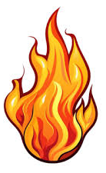
=
___________________

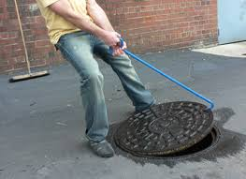
3. Brainteasers are questions that you need to think about carefully to figure out the answers.

Manhole Covers: Why is it better to have a round manhole cover than a square one?

4. Crypto-Quiz Mystery Sentence:
Fruit Salad
Hint: a fruit that is red on the outside white on the inside, You can pick them in the fall.
1. ₅ _A__ ₂₀ _P_ ₂₀ _P_ ₁₆ _L_ ₉_E__

Hint: a fruit that’s round but not like a ball, green or brown on the outside
and white in the inside.
2. ₂₀ P ₉ __ ₅ ___ ₂₂ __

Hint: Monkeys like them.
3. ₆B ₅ ___ ₁₈___ ₅ ___ ₁₈___ ₅ ___

Hint: It’s name is also a color.
5. ₁₉O ₂₂___ ₅ ___ ₁₈___ ₁₁___ ₉___

Hint: It’s made from fruit and you can drink it.
6. ₄J ₂₅___ ₁₃___ ₇ ___ ₉___

Hint: Makes everything a little sweeter.
7. ₂₃S ₂₅___ ₁₁___ ₅ ___ ₂₂___

W ₉___ _{5____} _{22___} _{9___} _{9___} _{5___} _T _{18___} _{11___} _{10___} _{22___} _{25___} _{18___} _T_

_{23___} _{5___} _{16 ___} _{5___} D.

5. My Story. This space is reserved for you to send in something you have written. Your tutor can help you decide what to write. You can write a paragraph or more about you, your family, your vacation, your favorite food – anything you want. Articles for My Story should be short – between approximately 25 and 125 words.

6. Captain Comprehension and Busy Words. Captain Comprehension is a new Super Hero! Captain Comprehension conquers Busy Words. Busy Words are words that sound the same but are spelled differently, have different meanings, and some can’t decide if they are nouns, verbs, or adjectives.

This month’s Busy Word is: write / rite / right
Captain Comprehension explains
write is a verb. He writes his name with a pencil. I write with a pen.

Rite is a noun, a cousin of ritual and means some kind of ceremony. The wedding rites usually include the groom giving a wedding ring to the bride and the bride giving a wedding ring to the groom.

Right can mean direction – Turn right at the next corner.

Right is the opposite of left as in right hand or left hand.

And Right is also the opposite of wrong. Your answer is right.

You can ask Captain Comprehension to explain any word that gives you trouble.

7. Cook’s Corner: This is the place for readers to share their favorite recipies. Your food is an important part of your culture. We would like to publish some recipes in every issue of this newsletter.

8. Questions and Suggestions Box: This is the place for readers to ask questions and make suggestions. We will try to answer your questions. Other readers may want to answer your questions, too. Suggestions are always welcome.

Send your Busy Words for Captian Comprehension, your Stories, your Recipes, your Questions and Suggestions to:

tuesdaytips@literacyservicesirc.org

1. Word Ladder:
H E A D
H E A L
T E A L
T E L L
T A I L

2. Word Picture Puzzle: Hot dog = hotdog

3. Brainteaser: Because a square manhole cover can be turned at an angle and dropped through the square hole. A round one cannot fall throught hole.

4. Crypto-Quiz: We are eating fruit salad.

