Welcome to the LSIRC Notebook, a newsletter for all adult students of Literacy Services of Indian River County, Florida. We hope you like this newsletter.

- Word Search
This year April bring us Easter and Passover as well as April Fool’s Day.
April Fools' Day, celebrated annually on April 1, is a lighthearted, unofficial holiday dedicated to playing practical jokes, hoaxes, and pranks on friends, family, and colleagues. It is a day marked by mischief and humor, where the goal is to trick someone and then reveal the prank by shouting "April Fools!".
Passover (or Pesach in Hebrew) is a major Jewish holiday commemorating the biblical story of the Israelites' liberation from slavery in Egypt over 3,300 years ago. Celebrated in early spring (March/April), it marks the "birth" of the Jewish nation, with traditions centered on retelling this story of freedom, eating unleavened bread (matzah), and holding a Seder meal. This year Passover begins at sundown April 1 and ends [in Israel] at sundown April 8 and outside Israel [Diaspora] ends at nightfall on April 9.
Easter is the most significant Christian holiday, commemorating the resurrection of Jesus Christ three days after his crucifixion, symbolizing victory over sin and death. It marks the end of Lent and is celebrated globally with church services, family gatherings, and traditions like Easter eggs symbolizing new life. This year, Easter Sunday falls on April 5 for Western churches and April 12 for Eastern Orthodox churches.
Find the BOLD words from the reading in the Puzzle.
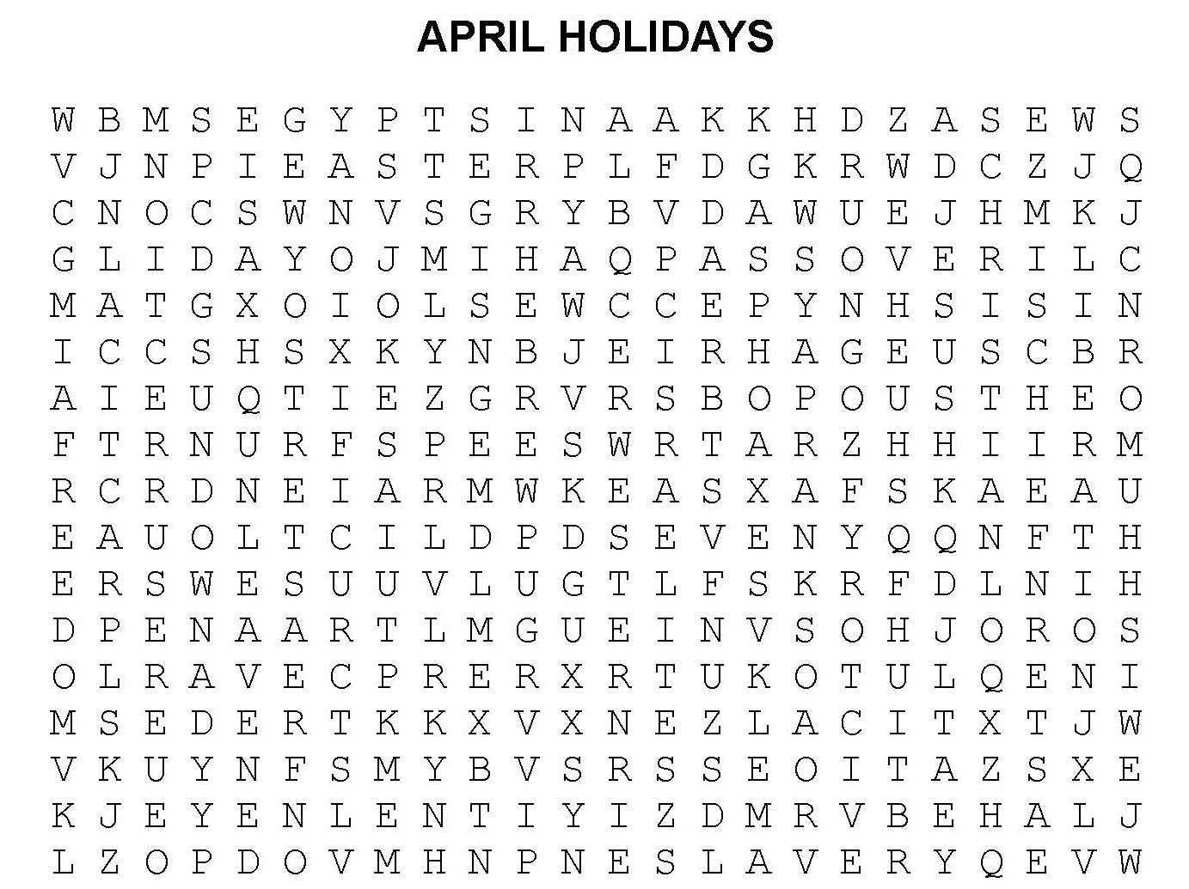

2. Word Math Puzzle: Solve the equation:
pray -y = _________
+cat -a = _________
+ice -e = _________
+alone -one =_________
+job -b =___________
+takes -ta = __________
Total = _________________ ___________
- Picture Talk: How many sentences can you write from these pictures?
[Think about yesterday, today, right now, tomorrow.]

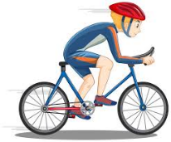


_____________________________________ _____________________________________
_____________________________________ _____________________________________
_____________________________________ _____________________________________

4. Silly Jokes and Riddles
1. Why do omelets love April Fools' Day?
2. What monster plays the most April Fools' jokes?
3. Which day of the year do monkeys like best?
1. They appreciate practical yolks.
2. Prankenstein
3. The first of Aperil

5. Crypto-Quiz Abraham Lincoln quotation
Instructions: Look at the picture clues. Write the letters of the word in the blanks.





1. 2. 3. 4.

1. 12__D__ 23_____ 15_____ 1 _____

2. 14__F__ 9_____ 21_____ 17_____ 20_____ 7_____

3. 11__C__ 3_____ 24_____

4. 10__B_ 26_____ 23_____ 2_____ 16_____ 13_____ 26_____ 9_____ 22_____ 12_____

1__S__ 17_____ 1_____ 2_____ 13_____ 26_____

Write the letters in the blanks to see a famous quote from Abraham Lincoln.
7_____ 23_____ 3_____ 11_____ 9_____ 22_____ 14_____ 23_____ 23_____ 20_____

9_____ 20_____ 20_____ 2_____ 16_____ 13_____ 24_____ 13_____ 23_____ 24_____ 20_____ 13_____

1_____ 23_____ 21_____ 13_____ 23_____ 14_____ 2_____ 16_____ 13_____

2_____ 17_____ 21_____ 13_____ , 9_____ 22_____ 12_____ 1_____ 23_____ 21_____ 13_____

23_____ 14_____ 2_____ 16_____ 13_____ 24_____ 13_____ 23_____ 24_____ 20_____ 13_____

9_____ 20_____ 20_____ 2_____ 16_____ 13_____ 2_____ 17_____ 21_____ 13_____,

10_____ 3_____ 2_____ 7_____ 23_____ 3_____ 11_____ 9_____ 22_____ 22_____ 23_____ 2_____

14_____ 23_____ 23_____ 20_____ 9_____ 20_____ 20_____ 2_____ 16_____ 13_____

24_____ 13_____ 23_____ 24_____ 20_____ 13_____ 9_____ 20_____ 20_____ 2_____ 16_____ 13_____

2_____ 17_____ 21_____ 13_____.

_____________________________________________________________________________________

______________________________________________________________________________________________________

6. Captain Comprehension and Busy Words. Captain Comprehension is a new Super Hero! Captain Comprehension conquers Busy Words. Busy Words are words that sound the same but are spelled differently, have different meanings, and some can’t decide if they are nouns, verbs, or adjectives. Other words are easy to confuse because they sound only slightly different from each other. Other words can
Art by Carlos Millan
be verbs or nouns without chaning their sounds!

Today’s Words: weight, weigh, wait, way, wade,

Weight [noun]
Definition: how heavy something is, usually measured in pounds and ounces
- The weight of this box is ten pounds.
- This bag has too much weight. It’s too heavy for me.
- The doctor checks my weight.
- Please check the weight of your suitcase before you leave for the airport.

Weigh/weighs, weighing, weighed [verb]
Definition 1: the act of measuring how heavy something is
- Many people weigh themselves in the morning.
- She weighs herself once a week.
- Some diets recommend weighing everything you eat.
- The nurse weighed the baby right after it was born,
- The bag of rice weighed ten pounds.
Definition 2: to compare to or more possibilities
- She weighed her choices before making a decision.
- He weighed the pros and cons of the new job.
- They weighed both ideas and picked the better one.
- They had to choose between taking a cruise to Alaska or to the Caribbean. They weighed their options.

Wait/waits, waiting, waited [verb]
Definition: to stay in one place or do nothing until something happens.
- Please wait here for me. I’ll be right back.
- I have been waiting for the bus for ten minuts.
- We waited in line at the store.
- Every afternoon, Tom’s dog waits by the door for him to come home.
Wait [noun]
Definition: a period of time spent waiting for something
- The wait to buy tickets for the movie was long.
- We had a three-hour wait at the airport.

Way [noun]
Definition 1: a method or manner of doing something.
- I like the way you look in that shirt.
- That is a good way to learn.
- We found a new way to solve the problem.
- There are more than two ways to cook this chicken.
Definition 2: a direction or path
- This is the way to the park.
- Show me the way to your house.
- This is a four-way stop.

Wade/wades, wading, waded [verb]
Definition: to walk in shallow water
- She likes to wade in the cool creek water on warm summer days.
- He thinks wading in the water is fun.
- They went wading near the shore where the water was not deep.
- They waded across the shallow stream to the small island.

Practice: Fill in the blanks with the words from the word box.

Passage 1. Bus Stop
wait wait waiting way weight weight

Lena stood at the bus stop and began to __________ for the bus. The bus was late again. She put her bag down because its __________ hurt her shoulder. A man nearby said, “We have been __________ for twenty minutes.” Lena sighed but stayed calm. She knew this was the only __________ to get to work. At last, the bus came. As she got on, she felt the __________ of her bag again, but she smiled because she did not have to __________ anymore.

Passage 2. Doctor’s Office
wait waited waiting way way way weight

Maria sat in the doctor’s office. She was a little early and was __________ to see the doctor. She looked at her phone and texted her friend. A nurse called her name, “Miss Maria, this __________ please.” She showed Maria the __________ to the scales and asked Maria to step on them. The nurse recorded her __________ on the chart. Then the nurse said, “Come this __________. Please __________ in this room. The doctor will in to see you in a few minutes.” Maria __________ again, but not for long. The doctor came in and smiled. “ Hello Maria. It’s good to see you. I hope you haven’t been __________ long. I see that you have lost some __________. That is a good sign.” Maria felt happy. She knew she was on her __________ to better health.

Passage 3. Grocery Store
wait wait way way way weigh weigh
weighed weighed weighed weight weight weight

Tamara went to the grocery store after work. She needed four pounds of potatoes. She put some potatoes on the scale to __________ them. She added two more potatoes and the __________ was close to four pounds. Then she __________ a bag of grapes. The grapes cost $2.79 a pound and she didn’t want a bag of grapes that __________ more than three pounds. She got cereal and bread. She found a bag of sugar. She checked the __________ on the label. It was five pounds. At the checkout, she had to __________ in a long line. She looked for a faster __________, but every line was full. Then a worker opened a new line, and Tamara did not have to __________ long after that. The clerk __________ her potatoes and grapes and told her the price. She asked the clerk to make sure the bags didn’t __________ too much. The clerk was careful to distribute the __________ carefully among the bags. Tamara told the clerk she appreciated the __________ he filled the shopping bags. Soon Tamara was on her __________ home. Her shopping was done.

Passage 4: A Dialogue
wading wading waiding wading wait wait waiting

Jose and Maria have finished eating lunch and want to go __________.
Maria: “Do you think we need to __________ 30 minutes before we go __________?”
Jose: “No, I don’t think it’s necessary to __________ before we go __________. That rule is for swimming.”
Maria: ”Okay, what are you __________ for? Let’s go __________!


!. Word Search Puzzle Solution
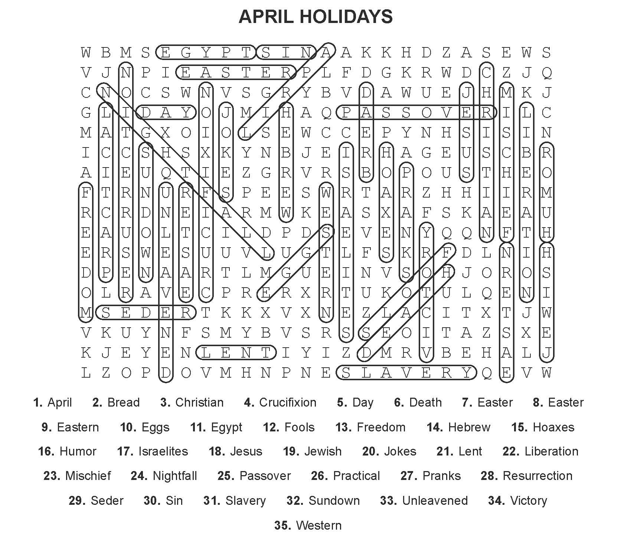

2. Word Math Puzzle: practical jokes
3. Many answers are possible. Check with your tutor. He rides his bike to the library. He is riding his bike to the library. He rode his bike to the library last week. He eats dinner. He is eating dinner. He likes to eat dinner at 6 pm.
5. Crypto-Quiz: You can fool all the people some of the time, and some of the people all the time, but you cannot fool all the people all the time.
Answer Key 1. dogs 2. family 3. cup 4. brother and sister

Passage 1. Bus Stop
Lena stood at the bus stop and began to wait for the bus. The bus was late again. She put her bag down because its weight hurt her shoulder. A man nearby said, “We have been waiting for twenty minutes.” Lena sighed but stayed calm. She knew this was the only way to get to work. At last, the bus came. As she got on, she felt the weight of her bag again, but she smiled because she did not have to wait anymore.

Passage 2. Doctor’s Office
Maria sat in the doctor’s office. She was a little early and was waiting to see the doctor. She looked at her phone and texted her friend. A nurse called her name, “Miss Maria, this way please.” She showed Maria the way to the scales and asked Maria to step on them. The nurse recorded her weight on the chart. Then the nurse said, “Come this way. Please wait in this room. The doctor will in to see you in a few minutes.” Maria waited again, but not for long. The doctor came in and smiled. “ Hello Maria. It’s good to see you. I hope you haven’t been waiting long. I see that you have lost some weight. That is a good sign.” Maria felt happy. She knew she was on her way to better health.

Passage 3. Grocery Store
Tamara went to the grocery store after work. She needed four pounds of potatoes. She put some potatoes on the scale to weigh them. She added two more potatoes and the weight was close to four pounds. Then she weighed a bag of grapes. The grapes cost $2.79 a pound and she didn’t want a bag of grapes that weighed more than three pounds. She got cereal and bread. She found a bag of sugar. She checked the weight on the label. It was five pounds. At the checkout, she had to wait in a long line. She looked for a faster way, but every line was full. Then a worker opened a new line, and Tamara did not have to wait long after that. The clerk weighed her potatoes and grapes and told her the price. She asked the clerk to make sure the bags didn’t weigh too much. The clerk was careful to distribute the weight carefully among the bags. Tamara told the clerk she appreciated the way he filled the shopping bags. Soon Tamara was on her way home. Her shopping was done.
Passage 4. A Dialogue
Jose and Maria have finished eating lunch and want to go wading.
Maria: “Do you think we need to wait 30 minutes before we go wading?”
Jose: “No, I don’t think it’s necessary to wait before we go wading. That rule is for swimming.”
Maria: ”Okay, what are you waiting for? Let’s go wading!

