Career Spotlight

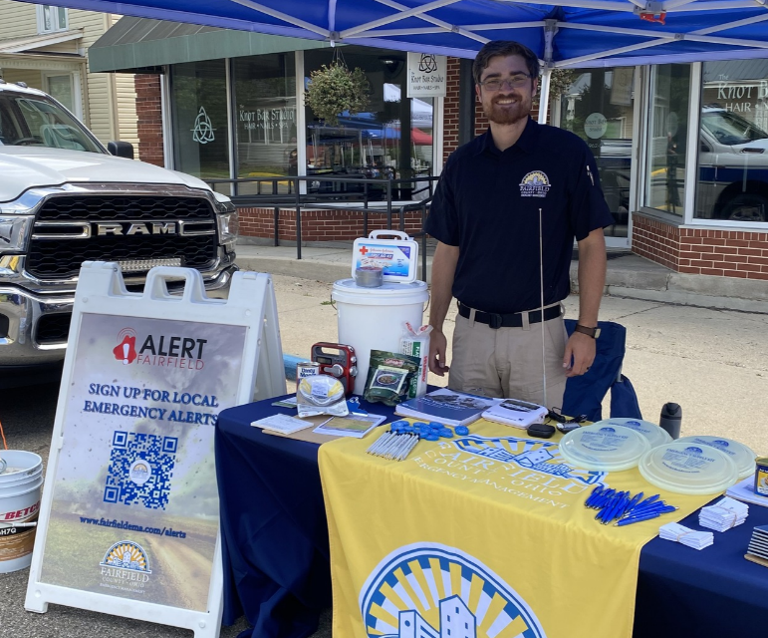
Meet Garrett Blevins, Deputy Director of Emergency Management.
The Fairfield County Emergency Management Agency plays a vital role in protecting citizens through emergency preparedness, risk reduction, and ensuring a coordinated response effort across the county. Their mission is to establish, coordinate, and sustain partnerships throughout Fairfield County, united in efforts to prepare for emergencies, minimize loss of life and property, and support the community’s return to normalcy when disasters occur.
As the deputy director, Garrett oversees the daily operations of the department, including emergency warning and notification systems, emergency planning and assuring the 24/7/365 readiness of the Fairfield County Emergency Operations Center. Garrett works closely in collaboration with community and public safety partners to enhance preparedness and deliver an effective emergency response to a wide range of incidents.
For those interested in emergency management, Garrett recommends pursuing a formal education in emergency management and acquiring hands-on experience through internships and volunteer work. Personal development, such as FEMA training courses and networking with industry professionals, can also provide a strong foundation.
Garrett says, “The most rewarding aspect of my role is knowing that our work directly contributes to the safety and resilience of our community. Whether it's planning for disasters, improving emergency response strategies, or working with dedicated public safety professionals, each day brings an opportunity to make a meaningful impact.”
To learn more about the Fairfield County Emergency Management Agency, please visit https://www.fairfieldema.com/. To register for Alert-Fairfield County, visit https://www.fairfieldema.com/alerts/index.html.

