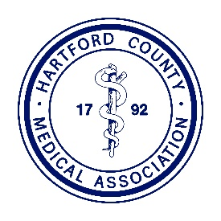
HARTFORD COUNTY MEDICAL ASSOCIATION

917 Bridgeport Avenue • Shelton, CT 06484
Tel: 203-513-2045 • Fax: 203-513-8036 • Email: info@hcma.org • Website: www.hcma.org

December 10, 2020

The Honorable Ned Lamont
Office of the Governor
State of Connecticut
210 Capitol Avenue
Hartford, Connecticut 06106

Dear Governor Lamont:

We thank you for everything that you have done in an effort to control the spread of the Coronavirus in Connecticut.

With the COVID vaccine about to become widely available to the public, we implore you to consider an Executive Order that would allow certified medical assistants to administer the Covid-19 and influenza vaccine under the order of and direct supervision of a physician, physician assistant or Advanced Practice Registered Nurse in order to assist with the mass vaccination efforts in private medical practices. Many patients receive their immunizations from their personal physicians and we anticipate there will be a large demand to be inoculated for COVID and flu.

Physicians in the community anticipate they will be inundated with requests for the vaccine and the ability of medical assistants to administer these vaccines will greatly relieve the burden on the medical practices.

Connecticut is the only state where certified medical assistants are unable to give vaccines and an Executive Order permitting this activity will be a critical tool in quickly and effectively reducing the spread of the viruses.

Sincerely,

Akella Sarma, MD
Akella Sarma, MD
President

