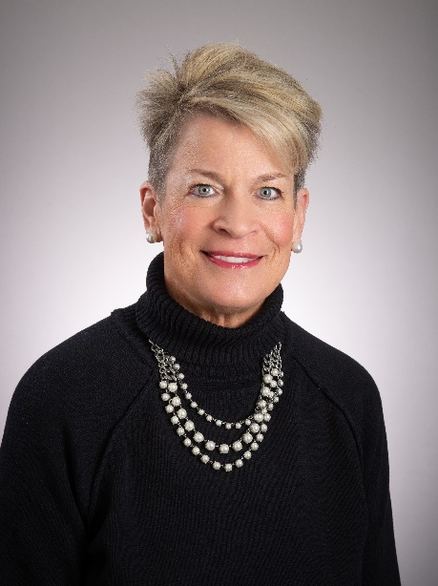
United Way of Knox County, Ohio Inc.
305 East High Street
Mount Vernon, Ohio 43050

For Immediate Release

Contact:
Lisa Lloyd
United Way of Knox County, Ohio Inc. Board President
lisa@knoxcf.org

Brenneman Announces May 31 Retirement as United Way of Knox County Executive Director

United Way of Knox County Executive Director Kelly Brenneman announced she will retire May 31 from the position she has held since 2015. United Way of Knox County has been a health and human service organization serving Mount Vernon and neighboring communities, since 1951, and Brenneman has been the Executive Director since 2015.

“I have been very proud of the achievements that we have made during my 8 years with United Way. We purchased a building and have a permanent home for the organization, established Women United, a group of dedicated philanthropic women who raise thousands of dollars to help women and children each year, helped create a Resource Navigator position, to help connect people, businesses, organizations with local resources and have raised over 8.5 million dollars thanks to the amazing support of our community members,” commented Brenneman.

Reflecting on her time at United Way, Kelly stated, “I have loved every single moment of leading this amazing local organization with a steadfast, devoted Board of Directors, loyal staff members, generous donors and volunteers who are giving of their time and talents. I know they will acquire the perfect leader to lead this organization into the future.”

“Kelly’s leadership, innovative fundraising and programming ideas, and collaborative efforts will be greatly missed,” said United Way Board Chair Lisa Lloyd. “We are sincerely appreciative of the significant contributions she has made in the community during her time with United Way.”

Since sharing her retirement date with board members last year, United Way’s Executive Committee has been developing a succession process, which will commence immediately. Candidates interested in becoming United Way of Knox County’s Executive Director may see a full job description and application information here: https://indeedhi.re/3H3XFzQ

