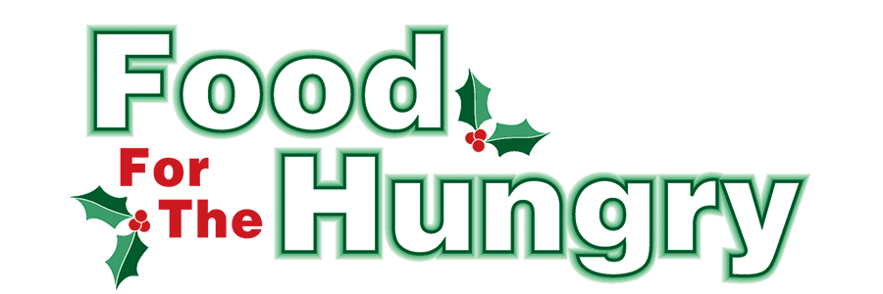

PRESS RELEASE
Contact Katelynn Mabe
Food For The Hungry Marketing Director
(740) 485-9907
katmabe@mail.mvnu.edu
December 21, 2020
FOR IMMEDIATE RELEASE

HEADLINE: Donations to Food For The Hungry total over $350,000

MOUNT VERNON, Ohio — The 39th annual Food For The Hungry drive was a success as Kenyon College’s recognition of the citizens of Knox County as the recipients of the William Stroud Award set the tone for 2020. Contributions from Knox County residents, businesses and organizations pushed FFTH to an historic mark raising $352,148.31 and 15.3 truckloads of food in 2020.

Due to the faithfulness this community has in serving the needs of Knox County, many financial donations began to flood in early this year at the early stages of the pandemic. Because of this generosity we were able to give close to $30,000 in COVID-19 relief grants. Now, through the consistency of giving, we are able to give more grants to combat whatever trials may come in 2021. The funds collected throughout 2020 have been distributed to our major grant applicants, The Salvation Army and Interchurch Social Services as well as many minor grant applicants throughout Knox County.

“Oh, Knox County, how I wish you could see yourself through my eyes — filled with tears right now! Your generosity and compassion never fails. You are truly the epitome of our slogan, “Working together to care for our neighbors.” I am humbled and honored to be a part of Food For The Hungry, and beyond blessed to call Knox County my home. Because of you, we will be able to continue to assist those on the front lines of meeting the needs of our friends, family, and neighbors through the coming year. This total is a reality because of every single donation whether time, talents, or funds, from every age and every walk of life. Thank you so much for being part of my ‘dream team’. May God bless you and yours!” Lisa Mazzari, Executive Director of FFTH.

“The generosity of the people and leadership in Knox County during 2020 has been a much needed blessing at just the right time,” said Samantha Scoles, FFTH president. “Because of your profound contributions to FFTH this year, we have extra funding available to help food insecurity initiatives, as well as those who provide financial assistance, as we continue to navigate the impact of the global pandemic. We are humbled by your trust in our organization to invest wisely in the programs that change lives right here in Knox County.”

Stephen W. Zelkowitz Memorial Award
Mount Vernon Nazarene University presented the Stephen W. Zelkowitz Memorial Award to: Corby Wise, Josh Worster and Joshua Morrison, who, through their work for the Mount Vernon News, helped the drive for many years with publicity, fundraising, marketing and photography.

School totals
The overall elementary collections totaled $14,110.09 and 8,227 food items.
Elementary breakdown:
- Centerburg Elementary, $1253.66 and 1,483 food items
- Danville Elementary, $1,011.27 and 440 food items
- East Knox Elementary, $1,306.25 and 865 food items
- Fredericktown Elementary, $1,892.16 and 227 food items
- Columbia Elementary, $1,333.81 and 869 food items
- Dan Emmett Elementary, $286.81 and 1,002 food items
- East Elementary, $1,616.25 and 601 food items
- Pleasant St. Elementary, $409.71 and 590 food items
- Mount Vernon Middle School, $513 and 296 food items
- St. Vincent DePaul, $499.00 and 346 food items
- Twin Oak Elementary, $1,882.59 and 879 food items
- Wiggin St. Elementary, $2,105.58 and 629 food items

The overall high school collections totaled $7,996.74 and 2,100 food items.
High school breakdown:
- Centerburg High School, $243.60 and 337 food items
- Danville High School, $611.00 and 78 food items
- Fredericktown High School, $2,076.52 and 274 food items
- Knox County Career Center, $3,800.67 and 1,084 food items
- Mount Vernon High School, $1,264.95 and 374 food items

The top collecting schools in both the Central Knox County and Greater Knox County competitions are recognized and awarded with multi-year traveling plaques to acknowledge their achievement and contribution to Food For The Hungry. The Central Knox County Award was presented to the Knox County Career Center while The Greater Knox County Award was earned by Fredericktown High School

Looking back, 2020 has been a very challenging year but we are thankful for everyone’s new and innovative ideas and collections. Those ideas added dollars and food items raised and also brought an increased awareness of the struggles within the community and increased the ability to reach more and more people.

Other notable donations include:
- The Snowflake Gala, hosted by Kenyon College, exceeded $155,000.00. This includes a $50,000.00 dollar-for-dollar match courtesy of Ariel Corporation and Karen Buchwald Wright.
- Service Club Competition, $6,237.00
- Mount Vernon Dental (along with Super Q 93.7 WQIO), $4,561.00 and 7 boxes of food
- Mount Vernon Nazarene University, $3,692.07 and 69 food items
- Battle of the Coffee Shops, $3,452.08 and 168 food items
- The Knox County Career Center Online Silent Auction of Christmas themed gift baskets, $2,978.00.
- The Knox County Park District Fire and Ice event, $1,267.00 and 1 truckload of food
- Turkey Trot with WeRun MV, $1,536.00 and 449 food items
- Elixir Presents Foodstock, $937.52
- Contemporary Dental Care, $657.00
- Facebook Pop-up Auction from Top Notch Hands Massage Therapy, $432.00
- Food for Fines (a partner for 3 decades), .36 truckloads of food
- Fredericktown Christmas walk—Total coming in January

Thank You
The Food For The Hungry Drive at the Memorial Theatre at the Knox Memorial would not have been possible without Megan Evans, the Knox Memorial Manager, working alongside the executive and broadcast teams, creating and implementing the approved COVID-19 plan as well as serving alongside Cheryl Splain as compliance officers. Without Megan’s dedication and the use of the Knox Memorial, FFTH 2020 may not have had the great outcome that occurred.

FFTH would like to thank these businesses for lending trucks to Mount Vernon collection points: Donley Ford-Lincoln, Mathews Chrysler Dodge Jeep Ram of Mt. Vernon, and Chevrolet Buick GMC of Mount Vernon. FFTH also thanks A+ Autobrokers for lending trucks to collect donations at The Knox Memorial and to Martin McAvoy and his team from Knox Area Transit and Susie Simpson of Mobility Management for providing vehicles and manpower to outlying collection points.

FFTH would also like to give a special thanks to
- Stores around Knox County who volunteered as collection points
- Everyone who generously donated their time and effort to man this year’s collection points
- Dedicated Postal workers who collected money on drive day throughout their routes

To see our full list of Thank Yous go to foodforthehungrycares.org.

For photos, videos, and interviews from the 2020 drive as well as continued opportunities to give, visit www.FoodForTheHungryCares.org. The 2020 broadcast is available on demand for a full year at www.mvnu.tv. Thank you for your continued support in working together to care for our neighbors.

###

