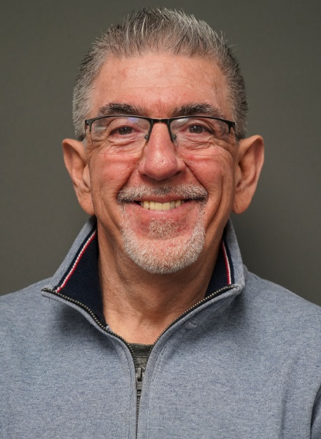
Cheek returns as MVNU’s Director of Alumni Relations and Advancement
MOUNT VERNON, Ohio (January 23, 2023) — Mount Vernon Nazarene University President Henry W. Spaulding II announced the appointment of Mike Cheek as Executive Director of Alumni and Advancement, effective Jan. 19. Cheek, a 1982 graduate, returns to a position he held in the early 2000s.
“I am thrilled to work with Mike in this capacity,” said James Smith, Vice President for University Relations. “I have known Mike for years and admire the way he loves others and serves the kingdom wherever the Lord leads him. It has been evident over the years how deeply Mike cares about MVNU. He has a passion for this place and these people, because of what it has meant to his life.”
Over a 28-year career as a lead pastor or in a staff position, he has served six churches, most recently the Akron Trinity Church.
Cheek has an extensive history at MVNC/U having earned a Bachelor of Arts in Physical Education (’82) and Master of Ministry (’98). He would later serve as alumni director, director of gifts and grants, and as a recruiter for the School of Graduate and Professional Studies. He credits his previous work, and return to Alumni Relations, as a testament to his personal experiences as a student.
“A lot of people, like me, came here not sure of who they were — very insecure, very low self-esteem, a lack of confidence. Something happened while I was here,” said Cheek. “My life was changed here through the faculty and staff that mentored me and the lifelong friends I made. I met my wife and we’ve had an amazing 40 years together. The charm of MVNU is people can be who they are and there is love there – there is acceptance. I knew what I experienced in my years here would never be duplicated in my life again.”
Cheek expects to spend most of his time meeting with alumni and supporting alumni events.
“I really do think it starts with alumni relations,” Cheek said. “It starts with helping people who are disconnected from the university to feel reconnected. The bulk of this job will not happen through emails or even social media. It will be through the opportunity to talk to people one-on-one, to meet new people and ask, ‘What’s your story?’ It brings alive what’s latent in a lot of people. I’m excited to get out on the road and meet our alumni, parents, and donors — the MVNU circle.”
“When Mike was the alumni director, he established and strengthened many of the opportunities for alumni connection that exist today. It will be natural for him to continue the good work that has been accomplished the past few years,” said Smith. “I am eager to watch Mike engage and mobilize our alumni into a strong network that invests in one another and our current students.”
Cheek and his wife, Janis (’83), have three grown children, all MVNU alumni, Drew (Elise), Tyler, and Courtney (Abe) Williams. They also have three grandchildren.
For more information on alumni events and representation, visit mvnu.edu/alumni.
Mount Vernon Nazarene University is a private, four-year, intentionally Christian teaching university for traditional age students, graduate students, and working adults. With a 327-acre main campus in Mount Vernon, Ohio, MVNU emphasizes academic excellence, spiritual growth, and service to community and church. MVNU offers an affordable education both in-seat and online to nearly 2,000 students from 25 states and 11 foreign countries.

