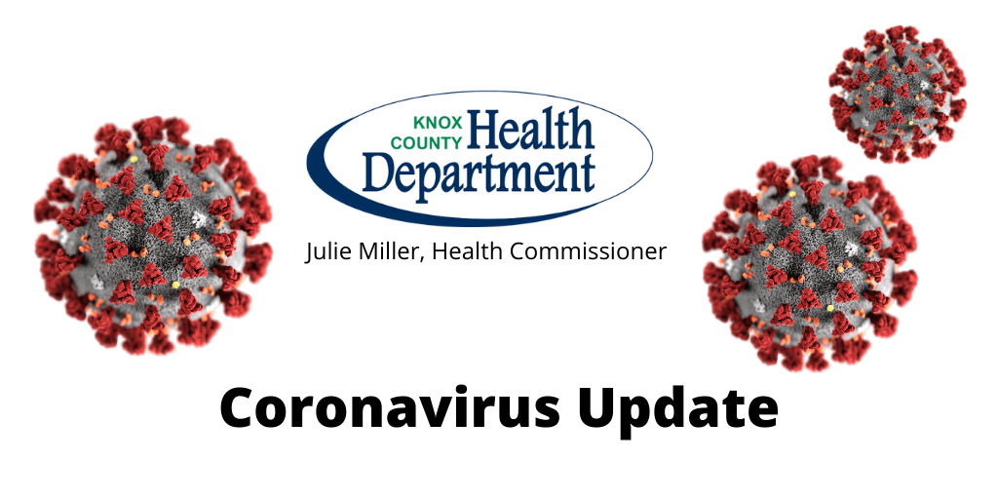
March 19, 2020 (Issue 10)
Stay Alert - Stay Healthy - Stay Educated - Stay Prepared
If you know of someone who would like to receive this community update on COVID-19 or you would like to be removed from the email list, please contact Pam Palm at 740-399-8002 or ppalm@knoxhealth.com.
CURRENT STATUS

All eight Knox County residents who were on the Mount Vernon Nazarene University trip to Italy have been cleared and are no longer being quarantined. Knox Public Health continues to monitor 26 students and staff from East Knox High School who were asked to quarantine after exposure to a teacher who tested positive for COVID-19. The teacher lives in Coshocton County where there are now two positive cases. The East Knox students and staff who were identified as close contacts will be under quarantine until March 25.
Ohio now has 119 cases of the coronavirus (COVID-19) in 24 counties. No deaths. Below is a list of the positive COVID-19 cases in the following counties:

- Ashland (1)  - Belmont (2)  - Butler (8)  - Clark (1)  - Coshocton (2)  - Cuyahoga (53)  - Darke (1)  - Delaware (2)  - Franklin (10)  - Geauga (1)  - Hamilton (1)  - Huron (1) | - Lake (2)  - Lorain (6)  - Lucas (1)  - Mahoning (5)  - Medina (5)  - Miami (1)  - Montgomery (1)  - Richland (1)  - Stark (5)  - Summit (6)  - Trumbull (2)  - Tuscarawas (1)

Nationally there are 10,442 total cases along with 150 deaths.

WE NEED BASIC MEDICAL SUPPLIES

As you probably heard in news reports, there is a nationwide shortage of basic medical supplies due to the COVID-19 outbreak. As such, local health officials are seeking donations for use in Knox County.
Needed supplies include:
- Gloves (vinyl, latex or nitrile)
- Face masks such as N-95 respirator or surgical masks
- Hand sanitizer
- Disinfectant wipes
To donate items, please call the Knox County COVID Call-Line, 740-399-8014.

NEW LOCAL COVID-19 CALL-LINE

The Knox County call-line is 740-399-8014 for medically related questions only and will be operational from 8 a.m. to 5 p.m., Monday-Friday.

NON-PROFIT FINANCIAL SUPPORT

The Knox County Foundation is starting an Emergency Funding Grant program for any Knox County non-profits having a financial strain due to COVID-19. Non-profits may apply for emergency operating funds up to $10,000 and the grant process will be expedited with decisions made on a weekly basis.
The application can be found at the KCF website or click on the logo above. Any questions please contact Lisa Lloyd at lisa@knoxcf.org or 740-392-3270.

MYTHBUSTERS

UNEMPLOYMENT HELP DUE TO COVID-19

If you have been displaced due to Coronavirus and need to seek financial support, click on the image or use this link:
http://jfs.ohio.gov/ouio/CoronavirusAndUI.stm

BEST FOODS TO BUY

So what are the best foods to buy when you know you're stuck at home for an extended period -- and is it even possible to consume a nutritious diet?
Choosing shelf-stable foods like canned goods, pastas, rice and legumes and utilizing your freezer - where you can store breads, meats, vegetables, fruits and more, are great ways to ensure you have a nice variety. Below is a list of foods that are not only nutritious but versatile too.
Foods to buy for the pantry:
- Beans and legumes
- Canned fish
- Nut butters
- Whole-wheat and bean pastas, quinoa and brown rice
- High-fiber cereal
- Steel-cut oats
- Canned, sugar-free fruits and vegetables (rinse vegetables to lower sodium content)
- Canned or jarred tomato-based sauces
- Dried fruit, popcorn (high fiber snacks!)
- Water, shelf-stable milk and coffee
Items to buy for your freezer:
- Bread, deli meat and fresh seafood
- Fruits and vegetables
Just remember that there's no need to buy out the stock at your local grocery store. It’s important to consider the needs of others and not overbuy. So only purchase what you actually need.

KNOX COUNTY SERVICES & LIMITATIONS

As this list of Knox County Services and Limitations is lengthy and changes often as new information is gathered, click on the county flag for the latest. Be Safe, Knox County!

FOR MORE INFORMATION

Call the State 24/7 COVID Hotline at 1-833-4-ASK-ODH for general questions and concerns.
If you have mental/behavioral health questions, you can email at covid19bh@mha.ohio.gov.
Please view the most, up-to-date information at the CDC or ODH websites, as well as our Knox Public Health page. (Click on the logos to be directed to the sites)

Should you have any questions regarding COVID-19 in Knox County, contact: Lisa Dudgeon, RN, Director of Nursing at Knox Public Health, 740-392-2200, ext. 2236 or ldudgeon@knoxhealth.com

