

To our Wonderful Teachers,

Welcome back to school! 

The Dearborn Farmers and Artisans Market is preparing for the new market season! We invite you to consider making the Farmers Market a class field trip for grades K-5. The market runs Friday, June 4th from 2pm to 7pm through September 24th. The market is located on West Village Drive between Mason and Monroe streets, at the new Wagner Place Park. The Google address is 1034 Monroe St, Dearborn, MI 48124. The market features local farms, bakers, artisans, community groups and so much more!

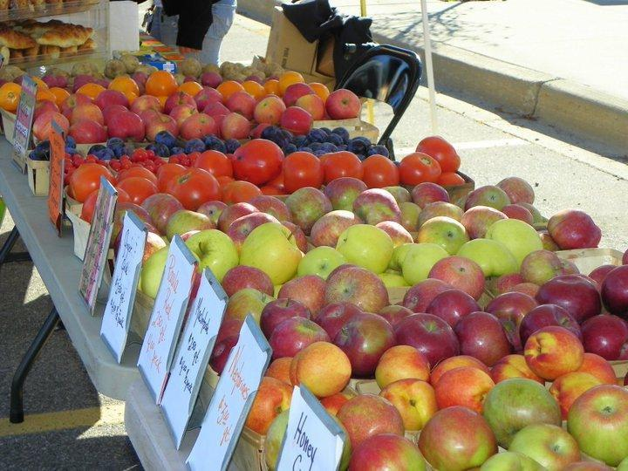

Through the generosity of Beaumont Health System, the market offers the **Power of Produce Kids Club** encouraging kids to sample new fruits and vegetables. Kids ages 5-12 can join the club simply by trying a new fruit or veggie each week. Two bites of the week’s offering earns kids $2 in tokens to spend on fruits and veggies in the market. Our kind farmers are always excited to share their knowledge of agriculture with curious kids.

Please consider joining us through this fantastic season.

The market gives kids a unique opportunity to experience local commerce, economics, conservation, social stewardship and artistry first hand. We invite you to share this opportunity with your class.

To schedule your visit, please contact Jean Smith at [jsmith@downtowndearborn.org](mailto:jsmith@downtowndearborn.org) or fill out the School Field Trip application form.

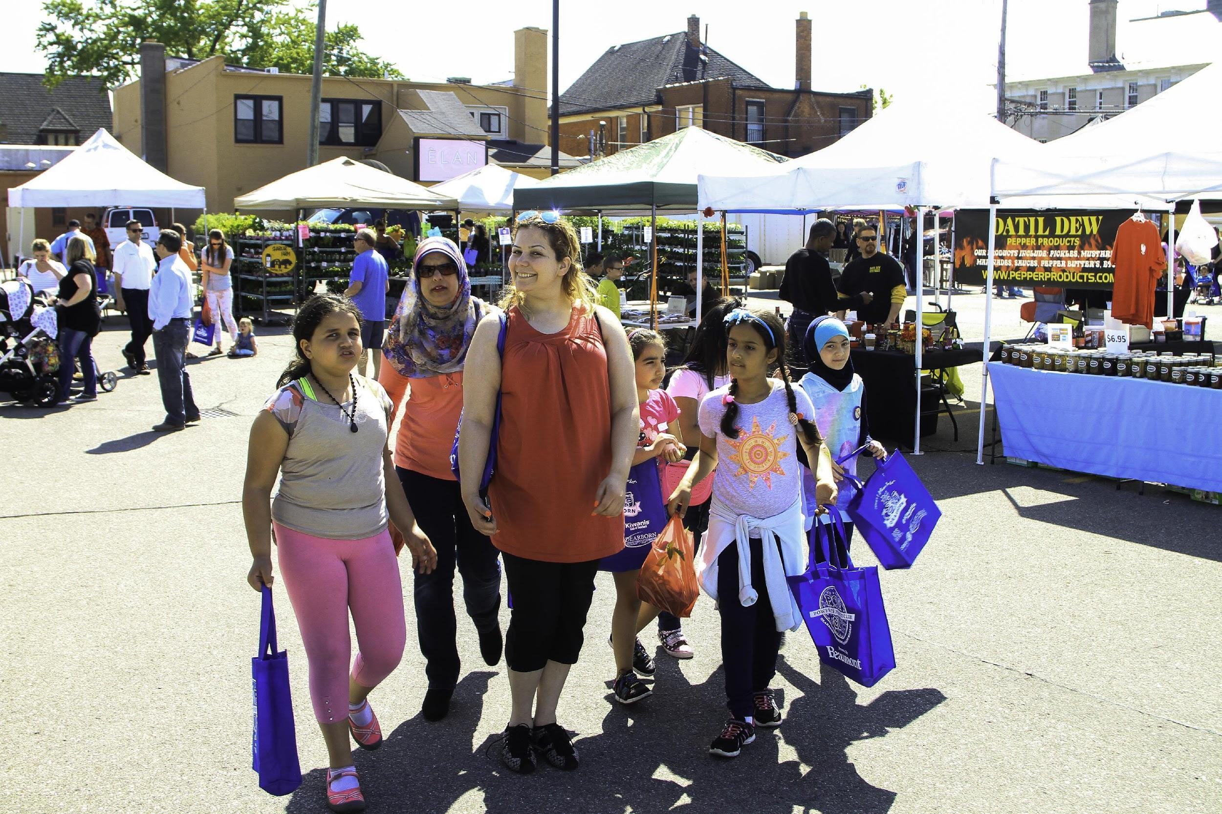

Sincerely,

Jean Smith, Event Manager

**Certified Market Manager**

**Dearborn Farmers & Artisans Market**

P: (313) 943-3141  
C: (248) 252-6921  
16901 Michigan Ave.  
Dearborn, MI 48126  
www.dearbornfarmersartisans.com

[*www.dearbornfarmersartisansmarket.com*](http://www.dearbornfarmersartisansmarket.com)

*jsmith@downtowndearborn.org*