**Resident’s Choice**



**Employee of the Month**

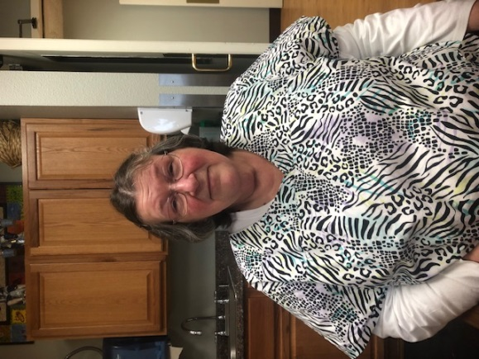****

**Janet Coonrod**

**Sherwood Park has been privileged to have Janet here for 21 years! A true Oregon Native, Janet was born in Sweet Home and has lived in Oregon all her life. When she isn’t working, Janet loves spending time with her grandbabies, all 7 of them. When asked if there’s anything the residents don’t know about her, Janet says the resident’s know it all! She enjoys talking to the residents and the residents love having Janet to talk to. Janet continually goes above and beyond and we are so lucky to have her!**

**Thank you for ALWAYS going the EXTRA mile!**