An End of Season CRAFT SALE
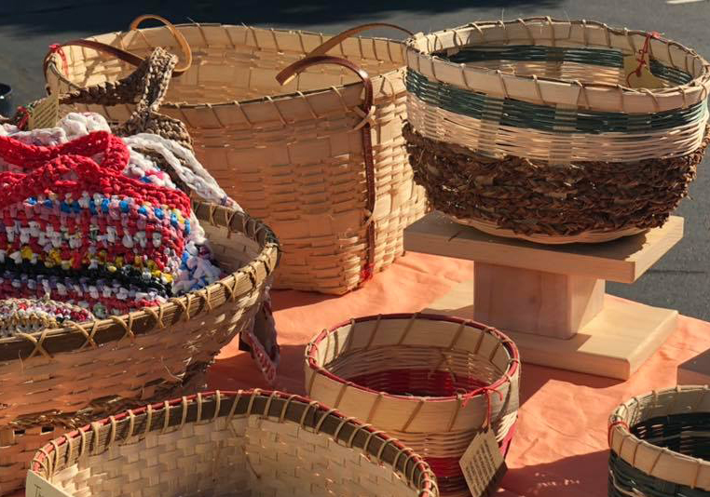

Join us for a cup of coffee and shopping for crafts,
handmade pottery, bracelets, lamps, wooden toys and more
made at H.O.M.E. in Orland, Maine.
Sunday, September 8th
11:30 AM – 2:30 PM
St. Brendan the Navigator Church
627 North Deer Isle Road, Deer Isle, Maine
(207) 348-6240 - www.stbrendans-me.org
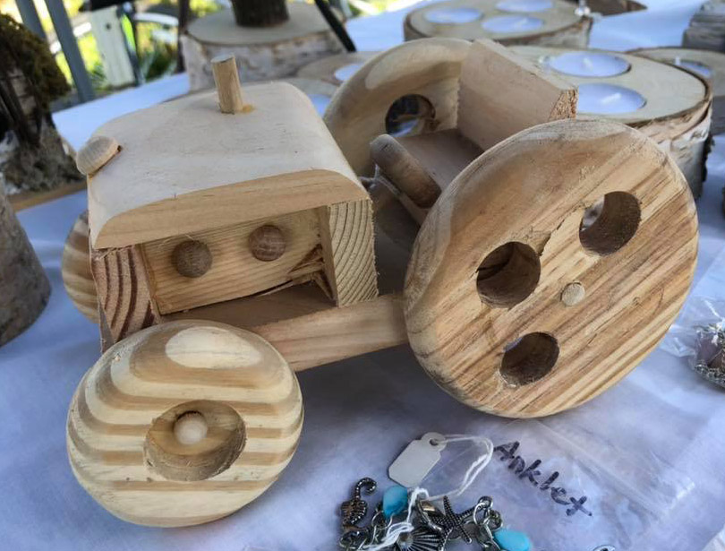
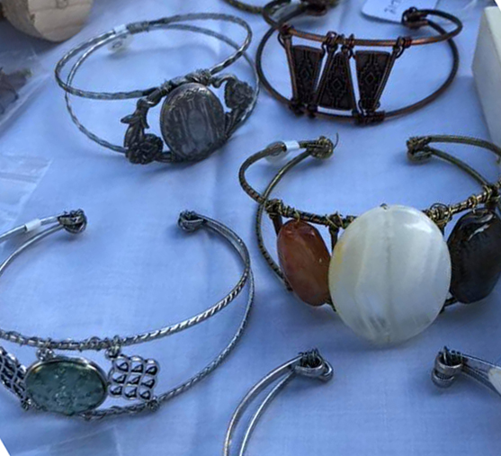

All proceeds from the sale will benefit H.O.M.E., Inc in its mission to keep and enhance the quality of life for low-income and homeless families through services, stewardship of resources, and shared responsibility.

