RDA: The First Look-Implement

Rapid Damage Assessment (RDA) Full-Scale Exercise

2022 Exercise Series – Event 3 of 3
Exercise Plan
October 20, 2022


The Exercise Plan (ExPlan) gives senior leaders, observers, media personnel, and players from participating organizations information they need to observe or participate in the exercise. It includes an exercise overview, objectives and aligned capabilities, roles and responsibilities, logistics, schedule, and communications plan. Some exercise material is intended for the exclusive use of exercise planners, controllers, and evaluators, but players may view other materials that are necessary to their performance. All exercise participants may view the ExPlan.
Table of Contents

Exercise Overview 2
General Information 3
Exercise Summary 3
Plan Background 4
Exercise Scenario 4
Exercise Objectives and Capabilities 5
Participant Roles and Responsibilities 6
Exercise Assumptions and Artificialities 7
Exercise Logistics 8
Post-exercise Activities 9
After-Action Process 9
Participant Information and Guidance 10
Exercise Rules 10
Players Instructions 10
Simulation Guidelines 11
Appendix A: Communications Plan 12
Controller Directory 12
Simulation Cell (SimCell) Directory 12
Evaluator Directory 12
Player Directory 13
Appendix B: Exercise RDA Resources 15
Appendix C: Exercise Participants 16
Appendix D: Exercise Schedule 18
Appendix E: Exercise Site Map(s) 19
Appendix F: Exercise Planning Team 21
Appendix G: ICS-214 Form 22
Appendix H: Participant Notes 23

Exercise Overview
Exercise Name | RDA: The First Look-Implementation Full-Scale Exercise
Exercise Dates | October 20, 2022
Scope | This five (5) hour mixed exercise event, hosted throughout Multnomah County, will provide countywide partners the opportunity to engage in a rapid damage assessment operations exercise event following a mid-level earthquake scenario. While the main scope of the County full-scale exercise is to test the ability for Multnomah County to organize and respond to this hazard, countywide partners have been collaborating their rapid damage assessment program participation during this event. External partner participation is based on their damage assessment program posture.
Focus Area(s) | Response
Capabilities | Operational Coordination, Infrastructure Systems
Objectives | - Multnomah County Departments will complete field damage assessment operations and coordination in response to a 5.5 magnitude Portland Hills Earthquake event within four (4) hours of StartEx.  - Multnomah County Departments, and county-wide response partners, will submit rapid damage assessment information and data to the County in response to a 5.5 magnitude Portland Hills Earthquake event within four (4) – Five (5) hours of StartEx.  - Multnomah County will collect and manage the incoming Rapid Damage Assessment information and data in the County Emergency Operations Center in response to a 5.5 magnitude Portland Hills Earthquake event within six (6) hours of StatEx.  - Note: Local response partners will have their own internal objectives as part of this exercise event.
Threat/Hazard | Earthquake
Scenario | A 6.0 magnitude Portland West Hills Fault Line Earthquake Event
Sponsor | Multnomah County Office of Emergency Management (MCEM)
Participating Organizations | A participants list can be found in Appendix B.
Point of Contacts | Robert Quinn, Training & Exercise Specialist – Exercise Director  Multnomah County Emergency Management  Robert.quinn@multco.us | 503-307-4129  Matt Burke, Logistics Division Lead – Exercise Evaluation Lead  Multnomah County Emergency Management  Matthew.burke@multco.us | 971-988-9939

General Information

Exercise Summary
RDA: The First Look-Implementation Full-Scale Exercise is the third component of three in the Multnomah County 2022 Rapid Damage Assessment (RDA) Exercise Series. This series is designed for county-wide response partners to design, develop, validate, and implement their RDA programs in collaboration with the County government. This Exercise Series has the following events:
- RDA: The First Look-Development - August 2022 Workshop Event (Compete)
- RDA: The First Look-Validation - August 2022 Tabletop Event (Compete)
- RDA: The First Look-Implementation - October 2022 Full-Scale Event
As part of the County Integrated Preparedness Plan (IPP), Infrastructure Systems has been identified as a key priority focus area for emergency management-related work through June 2024 (Fiscal Year ’24). The further development of the County Damage Assessment Plan, in collaboration with county-wide partners, allows us to take steps forward within this topic.
This exercise event will build off the August 2022 Workshop and Tabletop Exercise Events that provided participants the space to design, develop, and validate their internal RDA Programs. Resources, tools, and best practices were gathered from throughout FEMA Region X to assist local response partners develop their RDA Programs. This Full-Scale Exercise will test the products developed and validated in the two August exercises in an evaluated field-environment to identify areas of strength and opportunities for programmatic improvement.
The RDA: The First Look-Implementation Full-Scale Exercise will be held in alignment with The 2022 Great Shakeout. The findings from this exercise event, and the 2022 Exercise Series as a whole, will be used to complete a full revision of rapid damage assessment operations and build towards a future Initial Damage Assessment (IDA) Exercise Series in 2023 or 2024.
The Exercise Planning Team was made up of representatives from both governmental and other response entities within Multnomah County with the responsibility to design and coordinate this exercise event. A big thank you to everyone that participated on the Planning Team (Appendix C), your guidance and feedback were critical to the success of this event.
This exercise event will test the rapid response capabilities to a mid-level Portland West Hills Fault earthquake scenario, and will be hosted at a number of facilities throughout Multnomah County with participating organizations playing at varying exercise levels. This exercise includes players participating in tabletop, drill, and full-scale exercise environments.

Plan Background
The Multnomah County Damage Plan was completed in 2018, with the MCEM Operations Team taking responsibility to operationalize, train, and exercise the document. Coordination for implementing this Plan has occurred sporadically over the past 4 years, with competing organizational priorities limiting a full Plan implementation and aligned Training and Exercise Plan (TEP).
Appendix B to the County Damage Assessment is the document-specific TEP, developed in 2022 to outline the expectations for through 2024, and beyond. This TEP is subject to adjustments based on the outcomes of each event and programmatic priorities, however this resource provides a structured approach to building county-wide damage assessment capabilities.
This Full-Scale Exercise will be the fifth event of the County Damage Assessment Plan TEP.
- February 2022: Multnomah County hosted a Plan Seminar to re-engage local partners with the 2018 document.
- March 2022: The Multnomah County and City of Portland hosted a RDA Program Overview Workshop hosted during the Integrated Emergency Management Course (IEMC).
- August 2022: On August 9th, Multnomah County hosted RDA: The First Look-Development Workshop Event that built programmatic processes, tools, and determine the level of preparedness regarding RDA programs county-wide.
- August 2022: On August 31st, Multnomah County hosted RDA: The First Look-Validation Tabletop Exercise event that tested and validated local RDA programs, and the products developed during the August 9th workshop event.

Exercise Scenario
At approximately 0831 a 6.0 magnitude earthquake occurs along the Portland West Hills Fault/Cascadia causing shaking throughout the Portland Metropolitan Area. The Multnomah County Emergency Operations Center (EOC) has just activated in response to this event.
While specific damage is not currently known, this earthquake event did not significantly impact the use of routine roadways, buildings, communications infrastructure, or access to staff/personnel.
The weather forecast calls for cloudy skies, light winds, and temperatures hovering around 70 degrees.
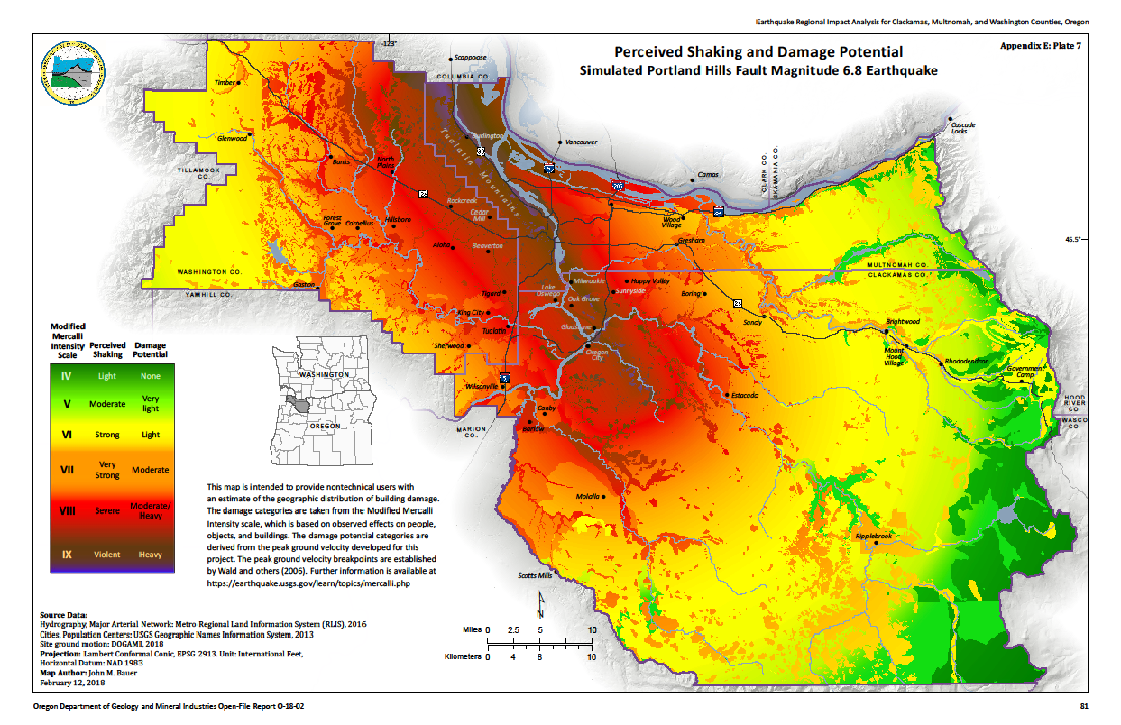

Exercise Objectives and Capabilities
The following exercise objectives in Table 1 describe the expected outcomes for this exercise. The objectives are linked to Federal Emergency Management Core Capabilities, which are distinct critical elements necessary to achieve specific mission area(s). The objectives and aligned capabilities were guided by the Exercise Planning Team.
Exercise Objective | Core Capability
- Multnomah County Departments will complete field damage assessment operations and coordination in response to a 5.5 magnitude Portland Hills Earthquake event within four (4) hours of StartEx. | Operational Coordination, Infrastructure Systems
- Multnomah County Departments, and county-wide response partners, will submit rapid damage assessment information and data to the County in response to a 5.5 magnitude Portland Hills Earthquake event within four (4) hours of StartEx. | Operational Communications
- Multnomah County will collect and manage the incoming Rapid Damage Assessment information and data in the County Emergency Operations Center in response to a 5.5 magnitude Portland Hills Earthquake event within six (6) hours of StartEx. | Operational Coordination, Infrastructure Systems
Table 1. Exercise Objectives and Associated Capabilities

Participant Roles and Responsibilities
The term participant encompasses many groups of people, not just those playing in the exercise. Groups of participants involved in the exercise, and their respective roles and responsibilities, are as follows:
- Players. Players are personnel who have an active role in discussing or performing their regular roles and responsibilities during the exercise. Players discuss or initiate actions in response to the simulated emergency.
- Controllers. Controllers plan and manage exercise play, set up and operate the exercise site, and act in the roles of organizations or individuals that are not playing in the exercise. Controllers direct the pace of the exercise, provide key data to players, and may prompt or initiate certain player actions to ensure exercise continuity. In addition, they issue exercise material to players as required, monitor the exercise timeline, and supervise the safety of all exercise participants.
- Simulators. Simulators are control staff personnel who deliver scenario messages representing actions, activities, and conversations of an individual, agency, or organization that is not participating in the exercise. They most often operate out of the Simulation Cell (SimCell), but they may occasionally have face-to-face contact with players. Simulators function semi-independently under the supervision of SimCell controllers, enacting roles (e.g., media reporters or next of kin) in accordance with instructions provided in the Master Scenario Events List (MSEL). All simulators are ultimately accountable to the Exercise Director and Senior Controller.
- Evaluators. Evaluators evaluate and provide feedback on a designated functional area of the exercise. Evaluators observe and document performance against established capability targets and critical tasks, in accordance with the Exercise Evaluation Guides (EEGs).
- Observers. Observers visit or view selected segments of the exercise. Observers do not play in the exercise, nor do they perform any control or evaluation functions. Observers view the exercise from a designated observation area and must remain within the observation area during the exercise. Very Important Persons (VIPs) are also observers, but they frequently are grouped separately.

Exercise Assumptions and Artificialities
In any exercise, assumptions and artificialities may be necessary to complete play in the time allotted and/or account for logistical limitations. Exercise participants should accept that assumptions and artificialities are inherent in any exercise and should not allow these considerations to negatively impact their participation.

Assumptions
Assumptions constitute the implied factual foundation for the exercise and, as such, are assumed to be present before the exercise starts. The following assumptions apply to the exercise:
- The exercise is conducted in a no-fault learning environment wherein capabilities, plans, systems, and processes will be evaluated,
- The exercise scenario is plausible, and events occur as they are presented. It is recognized that the likelihood of there being limited/no impact to local infrastructure is highly unlikely,
- Participating agencies and municipalities may need to balance exercise play with real- world operations and/or emergencies. Real-world actions take priority,
- There are no staffing impacts to the participating organizations due to the earthquake events.
- Communications infrastructure and the power grid are not impacted by the provided scenario, participants are advised to us all tools and systems they use on a daily basis.
- Roads and bridges may be impacted, but are not impassable for purposes of field assessment movement.

Artificialities
During this exercise, the following artificialities apply:
- Exercise communication and coordination will be limited to participating exercise organizations, venues, and the Simulation Cell (SimCell). Only communication methods listed in the Communications Plan are available for players to use during the exercise.
- There is no participation by many response partners and organizations during this exercise. Specific comments and questions directed towards their operations will be directed towards the exercise facilitator to document and/or address within the scope of the exercise.
- All infrastructure (buildings, roads, etc.) assessments are fake, and have been developed by the Exercise Design Team to provide participants the opportunity to practice the submission process.

Exercise Logistics

Safety
Participant safety takes priority over exercise events. The following general requirements apply to the exercise:
- Anyone who observes a participant who is seriously ill or injured should immediately notify emergency services and the closest controller, and, within reason and training, render aid.
- Any safety concerns must be immediately reported to an on-site exercise controller or evaluator. The on-site controller will determine if a real-world emergency warrants a pause in exercise play, and if exercise play can be resumed.
- For a non-exercise scenario emergency that requires assistance, participants will use the phrase “real-world emergency” to notify Exercise Control and Participants of the ongoing situation.
- The on-site controller aware of a non-exercise scenario emergency will notify the Lead Exercise Director with the location of the emergency and resources needed, if any.

Emergency Medical Services (EMS)
Multnomah County will not have emergency medical services on-site, or aiding field assessment exercise operations during this event. Medical needs will be addressed on an individual basis, and should be coordinated by individuals on-site to where the medical emergency is occurring. Any medical emergency will be communicated to an on-site exercise controller, starting with “real-world emergency”, and sharing the current situation. On-site control staff should notify the Exercise Director when time becomes available of the medical situation.
Partner organizations are responsible for coordinating first aid and/or emergency medical services for exercise participants at each individual exercise location.

Location
This full-scale exercise event will be held at various locations throughout Multnomah County. For purposes of this Exercise Plan, we will only provide instructions for the Multnomah County Government Exercise Site. This exercise will be hosted at the Prophet Building (401 N Dixon St. 97227).

Site Access
County Emergency Operations Center (EOC) players and exercise controllers are encouraged to check-in at the “FPM Exercise” location listed on Table __ of Appendix D. A runner will escort exercise participants to their rooms. Room purposes include:
- Broadway Room – Simulation Cell
- Morley Room – County EOC

Transportation & Parking
Public Transit – Participants do have the option to take public transportation, with the Street Car-Blue Line stopping 0.1 miles away at N Broadway & Ross. The #17 TriMet Bus also stops 0.1 miles away in a similar location to the Street Car.
Bike Access – Bike parking locations are available outside the Prophet Building Main Entrance – participants can also bring their bicycles into the Broadway and Morley Rooms.
Vehicle Parking – Street parking is available for this event along North Dixon Street, and connecting streets. Street parking is the encouraged option for those driving. A map has been included in Appendix D for reference.

Exercise Identification
Exercise staff are identified by vests to clearly display exercise roles. Table 2 describes these identification items. Exercise identification may be dependent on the participating organization, with the colors listed below used for Multnomah County operations.
Group | Color/Identification
Controllers | Green
Evaluators | Blue
Observer | Red
Table 2. Multnomah County Exercise Identification

Post-exercise Activities

After-Action Process
Post-exercise, the MCEM will lead an After-Action Process to evaluate the current County Damage Assessment Plan and county-wide RDA Program. This process will use the following timeline:
- Hot Wash (Day Of): At the conclusion of the full-scale exercise, the Evaluation Team at each exercise site will lead a Hot Wash to allow players to discuss operational strengths and areas for improvement related to Rapid Damage Assessment operations. This time will also be used for the Evaluation Team to seek clarification regarding actions taken during the exercise, or opportunities missed. The information gathered during this hot wash will contribute to the exercise After-Action Report and Improvement Plan (AAR/IP).
- Digital Participant Feedback Forms (1-7 Days Following Exercise): Digital Participant Feedback Forms will be provided to players immediately following exercise play. These forms provide players the opportunity to comment candidly on exercise activities and design, to share their observed strengths and areas for improvement. Participant Forms will be provided via a Google Form to all players.
- After-Action Meeting (14-21 Days Following Exercise): All participants will be invited to a virtual After-Action Meeting (AAM) to review the Participant Feedback Form content, elicit additional feedback, perform root cause analysis for findings themes, and discuss the After-Action Process.
- AAR-IP Finalize (30 Days Following Exercise): An exercise AAR-IP will be finalized from the Participant Form and AAM content within 30 days of the exercise event.

Participant Information and Guidance

Exercise Rules
The following general rules govern exercise play:
- Real-world emergency actions take priority over exercise actions,
- The purpose of this full-scale exercise is to evaluate the County Damage Assessment Plan and processes, specifically the Rapid Damage Assessment Operations, it is not intended to evaluate individuals or organizations. We are collective team working to improve our preparedness and resilience, keep that in mind as we enter into conversations that may be new to some, or all.

Players Instructions
Players should follow certain guidelines before, during, and after the exercise to ensure a safe and effective exercise.

Before the Exercise
- Participate in any exercise related training and/or seminar events hosted by your organization.
- Review any event-related materials distributed by your organizations Exercise Lead.
- Review organizational rapid damage assessment, and/or damage assessment plans, procedures, and exercise support documents.
- Be at the appropriate exercise site at least 30 minutes before the exercise starts.
- Review the Exercise Plan and send any questions to the Exercise Director, Robert Quinn (robert.quinn@multco.us), or your organization lead point of contact listed on page 13.
- Sign-in upon arrival to your exercise facility.

During the Exercise
- Respond to exercise events and information as if the emergency were real, unless otherwise directed by an exercise controller.
- Recognize that the exercise has objectives to satisfy and may require incorporation of unrealistic aspects. Every effort has been made by the exercise’s trusted agents to balance realism with safety and to create an effective learning and evaluation environment.
- Controllers will give you only information they are specifically directed to disseminate. You are expected to obtain other necessary information through existing emergency information channels.
- If you do not understand the scope of the exercise, or if you are uncertain about an organization’s participation in an exercise, ask a controller.
- All exercise communications will begin and end with the [“Exercise. Exercise. Exercise.”].This precaution is taken so that anyone who overhears the conversation will not mistake exercise play for a real-world emergency.
- Any exercise communication with organizations not participating should be directed towards the Simulation Cell. Identify the non-participating organization with whom you wish to speak upon contacting the Simulation Cell. Simulation Cell information can be found in Appendix A: Communications Plan
- Maintain a log of your activities on the provided ICS-214 Form. Many times, this log may include documentation of activities that were missed by a controller or evaluator. That form can be found in Appendix G: ICS-214 Form

After the Exercise
- Participate in the Hotwash with event controllers and evaluators.
- Complete the Participant Feedback Form that will be distributed digitally following the event. This form allows you to comment candidly on emergency response activities and exercise effectiveness. These forms provide players the opportunity to comment candidly on exercise activities and design, to share their observed strengths and areas for improvement. Participant Feedback Forms will be provided via a Google Form to all players.
- All participants will be invited to an After-Action Meeting (AAM) to review the Participant Feedback Form content, elicit additional feedback, perform root cause analysis for findings themes, and discuss the After-Action Process.

Simulation Guidelines
Because the exercise is of limited duration and scope, certain details will be simulated. The physical description of what would fully occur at the incident sites and surrounding areas will be relayed to players by simulators or controllers. A SimCell will simulate the roles and interactions of nonparticipating organizations or individuals. The SimCell contact information can be found on page 13. The SimCell can be used for the following purposes:
- Request additional consideration or guidance related to the scenario,
- Request clarification or guidance related to a sent inject,
- Communicate with organizations that do not have participants listed in Appendix A – Players. Please do not communicate with individuals that are not listed in Appendix A – Players, as they are not within the scope of the exercise and may be confused about questions/requests.

Appendix A: Communications Plan

Controller Directory
Name | Agency | Location | Phone | Email
Robert Quinn – Exercise Director | Multnomah County | 401 N Dixon St. 97227 | 503-307-4129 | robert.quinn@multco.us
Tigger Subotnick – Portland TTX Exercise Director | City of Portland | Virtual | 503-865-6848 | tigger.subotnick@portlandoregon.gov
Mark Dorin – Facilities Exercise Director | Multnomah County – Facilities | 401 N Dixon St. 97227 | 503-351-5848 | mark.dorin@multco.us
Horace Ward – Pacific Power Exercise Director | Pacific Power | Remote | 503-347-9778 | Horace.Ward@pacificorp.com
Kelle Landavazo – Gresham Exercise Director | City of Gresham | Remote | 503-319-0920 | Kelle.landavazo@greshamoregon.gov

Simulation Cell (SimCell) Directory
Name | Agency | Location | Phone | Email
Haley Zilka | Multnomah County | 401 N Dixon St. 97227 | 971-988-9713 | exercise_simcell@multco.us

Evaluator Directory
Name | Agency | Location | Phone | Email
Matt Burke (He/Him) – Lead Event Evaluator | Multnomah County | 401 N Dixon St. 97227 | 971-988-9939 | matthew.burke@multco.us
Michael Smith | Multnomah County | 401 N Dixon St. 97227 | 541-729-8952 | michael.smith@multco.us
Gabriel Hernandez (They/Them) | Multnomah County | 401 N Dixon St. 97227 | 971-988-9714 | gabriel.hernandez@multco.us

Player Directory
Position | Name | Location | Phone | Email | Radio
Multnomah County
EOC Planning Section
Damage Assessment Unit | David Lentzner | 401 N Dixon St. 97227 | 503-679-3275 | eoc.damageassessment@multco.us | N/A
Damage Assessment Unit | Yvette Osborne | 401 N Dixon St. 97227 | 503-729-6594 | eoc.damageassessment@multco.us | N/A
GIS Unit | Wayne Coffee | 401 N Dixon St. 97227 | N/A | eoc.gisunit@multco.us | N/A
GIS Unit | Ben Harper | 401 N Dixon St. 97227 | 503-953-0404 | eoc.gisunit@multco.us | N/A
Emergency Support Function #1 – Transportation (DCS-Roads & Bridges)
ESF #1 | Jill Wolf | Remote | 503-307-1297 | jill.a.wolf@multco.us | N/A
ESF #1 | Tina LeFevre | 401 N Dixon St. 97227 | 503-816-8743 | tina.lefebvre@multco.us | N/A
Emergency Support Function #3 – Public Works (DCA-Facilities)
Facilities Dispatch Lead | Patty Hanson | 401 N Dixon St. 97227 | 503-849-7530 | fmdispatch@multco.us | MCEM-2 147.280
Facilities Dispatcher | Shane Walch | 401 N Dixon St. 97227 | 503-849-7530 | fmdispatch@multco.us | MCEM-2 147.280
Facilities Dispatcher | Michael Sommers | 401 N Dixon St. 97227 | 503-849-7530 | fmdispatch@multco.us | MCEM-2 147.280
Note: Field Facilities Staff can be contacted via Facilities Dispatch (DCA-Facilities Communications List)

Position | Name | Location | Phone | Email | Radio
City of Troutdale
Public Works | Travis Hultin | Remote | 503-674-7265 | travis.hultin@troutdaleoregon.gov | N/A
Waste/Streets | David Scaffer | Remote | 503-674-3305 | david.schaffer@troutdaleoregon.gov | N/A
Parks/Facilities | Tim Seery | Remote | 503-674-7271 | tim.seery@troutdaleoregon.gov | N/A
Facilities Maintenance | Daron Smith | Remote | 503-674-7226 | daron.smith@troutdaleoregon.gov | N/A
Building & Code Compliance | Heather Jones | Remote | 503-674-7262 | heather.jones@troutdaleoregon.gov | N/A
Austin Michael | GIS Analyst | Remote | 503-674-7245 | austin.michael@troutdaleoregon.gov | N/A
Multnomah County Drainage District
MCDD Liaison | Matt Burlin | Remote | 503-320-5370 | mburlin@mcdd.org | N/A
Northwest Natural
Liaison | Todd Felix | Remote | 503-610-7236 | todd.felix@nwnatural.com | N/A
PacificPower
Liaison | Jeff Bolton | Remote | 503-260-7782 | Jeffrey.bolton@PacifiCorp.com | N/A
Vibra Specialty Hospital
Liaison | William Mackin | Remote | 971-269-9324 | wmackin@vshportland.com | N/A
City of Gresham
EOC Manager | Kelle Landavazo | Remote | 503-319-0920 | Kelle.landavazo@greshamoregon.gov | N/A
Portland Fire & Recue
Fire Liaison | Louisa Jones | Remote | 503-341-2909 | louisa.Jones@portlandoregon.gov | N/A

Appendix B: Exercise RDA Resources
This exercise will test the Version 1 products of the rapid damage assessment tools developed prior to, and during the 2022 Rapid Damage Assessment Exercise Series. The resources available to support those participating in this exercise include:
- Submission Process & RDA Overview
  - Submission Process, County Damage Assessment Plan – 2018. page 19
  - RDA Overview, County Damage Assessment Plan – 2018, page 17
- Tools
  - Digital Tool: Geographic Information System (GIS) Tool (Link)
  - Physical Field Assessment Form: Damage Assessment Collection Physical Tool and/or ATC-20 Form
  - Physical Organizational Summary Form: Damage Assessment Summary Document
Dropbox Link for All Documents

Appendix C: Exercise Participants
Participating Organizations | Type of Participation
Multnomah County
- Office of Emergency Management (MCEM) | Participant
- Department of County Assets (DCA) – Facilities | Participant
- Department of County Assets (DCA) – Geographic Information Systems | Participant
- Department of Community Services (DCS) | Participant
Municipalities
- City of Gresham – Emergency Management | Participant
- City of Gresham – Fire Department | Participant
- City of Portland – Bureau of Emergency Management | Independent Tabletop
- City of Portland – Bureau of Transportation | Independent Tabletop
- City of Portland – Bureau of Environmental Services | Independent Tabletop
- City of Portland – Parks & Recreation | Independent Tabletop
- City of Portland – Water Bureau | Independent Tabletop
- City of Portland – Fire & Rescue Bureau | Independent Tabletop
- City of Troutdale | Participant
- Suavie Island Fire Department | Simulated Assessments
Regional Partners
- Metro | Simulated Assessments
- Pacific Power | Participant
- Northwest Natural | Participant
- Federal Executive Board (FEB) | Simulated Assessments
- Multnomah County Drainage District (MCDD) | Participant
- Vibra Specialty Hospital | Participant
- Health Preparedness Organization (HPO) | Simulated Assessments
- University of Portland | Simulated Assessments
- Portland State University (PSU) | Simulated Assessments
- Lewis & Clark College | Simulated Assessments
- Reynolds School District | Simulated Assessments
Table 4. Exercise Participants

Appendix D: Exercise Schedule
Agenda Item | Timeframe
Registration | 0800 – 0845
Exercise Briefing | 0845 – 0900
Start Exercise (StartEx) | 0900
Exercise Play (Varying Based on Organization) | 0900 – 1430
End Exercise (EndEx) | 1400
Section Hot Wash | 1400 – 1415
Event Hot Wash | 1415 – 1500
Wrap-Up & Conclude | 1500
Table 5. Exercise Timeline

Appendix E: Exercise Site Map(s)
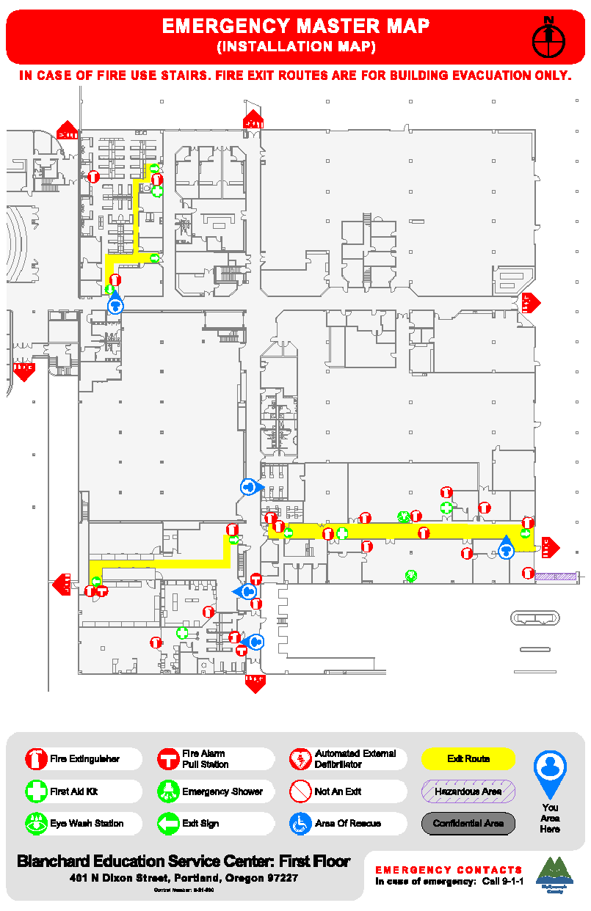
Broadway Room - SimCell

Morley Room – County EOC
Dixon Street
Figure 3. Prophet Building Internal Map
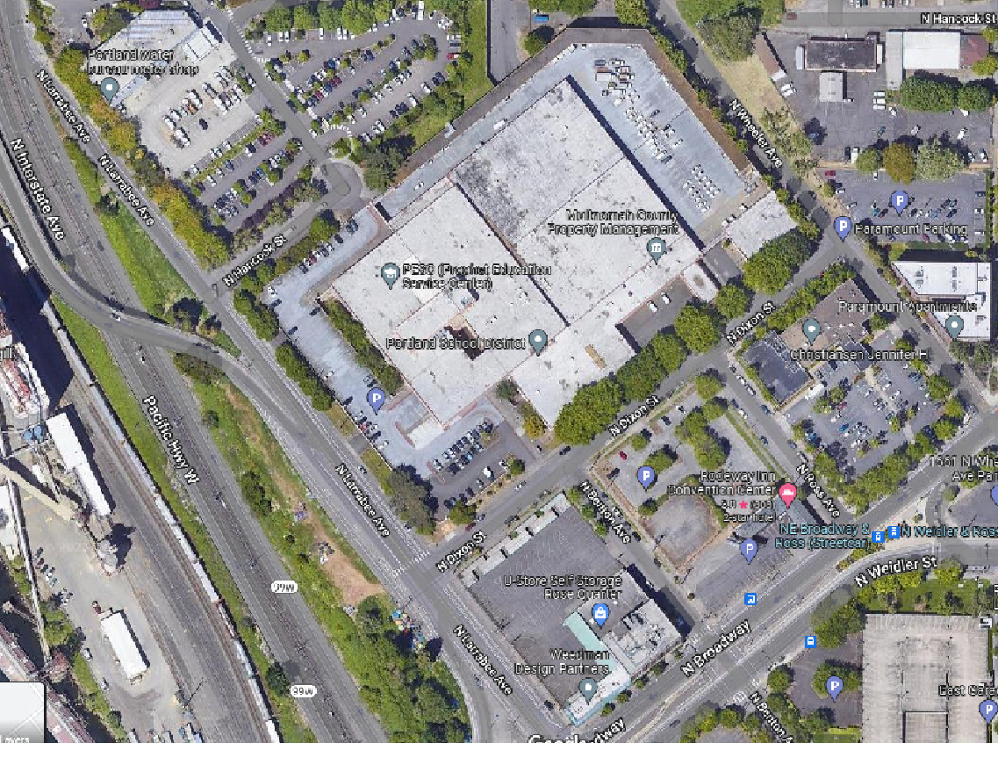
Morley Room – County EOC
Broadway Room - SimCell
Try to park on the street, but there may be a few spots here
FPM Exercise

Figure 4. Prophet Building External Map

Appendix F: Exercise Planning Team
A big thank you to everyone who participated on the Exercise Planning Team. This group met three times virtually to design and develop the July 19th Fuel Exercise Day, and spent time separately coordinating internal participation and reviewing documentation in preparation for this event.
Individual | Organization
Jason Bettles | Multnomah County - Department of Assessment, Recording, and Taxation
Matt Burke | Multnomah County – Office of Emergency Management
Matt Burlin | Multnomah Drainage District
Mark Dorin | Multnomah County – Department of County Assets
Scott Elliot | Multnomah County - Department of Assessment, Recording, and Taxation
Sherrie Forsloff | Oregon Health & Sciences University
Joyce Hamilla | Federal Executive Board
Michael Lacina | State of Oregon – Department of Emergency Management
Tina LeFebvre | Multnomah County – Department of Community Services
Johnny Lewis | Portland Public Schools
Michelle Montross | City of Maywood Park
Robert Quinn | Multnomah County – Office of Emergency Management
Emma Stocker | Portland State University
Horace Ward | Pacific Power
Jill Wolf | Multnomah County – Department of Community Services
Katy Wolf | City of Portland – Bureau of Emergency Management
Table 6. Exercise Planning Team

Appendix G: ICS-214 Form
- Incident Name: | - Operational Period (Date/Time)  From: To: |  | Individual Log ICS-214 Form
- Individual Name: | - ICS Section: |  | - Assignment/Location:
      - Activity Log
Time | Major Events/Actions
- Prepared By: |  | - Date/Time:
ICS-214 Form: Individual Log

Appendix H: Participant Notes
______________________________________________________________________________________________________________________________________________________________________________________________________________________________________________________________________________________________________________________________________________________________________________________________________________________________________________________________________________________________________________________________________________________________________________________________________________________________________________________________________________________________________________________________________________________________________________________________________________________________________________________________________________________________________________________________________________________________________________________________________________________________________________________________________________________________________________________________________________________________________________________________________________________________________________________________________________________________________________________________________________________________________________________________________________________________________________________________________________________________________________________________________________________________________________________________________________________________________________________________________________________________________________________________________________________________________________________________________________________________________________________________________________________________________________________________________________________________________________________________________________________________________________________________________________________________________________________________________________________________________________________________________________________________________________________________________________________________________________________________________________________
______________________________________________________________________________

