Twelfth Annual
ECIRMAC 2019 Fundraiser Banquet
Saturday, April 27, 2019
RSVP by Monday, April 22, 2019

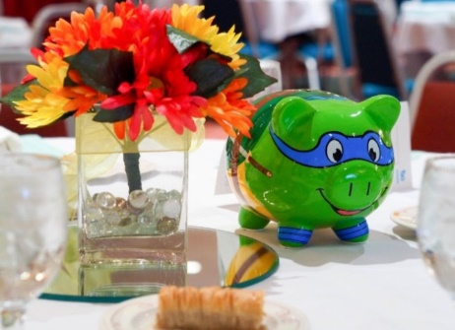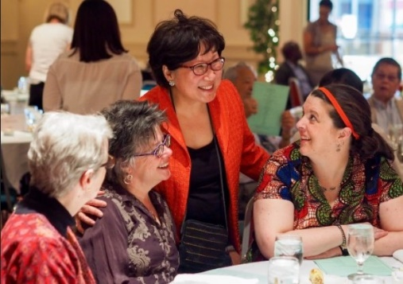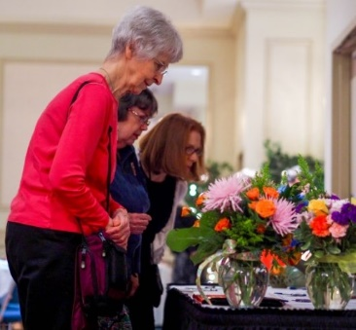

Established in 1980, the East Central Illinois Refugee Mutual Assistance Center has provided services to refugees, immigrants, and their families who settle in East Central Illinois. This past year, we have served over 2,000 clients by providing a variety of services that include resettlement, translation, adjustment, citizenship, and a children’s tutoring program. Helping our clients is an ongoing process that requires tremendous efforts and support.

To benefit the work of the Refugee Center,
the Twelfth Annual Fundraising Banquet
will be held on
Saturday, April 27, 2019, at 6:00 p.m.
at the Vineyard Church
Located at the corner of Lincoln and Bradley in Urbana, IL (1500 North Lincoln Ave. Urbana)

Evening Itinerary
6:00 p.m. - Silent Auction Opens & Welcoming Entertainment Begins
6:45 p.m. - Introductions
7:00 p.m. - Buffet Dinner Service Begins
(Vegetarian Option will be available)
Entertainment and Program will follow dinner service

Ticket pricing
$80 per person or $600 per Table of Eight.
Tickets now available for purchase!

For more information
Call 344-8455 or Board President John Muirhead at 398-1048
Email: admin@ecirmac.org

Unable to attend? Please consider making a
donation to help support the work of ECIRMAC
Online at www.ecirmac.orgor mail a check to our new address:
201 W. Kenyon Rd., Suite 4D Champaign, IL 61820

We are a 501(c) (3) organization, so your donation is tax deductible.

