**2. Search by sponsor name, donor center, zip code, and more!**

**1. Click Donate Now.**

**Scheduling an Appointment**

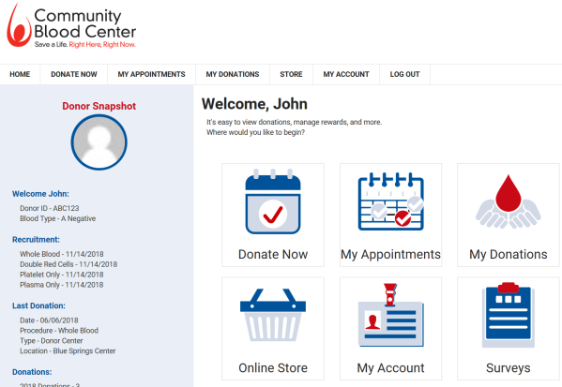

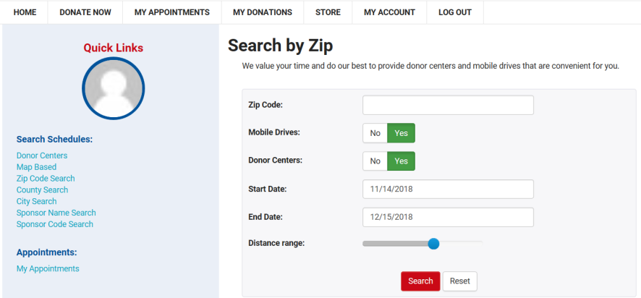

**3.** **Click Schedule by the blood drive or donor center you want.**

**4:** **Click on the time you wish to donate.**

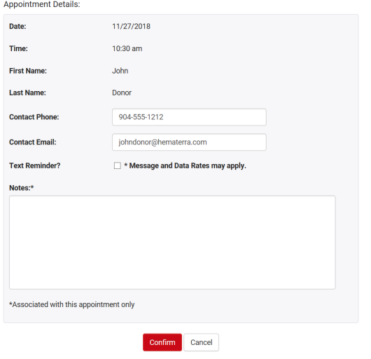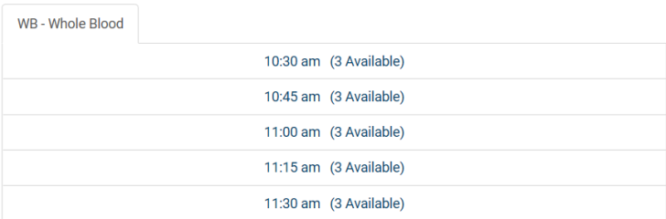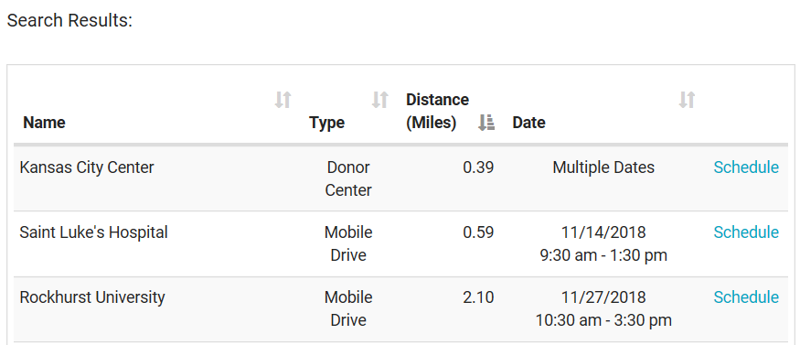

If you require any assistance, please do not hesitate to contact us at **(816) 753-4040.**

**5.** **Verify your information & click Confirm.**