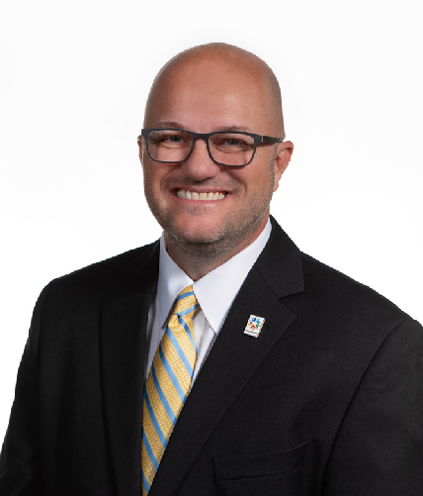

B R E N T
K I S L I N G
E X E C U T I V E D I R E C T O R

Oklahoma Department of Commerce Phone: 405-815-5306
brent.kisling@okcommerce.gov

Brent Kisling is a husband, dad, deacon, and public servant. Born and raised on a farm and ranch in rural Northwest Oklahoma, he graduated from Burlington High School and then attended college at Oklahoma State University where he graduated with a bachelor’s degree in Agribusiness. He was the Outstanding Graduate from the College of Agriculture and served as the State FFA President.
Following graduation, Brent went to work for U.S. Senator Jim Inhofe before being appointed by the George W. Bush Administration to be the State Director for USDA Rural Development. While working all eight years with the President’s administration, he oversaw the rural housing, utilities, and business programs state-wide.
For 13 years, Brent and his wife owned and operated Maple Place Bed and Breakfast in downtown Enid. When they sold the business in 2012, it had become the largest Bed and Breakfast in the state.
In March of 2009, Brent was named as the Executive Director of the Enid Regional Development Alliance. The mission of the Alliance is to ensure quality job growth through the expansion and retention of existing businesses and the recruitment of new industry to Enid and Northwest Oklahoma.
In 2019, Brent was appointed by Governor Kevin Stitt to serve as the Executive Director for the Oklahoma Department of Commerce. The mission for the Department of Commerce is to create an environment where economic growth can occur. This agency oversees the business expansion, business recruitment, workforce development, economic research, and community development efforts for the State of Oklahoma.
Brent has served as the Chair of the Oklahoma CareerTech Foundation Board, the OSU Agriculture Alumni Board, and the 2020 Oklahoma Census Complete Count Committee. In 2022, he received the Leadership Oklahoma Distinguished Leadership award. In 1995, Brent married the girl of his dreams, Jennifer, and they have two wonderful children, Layne and Bree. He is a deacon at the First Baptist Church of Enid where he also teaches Sunday School.

