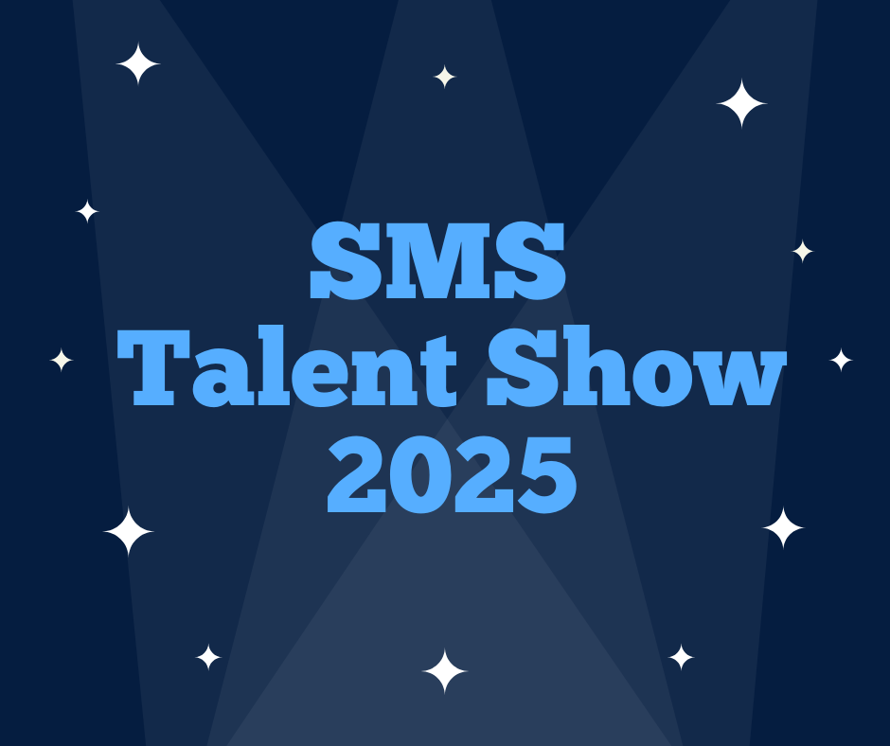

SMS Talent Show 2025 Rules

- All participants must be current St. Monica School students Kindergarten - 8th grade.
- All participants must complete a registration form and be available for applicable talent show dates:
  - Tryouts: February 25, 26 or 27th after school at 3:30 (see SignUpGenius to sign up for slot)
  - Dress Rehearsal: Tuesday, April 1st
  - Talent Show: Wednesday, April 2nd at 6pm
- The tryouts are a preview to make sure the act is in line with all rules. Do not worry if the act is not perfected yet. Please have your song choice, lyrics and most of the performance complete so we will know what you’ll be performing.
- All participants’ talent must fall under one of the following categories and must be live (no recordings allowed). Anyone wanting to present an act outside of one of these categories must have the act approved by Mrs. Plote or Talent Show Chair, Christina Arnott.
  - Singing, playing an instrument, dance, magic show, gymnastics routine, ventriloquism, athletics, acting, comedy routine.
- MC’s needed - we will need 2-3 MC’s so please fill out the form below if you wish to be considered for MC of the talent show! Please sign up for tryout times as well.
- All acts (single or group) must have a parent chaperone (with current Safe Environment) at all times and are responsible for making sure the act gets to each position on time.
- Please submit all song lyrics to Mrs. Plote or Christina Arnott for review. Most can be found by simply Googling and printing. Lyrics of any song being used must be appropriate for all ages, no curse words allowed or references to drugs. Songs used for an act must be provided by the act. Please bring your song digitally (phone/iPad/must be Bluetooth compatible).
- If the same song is requested by multiple acts, the act who turned in their application first will be given preference.
- All apparel worn for the talent show must be age appropriate (no midriffs; shorts and skirts must come to mid-thigh). All costumes must be worn to dress rehearsal for approval.
- Dance moves must be appropriate for all ages to view.
- Talent show committee reserves the right to deem any dance move, wording, costume or part of any act inappropriate or dangerous and can require change in order to participate.
- Time allotment:
  - Solo Acts: 2 min 15 seconds max
  - Group Acts: 3 min 15 seconds max
- Any SMS student may only participate in 2 acts maximum (one solo and one group). If more than 35 acts are turned in by SMS students, anyone participating in more than one act will be asked to choose only one for time constraints.
- Due to the 2 hour maximum for the show, priority will be given in the order the applications were turned in if the total acts submitted exceed this time limit.
- All participants are expected to behave consistent with the behavior expected during classroom hours. Any student acting otherwise may be removed from the talent show.

SMS Talent Show 2025 Registration Form

Please turn in this form to McManus Hall by February 20, 2025
See SignUpGenius link to sign up for a tryout slot
Contact Christina Arnott with any questions: christina.arnott1@gmail.com or 214-415-2352

Circle One: Individual Act Group Act
(Only one form needed for a group act but each child must have permission slip signed by parent or guardian)

Name(s) of students participating in the act (feel free to add more if needed, not limited to 8):

Name | Grade | Parent Email | Phone Number

Act Parent Chaperone Name and Contact Information:

Title of Performance or Group Name (if applicable)

Type of talent/brief description of act:

Circle one category: Song Instrument Dance Cheer/Gymnastics Magic Comedy Acting MC (host of the show, not an act) Other
If other, please include a description below:

Approximate length of act:

Will act need props? Circle one: YES NO (If yes, please describe below, include setup or arrangement details)

Parent and student signatures are required for each group member. This is to acknowledge that all parties understand and consent to the above stated rules and their child’s participation in the talent show.

Parent Signature & Date Student Signature & Date

Parent Signature & Date Student Signature & Date

Parent Signature & Date Student Signature & Date

Parent Signature & Date Student Signature & Date

Parent Signature & Date Student Signature & Date

Parent Signature & Date Student Signature & Date

Parent Signature & Date Student Signature & Date

Parent Signature & Date Student Signature & Date

Parent Signature & Date Student Signature & Date

Parent Signature & Date Student Signature & Date

Parent Signature & Date Student Signature & Date

Parent Signature & Date Student Signature & Date

