50th Anniversary Celebration, Exclusive Ticket Sales
Social Media & Marketing Toolkit
Hashtag #WineRoad50
Event Ticket Page URL: Each winery has its own exclusive ticket link thru June 30th.
Dropbox Link to Media Photos/Video: https://www.dropbox.com/scl/fo/uw8lcg0v2hn8mg8xwevuu/ADaIkBVQsLlnltOKGLQJn5E?rlkey=17p26mzt7bd8cyynmovnm8lvm&dl=0
Facebook Event:
You can share/add the 50th Anniversary event that is already created on Facebook: https://www.facebook.com/events/909980478726214/
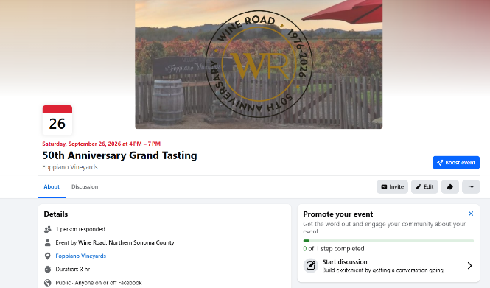

Hashtags to use on Instagram (plus add yours!):
#WineRoad50 #wineroad #sipsonoma #sonomacountywine #californiawine #wineevents #winetasting

Social Media Post Ideas:
NOTE: Please be sure to post before June 30th so that your fans and wine club members have time to purchase tickets at a discounted rate.
- Celebrate 50 years of Wine Road with us at their 50th Anniversary Grand Tasting, Saturday, September 26th. Grab your tickets now for $100 through June 30 using our exclusive link: [INSERT YOUR DEDICATED TICKET LINK HERE] Join us for an unforgettable evening featuring 50 wineries, amazing food, live music, and a silent auction. We’d love to see you there.
- Celebrate 50 years of Wine Road with us! We’re excited to share exclusive $100 tickets to the Wine Road 50th Anniversary Grand Tasting, available through June 30 only through our dedicated link. This will be one for the books: 50 wineries, incredible food, live music, and a silent auction, all wrapped into one unforgettable evening in wine country on September 26th. .
Grab your tickets here: [INSERT YOUR DEDICATED TICKET LINK HERE]. We’d love to celebrate with you.
- September 26 at Foppiano Vineyards — join us for the Wine Road 50th Anniversary Grand Tasting. Get exclusive $100 tickets through June 30 with our winery link: [INSERT YOUR DEDICATED TICKET LINK HERE]
Expect 50 wineries, amazing food, live music, and a silent auction. We’d love to see you there.
- Join us in celebrating Wine Road’s 50th Anniversary Grand Tasting, Saturday, September 26th.
Secure your tickets now for $100 through June 30 with our dedicated link: [INSERT YOUR DEDICATED TICKET LINK HERE]. It’s set to be a special evening with 50 wineries, delicious food, live music, and a silent auction benefiting the Redwood Empire Food Bank and the Healdsburg Museum. We’d love to celebrate with you there.
- Big celebration, better grab your ticket early. We’re inviting you to join us for the Wine Road 50th Anniversary Grand Tasting, and through June 30, tickets are just $100 through our winery link. Think 50 wineries, delicious food, live music, dancing, and a silent auction all in one unforgettable evening.
Get your tickets here: [INSERT YOUR DEDICATED TICKET LINK HERE]. Come celebrate with us!
- Come raise a glass with us at Wine Road’s 50th Anniversary Grand Tasting, Saturday, September 26! It’s going to be a party for the ages, and you’re invited. Grab your tickets for just $100 until June 30th! Don't miss out on this incredible deal because after June 30th, the price goes up!
Get your tickets here: [INSERT YOUR DEDICATED TICKET LINK HERE]
Cheers to the journey and all the amazing wine yet to come. We’ll see you there.
Newsletter Copy
Mark your calendar for the Wine Road 50th Anniversary Grand Tasting on September 26, from 4–7pm at Foppiano Vineyards. Through June 30, you can grab tickets for $100 through our exclusive winery link—a special early price before tickets open to the public.
This festive evening brings together 50 wineries, amazing food from local chefs and restaurants, live music, and a silent auction, all in one unforgettable Wine Road celebration. Get your tickets now with [INSERT YOUR DEDICATED TICKET LINK HERE].
Website Copy
Wine Road 50th Anniversary Grand Tasting.
Join us for the Wine Road 50th Anniversary Grand Tasting on September 26 from 4–7pm at Foppiano Vineyards. This special evening brings together great wine, great food, and great company, with exclusive $100 tickets available through June 30 through our winery link.
Hosted at one of Wine Road’s founding member wineries, this walk-around tasting is a chance to be part of a milestone celebration honoring 50 years of Wine Road. You’ll enjoy pours from 50 wineries, delicious bites from local chefs and restaurants, live music, dancing, and a silent auction during a beautiful early evening gathering at Foppiano Vineyards.
This event is ideal for wine lovers who want to sip, stroll, and take in the spirit of Sonoma County wine country on one unforgettable evening.
What to expect
- Tastes from 50 featured wineries
- Amazing food from local chefs and restaurants
- Live music and plenty of room to dance
- A silent auction benefiting the Redwood Empire Food Bank and The Healdsburg Museum
- A festive setting that honors 50 years of Wine Road history
Secure your tickets at the special $100 winery partner price through June 30 using [INSERT YOUR DEDICATED TICKET LINK HERE].

