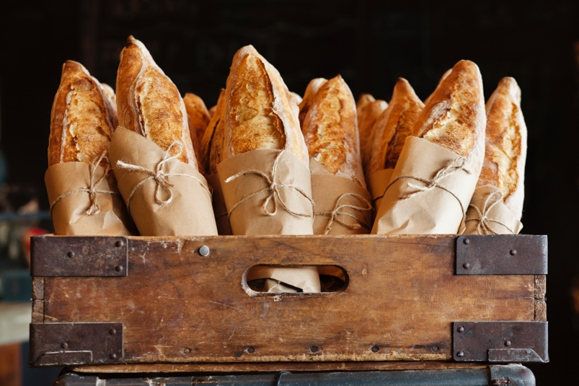
Food Justice
The Immaculate Heart of Mary
Social Action Coordinating Committee
And SEM - Southeastern Ecumenical Ministry will present and discuss the topic of Food Justice. This will be a ZOOM presentation on Friday,
March 26, from 7:30 – 8:45 pm.

“We cannot look the other way and pretend this does not exist. The food available in the world is enough to feed everyone.” Pope Francis

There is enough food in the world to for everyone to eat healthy, nutritious food, yet a billion people are hungry. If food production, distribution and justice were improved, no one would be hungry. Discussion to include food insecurity, waste, deserts/swamps, food chain workers, regenerative agriculture, local opportunity and more. All are welcome. Please contact Maggie Leon-Guerrero (maggiek@ihom.org) to register.

