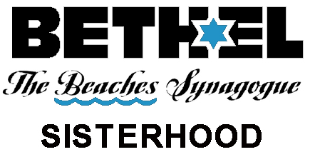
Join Us As We Serve Our Synagogue, Support Our Community, and Enrich Our Lives
2021-2022 Calendar
(as of 7/6/21)
More events to be added.
Each Tues and Fri, 9:30 on Zoom, Bone Builders; Wednesday 10:30 at Beth El, Shalom Yoga

Thurs, July 1st 6:15 BELLES (Beth El Literary Ladies Enjoying Sisterhood)
PotLuck. Discussion hybrid-- in person and on Zoom.
Sun, August 8th 10:00 Silver Polishing for the High Holy Days
Sun, August 22 nd 3:00 Welcome Back! Festive Members’ Tea
Sat, August 28th Selichot Service and Ice Cream
Wed, Sept 16th Yom Kippur Break Fast
Sun, Sept 26 th 5:00 Movie Night with JTB
Thurs, Nov 4th 6:15 BELLES (Pot Luck at 6:15, discussion at 7:00)
Sun, Nov 14 th 5:00 Wine, Cheese, and Movie Night with JTB
Thurs, Dec 2nd 6:30 Sisterhood Hanukah Party
Wed, Dec 25th 11:00 First Responders’ Appreciation
2022
Thurs, Jan 6th 6:15 BELLES (Pot Luck at 6:15, discussion at 7:00)
Sun, Jan 16th 5:30 Sisterhood’s Tu B’Shevat Seder, for everyone
Fri, Feb 18th 7:00 Sisterhood Led Shabbat
Sun, Feb 27th 11:00 Religious School Purim Celebration
Thurs, March 3rd 6:30 Amazing Fashion Show
Tues, March 15st 6:30 Pre-Passover Miriam’s Seder, for everyone
Thurs, April 7th 6:15 BELLES (Pot Luck at 6:15, discussion at 7:00)
Thurs, April 14th 6:30 Brotherhood/Sisterhood Dinner with the Rabbi
Thurs, May 5th^{th} 6:15 BELLES (Pot Luck at 6:15, discussion at 7:00)

