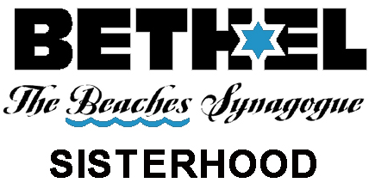
Join Us As We Serve Our Synagogue, Support Our Community, and Enrich Our Lives
2022-2023 Calendar, subject to change
(11/30/2022)

Weekly wellness: Zoom Every Tues and Fri, 9:30, Bone Builders
In person Wednesday 10:00, Shalom Yoga
In Person Wednesdays 11:15, Jewish Meditation
Weekly fun starting Dec 2 (6 weeks) Fridays 10:00 – 12, Mah Jong Lessons

Sunday, Aug. 28th 10:00 Polish Torah Silver
Sunday, Sept 11th 2:00 General meeting/ Meet and Greet Rabbi Dyme
Thursday Sept 15th 6:30 Fabulous Fashion Show
Sat Sept. 17th 7:00 Selichot Ice Cream Social
Wednesday, Oct 5 Yom Kippur Break Fast
Sunday, Oct 16th 1:30 JFCS Visit and Exhibit Tour--Art in the Holocaust
Sunday, Oct 23rd 5:00 Movie Night
Tuesday, Nov 8th 12:00 Lunch and learn with Rabbi Dyme
Mon, Dec 5 th 7:00 BELLES Book Group (Zoom)
Thurs, Dec 22nd 6:30 Sisterhood Hanukah Party
Sun, Dec 25th 12:00 First Responders’ Appreciation

2023
Tues, Jan 10th 12:00 Lunch and learn with Rabbi Dyme
Sat Jan 21st all day Joint Shabbaton, with Sisterhood Ahavath Chesed
Sun, Feb 5th 5:30 Sisterhood’s Tu B’Shevat Seder, for everyone
Fri, Feb 10th 7:00 Sisterhood Led Shabbat, for everyone
Wed, Feb 22 7:00 BELLES Book Group (Zoom)
Sun, Mar 5th 11:00 Religious School Purim Celebration
Tuesday, Mar 21st 12:00 Lunch and learn with Rabbi Dyme
Thurs, Mar 30th 6:00 Pre-Passover Miriam’s Seder, for everyone
Tuesday, May 9th 12:00 Lunch and learn with Rabbi Dyme

