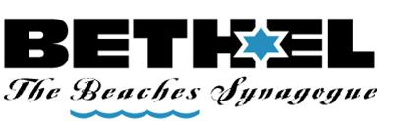

LEAD THE WAY INTO OUR SYNAGOGUE
BY ADDING A PERSONALIZED BRICK TO OUR ENTRYWAY

Remember a loved one for years to come.
Honor a New Baby, Consecration, Bar or Bat Mitzvah, Confirmation, Wedding, Anniversary or other special event.
Please print your inscription as you wish it to appear on the brick.
Three lines with 11 characters per line (including spaces)
___ ___ ___ ___ ___ ___ ___ ___ ___ ___ ___
___ ___ ___ ___ ___ ___ ___ ___ ___ ___ ___
___ ___ ___ ___ ___ ___ ___ ___ ___ ___ ___
CONTACT INFORMATION:
NAME:__________________________________________________________
PHONE:__________________________________________________________
Please send completed order form and a check for $100 per brick to:
Beth El Sisterhood
288 North Roscoe Blvd.
Ponte Vedra Beach, FL 32082

