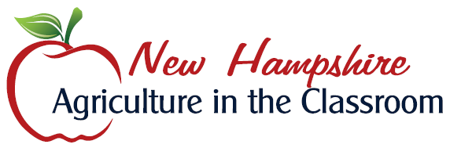

MAPLE SYRUP PRODUCTION SUPPLIES GRANT

GRANT: apply for either $200 equipment grant
TAPPING AND TESTING SUPPLIES (10 taps, 10 plastic buckets, 10 bucket covers, hydrometer cup, hydrometer, grading set, North American Maple Manuel and a bottle to submit your sample to the Felker Award Classroom Competition)
EVAPORATOR CONSTRUCTION SUPPLIES (receive $200 to purchase supplies to build an oil drum or concrete block evaporator)

ELIGIBILITY: teacher in a New Hampshire K-12 classroom
Grant recipients must participate in the 2018 Tucker Mountain Challenge (formerly the Felker Award Classroom Competition)

APPLICATION: completed grant applications must be received by New Hampshire Agriculture in the Classroom no later than December 15, 2017 (295 Sheep Davis Road Concord, NH 03301 or emailed to nhaitc@nhfarmbureau.org)
Completed applications for the Felker Award Classroom Competition must be submitted by 1/15/18.

AWARD: grant winners will be notified by 12/31/17
tapping and testing supplies are to be picked up in January in Concord or Wilton, NH
evaporator construction supplies recipients will be mailed a check in early January 2018

REPORTING: winners will be required to submit several written paragraphs describing their 2018 maple sugaring experience and classroom application along with several photographs which can be used for promotional purposes
report submission deadline: 4/30/18

