Executive Coaching to Support Effective State Chapter Leaders
State chapter organizations play a key role in the children’s advocacy center (CAC) movement, serving as a leading resource for CACs in their state and facilitating a network of providers dedicated to a coordinated and comprehensive statewide response to child abuse. Our staff at the Western Regional Children’s Advocacy Center (WRCAC) believe strong state chapters lead to strong CACs, and that building strong state chapters requires effective state chapter leadership. However, we also know state chapter leaders face many challenges in this work, and often lack the professional support and development needed to strategically guide their state’s response to child abuse without burning out.
State chapter growth in the western region has been slower than in other parts of the country, with most chapter leaders running one-person or small-staffed operations. According to preliminary state chapter data obtained through the National Children’s Alliance (NCA) 2022 Chapter Census, three of the five states in the country that do not have a full-time chapter director are in the western region, and over half of chapters in the west are staffed by only one person. As of 2019, the average annual budget for chapters in the west was just over $301,000, almost 60% lower than the national average and 33% below the next lowest region, and we expect 2022 data to be similar. As membership associations, state chapters are uniquely challenged to balance the demands of growing and sustaining their own resources, operations and programs while also supporting and fostering growth and development of individual CACs within their state. Leading this effort, particularly with limited infrastructure, resources, and staff support, can be challenging and isolating for chapter directors, which can lead to burnout and turnover. In 2021, WRCAC saw an opportunity to utilize executive coaching as a strategy to provide needed support to state chapter leaders in our region.

What is Executive Coaching?
Historically, businesses and organizations have focused on training individuals on their specific job-related tasks and activities. While training can provide a leader with new skills and knowledge, changing behavior requires changing one’s internal thought processes, and this is where coaching can really make an impact. Executive coaching, introduced in the 1980s, offers a different way to develop leaders by engaging individuals through a tailored and personal process that cultivates and employs their strengths. The International Coaching Federation defines coaching as “partnering with clients in a thought-provoking and creative process that inspires them to maximize their personal and professional potential. The process of coaching often unlocks previously untapped sources of imagination, productivity, and leadership.” Coaching has become popular in the corporate sector, prompted by a desire to improve performance in a competitive and changing world and because of the numerous benefits to individual leaders, including greater confidence, clarity around purpose and goals, and improved job satisfaction.

WRCAC State Chapter Coaching Pilot Program
In my role as State Chapter Liaison, I became certified in Executive Life Coaching after successfully completing formal training, extensive practice hours, and mentoring through an accredited coach training program, and developed a framework for implementing executive coaching with state chapter leaders. Recognizing a need to help state chapter leaders facilitate purposeful learning and growth to support their work and build resiliency in their role, and the limited professional development opportunities available for state chapter leaders, WRCAC is launching the State Chapter Coaching Pilot Program to provide personalized support for state chapter leaders through one-on-one coaching.
Our framework utilizes an executive coaching model designed to build a leader’s self-awareness and clarify vision and goals, as well as strategies to help accomplish those goals. The practice is individualized, where the coach creates a safe and structured environment for the chapter leader to creatively explore current competencies, specific goals, and appropriate action steps, and is also designed to help a chapter leader stay accountable and build resiliency along the way. Unlike traditional technical assistance or consulting, WRCAC’s coaching is focused on developing a chapter leader’s ability to solve problems using their unique strengths and tools such as goal setting and accountability.
While everyone can benefit from coaching, we are currently offering this resource to individuals who are the primary leader for their state chapter in the western region. It is designed for new and established chapter leaders who are looking to develop skills in leadership, management, and communication, while building resilience and identifying strategies to adapt to difficult or challenging experiences.

WRCAC State Chapter Coaching Framework
Coaching will be provided over 6 to 10 sessions about an hour in length, delivered by Zoom or phone, depending on the need of the individual. The coaching recipients (chapter leaders) will provide the coach with key information about themselves and ideas of want they want to achieve through coaching through a questionnaire. The coach will also utilize shorter pre- and post-session questionnaires to give the leaders an opportunity to share what they hope to get out of each individual session, and as a tool for self-reflection and to track progress.
The first coaching session is a discovery session in which the groundwork is laid for the following coaching sessions. In this session, the coach will lead the agenda. The coach and leader will design their alliance and set clear expectations and a strategic agenda for the coaching relationship and leaders will set their coaching goal. Subsequent sessions are led by the leader but will follow a similar structure including a grounding practice, accountability check-in, exploration, and action planning.
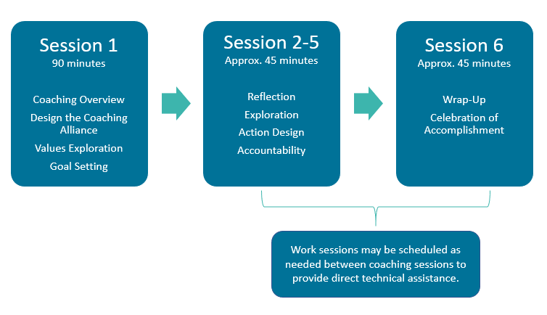

Our model combines the Hope Theory (hope as a powerful motivational state), with powerful questions and direct communication. Powerful questions are short, direct, and open-ended questions that help the individual gain insight and elicit learning, inspire creative problem solving and increase motivation to follow-through with specific action. Coaches use these questions to address habits, thoughts and even feelings that provide a deeper level of learning and self-awareness for individuals. As individuals gain self-awareness through this process, they are also able to increase clarity and confidence in the action steps they want to take. In our program, we will use powerful questions that can be categorized as learn-be-do questions
- “Learning questions” help the leader explore who they are and what they are capable of, as well as strategies and action steps they need to achieve a goal. Examples of learning questions include “what new skill is this challenge requiring you to develop?” or “how is your action aligned with your intention on that issue?”
- “Being questions” help the leader explore the characteristics they have or desire to have, the energy they bring to a project, the assumptions they make about their abilities, and how achievements influence their identity. An example of a being question might be “what would this accomplishment mean to how you think about yourself as a leader?”
- “Doing questions” elicit action steps an individual will take toward achieving their goals. A common doing question is “based on our discussion, what are a few action steps that you want to take in the next two weeks?”

While our current focus is on utilizing coaching to provide chapter leaders with professional development and support their resiliency, there are additional ways that coaching could be integrated into the CAC field. CAC and multidisciplinary team leaders can benefit from receiving coaching and learning coaching skills to improve their relationships and communication with their own staff and team members. Coaching can also be a great resource in supporting executive leadership transitions for both the outgoing and incoming leaders by helping develop and build relationships, strategize actions and communications, and define and prioritize goals.
CAC professionals who are interested in learning more about opportunities to engage in coaching can reach out to their State Chapter or their Regional Children’s Advocacy Center. While they may not be able to provide coaching directly, they may be able to refer you to a skilled coach. You can also look for a credentialed coach in your community or through the International Coach Federation. If you have questions or would like to learn more about WRCAC’s Coaching for State Chapter Leaders Pilot Program, please reach out to me, Patty Terzian, State Chapter Liaison at pterzian@rchsd.org

WRCAC is funded through the U.S. Department of Justice, Office of Juvenile Justice and Delinquency Prevention, Grant #2019-CI-FX-K002
The opinions, findings, and conclusions or recommendations expressed in this product are those of the authors and do not necessarily reflect those of the Department of Justice.

Institute of Coaching, McLean, Affiliate of Harvard Medical School. Benefits of Coaching. https://instituteofcoaching.org/coaching-overview/coaching-benefits
Snyder, C. (1994). The psychology of hope: You can get there from here. New York, Free Press.
Williams, J.A. (2020). Executive Life Coach 1.0 Training Guide. Coach Training EDU.

