OIG DHC Abuse, Neglect, and Exploitation Training
September 23 and September 24, 2024 – 1122605

Important Things to Know & Helpful Suggestions

- For registration assistance, please contact Darlene Cox-Raisor at darlene.cox@ky.gov or call 502-564-5805.
- The Kentucky Board of Nursing has approved 7.8 contact hours for RNs and LPNs. Kentucky Administrators will also receive 7.8 contact hours. Participants MUST sign in at the Registration Desk and stay for the entire course to receive CEU's.
- Disclaimer Statement: The Kentucky Board of Nursing approval of an individual continuing education provider does not constitute endorsement of program content.

- Participants must print all resource materials (found under Resources in TRAIN) and bring documentation with them to the training event. These materials will not be available for distribution at the training venue.
- Bring a sweater or jacket, as there may be notable temperature variations in the training room.
- You may bring drinks and snacks to the training event. Vending machines are in the basement. Cash is recommended but cards may be used; however, it has been reported that the card reader operability is somewhat sketchy and that the vending machines may be low on stock.
- Link for map, nearby overnight accommodations, accessibility options, and parking: https://louisville.edu/conferenceservices/where?anchor=parking&anchor-tab=yes

University of Louisville Shelby Campus Conference Center
Founders Union Building
450 N Whittington Pkwy
Louisville, KY 40222
https://louisville.edu/conferenceservices/where
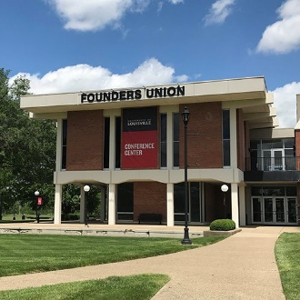
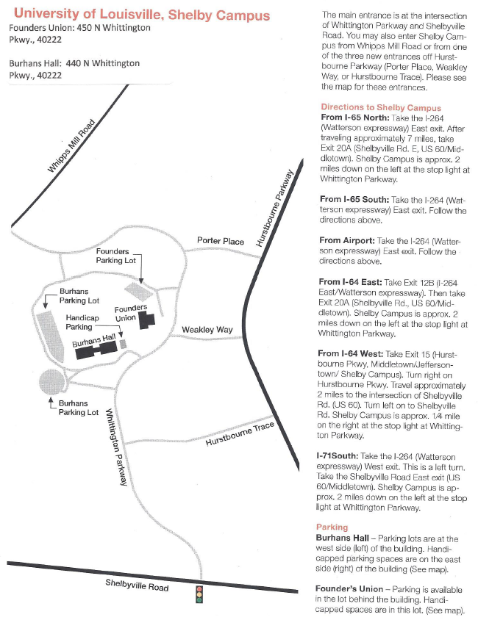

Parking

Founders Union Building
450 N. Whittington Pkwy
Louisville, KY 40222
Parking is available in the lot behind the building. Handicapped accessible spaces are closest to the building.

Burhans Hall
440 N Whittington Pkwy
Louisville, KY 40222
Parking lots are on west side (left) of building. Handicapped accessible parking spaces on east side (right) of building.
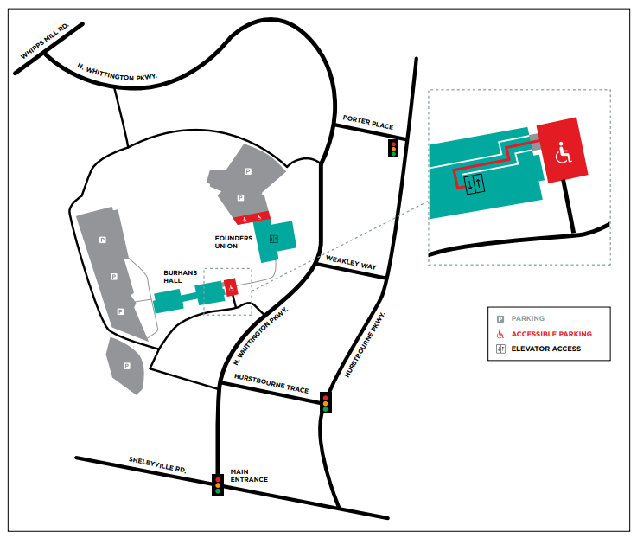

HOTELS

*Shuttle service available
Homewood Suites by Hilton® Louisville East
9401 Hurstbourne Trace
Louisville, KY 40222
502.429.9070
Distance: Three-minute walk from Shelby Campus*.
Residence Inn® by Marriott® Louisville East
120 North Hurstbourne Parkway
Louisville, KY 40222
Distance: Eight to ten-minute walk to Shelby Campus*.
Embassy Suites by Hilton Louisville East
9940 Corporate Campus Drive
Louisville, KY 40223
502.426.9191
Distance: 1.7 miles from Shelby Campus*.
Hampton Inn by Hilton - Louisville East/Hurstbourne
1150 Forest Bridge Rd
Louisville, KY 40223
502.426.1822
Distance: Less than 1 mile from Shelby Campus*.
Hawthorn Suites by Wyndham - Louisville
751 Cypress Station Drive
Louisville, KY 40207
502.899.5959
Distance: 4 miles from Shelby Campus*.
Holiday Inn Louisville East
1325 S. Hurstbourne Pkwy
Louisville, KY 40222
502.426.2600
Distance: 2.5 miles from Shelby Campus*.
Use code ILUYL and receive 20% discount on overnight accommodations.
Home2 Suites by Hilton - Louisville East/Hurstbourne
1150 Forest Bridge Rd
Louisville, KY 40223
502.326.3824
Distance: 1.2 miles from Shelby Campus*.
Hyatt House Louisville – East
9315 Leesgate Road
Louisville, KY 40222
502.919.7855
Distance: 1 mile from Shelby Campus*.

RESTAURANTS *within walking distance to UofL Shelby Campus

*Brasserie Provence
150 N. Hurstbourne Pkwy. 502-883-3153
Monday – Saturday 11:00 AM – 2:00 PM (Lunch)
Monday – Thursday 5:00 PM – 9:00 PM (Dinner)
Friday and Saturday 5:00 PM – 10:00 PM (Dinner)
Closed on Sunday

*Bristol Bar and Grille
300 N. Hurstbourne Pkwy 502-426-0627
Monday – Thursday 11:00 AM – 10:00 PM
Friday – Saturday 11:00 AM – 11:00 PM
Sunday Brunch 10:00 AM – 2:00 PM, Dinner 2:00 PM – 10:00 PM

*Jason’s Deli
410 N Hurstbourne Pkwy Ste 100 502-412-4101
Sunday – Thursday 8:00 AM – 10 PM
Friday – Saturday 8 AM – 11 PM

*Shiraz Mediterranean Grill
502 426-3440
205 N. Hurstbourne Pkwy.
Mon. - Thur.: 11:00 AM - 9:00 PM
Fri. & Sat.: 11:00 AM - 9:30 PM
Sun.: 12:00 PM - 9:00 PM

*Subway
201 N Hurstbourne Pkwy Suite #210 502-426-8963
Monday – Saturday 9:30 AM – 12:00 AM
Sunday 10:00 AM – 11:00 PM

*Smashburger
502-326-4141
9409 Shelbyville Rd.
Open every day, 10 AM – 10 PM

*Starbucks
502 412-4545
Hurstbourne & Shelbyville Rd.
101 No. Hurstbourne Ln.
Open Sunday-Thursday, 5:30AM-11:00PM
Fri. & Sat.: 5:30 AM – Midnight

Fazoli’s Italian Fast Food
337 Whittington Parkway 502-423-1777
Sunday – Thursday 10:30 AM – 10:00 PM
Friday – Saturday 10:30 AM – 11:00 PM

Connors Steak & Seafood
615 S. Hurstbourne Lane 502-812-1122
Sun-Thurs 11am to 10pm
Fri-Sat 11am to 11pm

*PF Changs
9120 Shelbyville Rd 502-327-7707
Sunday – Thursday 11:00 AM – 11:00 PM
Friday – Saturday 11:00 AM – 12:00 AM

McDonalds
9901 Ormsby Station Road 502-326-5191
Every day – 8:30 AM – 9:00 PM

McAlister’s Deli
601 S. Hurstbourne Pkwy 502-425-8900
Monday – Saturday 10:30 AM – 9:00 PM

The Cheesecake Factory
5000 Shelbyville Road 502-897-3933
Monday – Thursday 11:30 AM – 11:00 PM
Friday 11:30 AM – 12:30 AM
Saturday 11:00 AM – 12:30 AM
Sunday 10:00 AM – 11:00 PM

Momma’s Mustard, Pickles & BBQ

119 S. Hurstbourne Pkwy. 502-290-7998
Sun-Thur 11am to 9pm
Fri-Sat 11am to 10pm

First Watch

210 S. Hurstbourne Pkwy 502-384-6075
Mon-Sun 7am to 2:30pm

