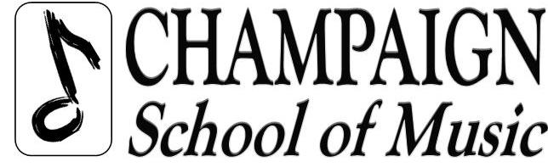
1712 S Duncan, Champaign, IL 61822
ChampaignSchoolofMusic@gmail.com
Phone: (217) 359-0541

2020-2021 Private Lesson Calendar
Open/Closed & Recital Dates

Labor Day CLOSED
Monday, Sept 7th

Thanksgiving Break
Tue-Sun, Nov 24th -29th

Holiday Concert
TBD

Holiday Break
Tue, Dec 22nd-Sun Jan 3rd

Spring Break
Tue, Mar 16th - Sun, Mar 21st

Memorial Day CLOSED
Mon, May 31st

Spring Concert
TBD

Summer Break
Sun, Jul 4th – Mon, Jul 5th

We are a year round school, open Mon-Saturday for Private Lessons
NOTE: Music Together and Music Explorers may follow a different schedule.

