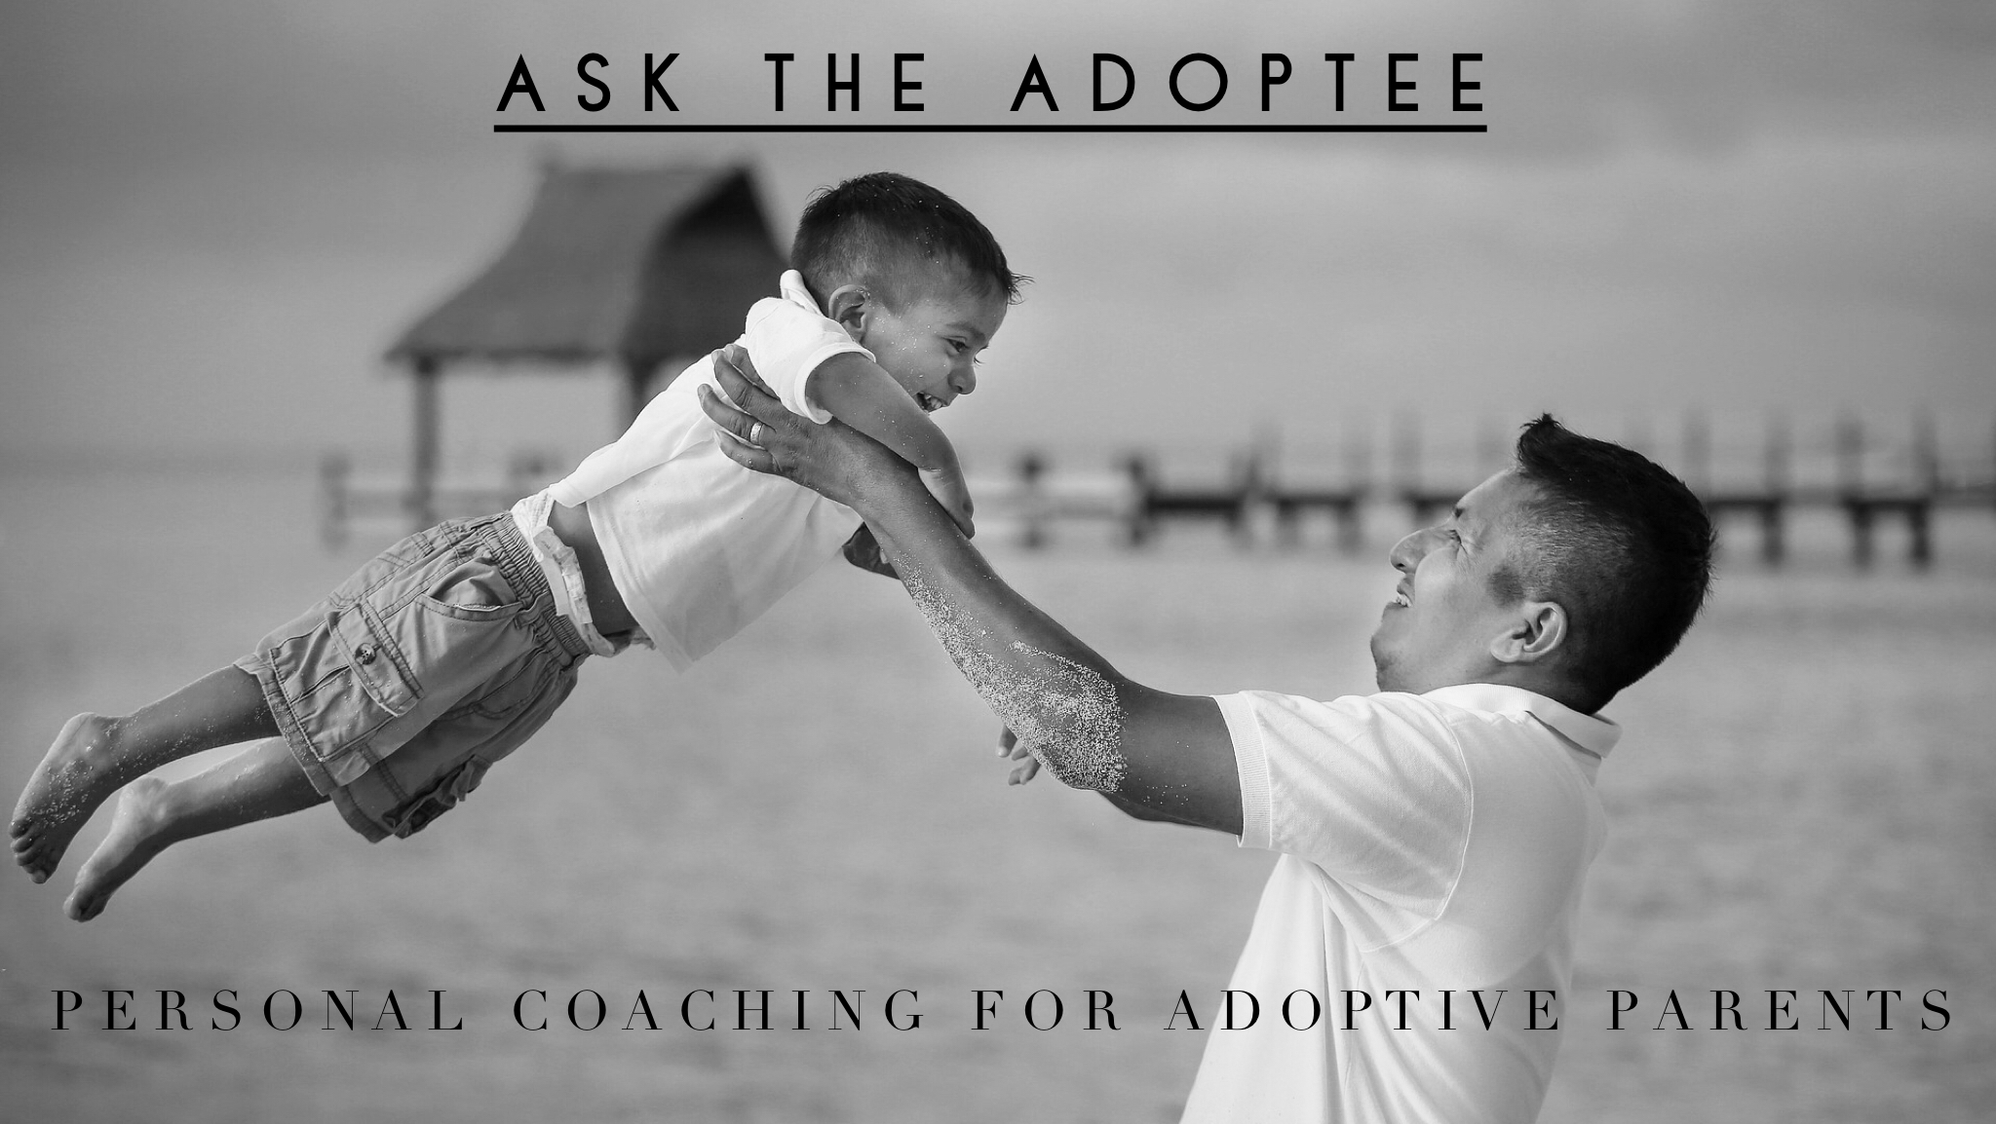
Are you an adoptive parent with questions? Let me help you.

"When should we start talking about adoption?"

“I know my son is deeply grieving his birth family. How can I help him?”

"How do we talk about our child's birth family when we don't know all of the details?"

"My daughter just 'met' her biological sister on Facebook. Now what?"

"What’s the best way to talk about complicated and difficult topics with our child?"

“What’s normal teen behavior and what’s related to adoption?”

“Our extended family doesn’t understand our desire for openness in our son’s adoption.
How can we help them realize how important this is for us?”
______________________________________________________________________________

These are just a few questions I frequently get from adoptive parents worldwide.
I am committed to helping parents navigate difficult situations and conversations.
Let’s work together so you, your child's best advocate, will have the tools, language and
answers to help your child connect the dots of their adoption story.
Coaching is somewhat different than therapy - conversations take place in real time,
when parents need answers and information most.
Coaching meetings are offered in person, by phone or virtually for convenience and for those who aren't local.

Contact me today and learn about special package rates.

Lesli Johnson, MFT ~ Adoptee, Therapist, Parent Coach
www.yourmindfulbrain.com
lesli@yourmindfulbrain.com 310-614-1867

