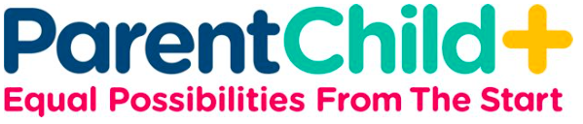

Family Resource Network ParentChild+
Serving Lynnfield, Melrose, North Reading, Reading,
Stoneham, Wakefield & Winchester

WHAT: A FREE program that helps you prepare your child for early learning
- Builds communication and verbal skills
- Strengthens the parent-child relationship
- Prepares families for school success
The visits are fun! You will receive FREE books and toys each week

WHERE: A trained Early Learning Specialist will visit your home twice a week for 30 minutes and will provide ideas to help your child develop language, literacy, and social-emotional skills through fun engagement activities

WHO: Children ages 16 months to 4 years old
ParentChild+ is free for families that meet certain eligibility guidelines

WHEN: A convenient time that works for your family.

HOW: Contact Kathy at the Family Resource Network ParentChild+
for more information and to set up an information meeting

CONTACT: Email Kathy.Byrne@wpsk12.org OR
Call (781) 246-5187

Funded by the Massachusetts Department of Early Education and Care through the Coordinated Family and Community Engagement (CFCE) grant awarded to the
Wakefield Public Schools.

