An Order of Worship for the Evening

with Daily Evening Prayer

during Lent

Create

in me a

clean heart,

O God,

and put a

new and right

spirit within me.

Psalm 51:10

**St. John’s Episcopal Church**

Beverly Farms, Massachusetts

*One of the following, or some other Short Lesson of Scripture appropriate to the occasion or to the season, may then be read. BCP pg 115*

If we say we have no sin, we deceive ourselves, and the truth is not in us, but if we confess our sins, God, who is faithful and just, will forgive our sins and cleanse us from all unrighteousness. *1 John 1:8,9*

Rend your hearts and not your garments. Return to the Lord your God, for he is gracious and merciful, slow to anger and abounding in steadfast love, and repents of evil.  *Joel 2:13*

I will arise and go to my father, and I will say to him, “Father, I have sinned against heaven and before you; I am no longer worthy to be called your son.” *Luke 15:18,19*

To the Lord our God belong mercy and forgiveness, because we have rebelled against him and have not obeyed the voice of the Lord our God by following his laws which he set before us. *Daniel 9:9,10*

Jesus said, “If anyone would come after me, let him deny himself and take up his cross and follow me.” *Mark 8:34*

Let my prayer be set forth in your sight as incense, the lifting up of my hands as the evening sacrifice.   *Psalm 141:2*  
  
Grace to you and peace from God our Father and from the Lord Jesus Christ. *Philippians 1:2*  
  
Worship the Lord in the beauty of his holiness; let the whole earth tremble before him.

*Psalm 96:9*  
  
Yours is the day, O God, yours also the night; you established the moon and the sun. You fixed all the boundaries of the earth; you made both summer and winter.    *Psalm 74:15,16*  
  
I will bless the Lord who gives me counsel; my heart teaches me, night after night. I have set the Lord always before me; because he is at my right hand, I shall not fall.    *Psalm 16:7,8*  
  
Seek him who made the Pleiades and Orion, and turns deep darkness into the morning, and darkens the day into night; who calls for the waters of the sea and pours them out upon the surface of the earth: The Lord is his name.    *Amos 5:8*

**Confession of Sin**

*The officiant says* Let us confess our sins against God and our neighbor.

*Silence may be kept.*

***All* Most merciful God,**

**we confess that we have sinned against you**

**in thought, word, and deed,**

**by what we have done,**

**and by what we have left undone.**

**We have not loved you with our whole heart;**

**we have not loved our neighbors as ourselves.**

**We are truly sorry and we humbly repent.**

**For the sake of your Son Jesus Christ,**

**have mercy on us and forgive us;**

**that we may delight in your will,**

**and walk in your ways,**

**to the glory of your Name. Amen.**

**Absolution**

Almighty God have mercy on you, forgive you all your sins through our Lord Jesus Christ, strengthen you in all goodness, and by the power of the Holy Spirit keep you in eternal life. **Amen.**

**The Invitatory and Psalter**





*The following hymn, or a metrical version of it, or some other hymn is then sung.*

**O Gracious Light** *Phos hilaron*

O gracious light,  
pure brightness of the everliving Father in heaven,  
O Jesus Christ, holy and blessed!   
  
Now as we come to the setting of the sun,  
and our eyes behold the vesper light,  
we sing your praises, O God: Father, Son, and Holy Spirit.   
  
You are worthy at all times to be praised by happy voices,  
O Son of God, O Giver of Life,  
and to be glorified through all the worlds.

*Then follows* ***The Psalm or Psalms Appointed. Psalm 84 pg. 707***

*At the end of the Psalms is sung or said*

**Glory to the Father and to the Son and to the Holy Spirit;\***

**as it was in the beginning is now and shall be for ever. Amen.**

***The Lesson***

***The Canticle*** *one of the following, as indicated by officiant*

**The Song of Mary***Magnificat*   
*Luke 1:46-55*   
  
My soul proclaims the greatness of the Lord,  
my spirit rejoices in God my Savior; *  
    for he has looked with favor on his lowly servant.   
From this day all generations will call me blessed: *  
    the Almighty has done great things for me,  
    and holy is his Name.   
He has mercy on those who fear him *  
    in every generation.   
He has shown the strength of his arm, *  
    he has scattered the proud in their conceit.   
He has cast down the mighty from their thrones, *  
    and has lifted up the lowly.   
He has filled the hungry with good things, *  
    and the rich he has sent away empty.   
He has come to the help of his servant Israel, *  
    for he has remembered his promise of mercy,   
The promise he made to our fathers, *  
    to Abraham and his children for ever.   
  
Glory to the Father, and to the Son, and to the Holy Spirit: *  
    as it was in the beginning, is now, and will be for ever. Amen.

**The Song of Simeon** *Nunc Dimittis  
Luke 2:29-32*  
  
Lord, you now have set your servant free *  
    to go in peace as you have promised;   
For these eyes of mine have seen the Savior, *  
    whom you have prepared for all the world to see:   
A Light to enlighten the nations, *  
    and the glory of your people Israel.   
  
Glory to the Father, and to the Son, and to the Holy Spirit: *  
    as it was in the beginning, is now, and will be for ever. Amen.

**A Song of Our True Nature** *Julian of Norwich*

Enriching Our Music 180

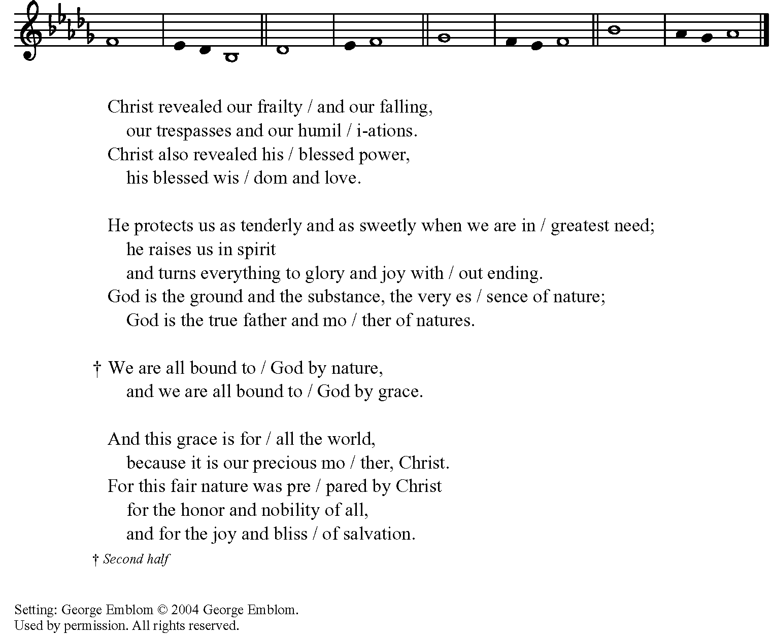

*Gloria Patri (optional)*

Glory to the Father and / to the Son,

and to the Holy / Spirit;

As it was in the begin- /ning, is now,

and will be for ev – / ver. Amen.



**A Song of the Wilderness** *Isaiah 35:1-7, 10*

Plainsong Tone 3 Enriching Our Worship I

*- underlined syllables are sung to the two notes that are tied together* 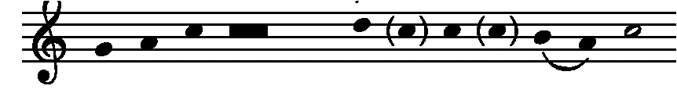

The wilderness and the / dry land shall be glad,

the desert shall rejoice / and blossom;

It shall / blossom abundantly,  
and rejoice with joy / and singing.

They shall see the / glory of the Lord,

the majes- / ty of our God.

Strengthen / the weary hands,  
and make firm / the feeble knees.

Say to the anxious, “Be / strong, do not fear!  
Here is your God, coming with judgment / to save you.”

Then shall the eyes of the / blind be opened,

and the ears of the deaf / be unstopped.

Then shall the lame / leap like a deer,  
and the tongue of the speech- / less sing for joy.

For waters shall break / forth in the wilderness

and streams in / the desert;

The burning sand / shall become a pool  
and the thirsty ground, springs / of water.

The ransomed of God shall re- / turn with singing,

with everlasting joy / upon their heads.

Joy and / gladness shall be theirs  
and sorrow and sighing / shall flee away.

Glory to the Father / and to the Son,

and to the Ho- / ly Spirit;

As it was in the be- / ginning, is now,

and will be for ev- /er. Amen.

**A Song of Christ’s Goodness**  *Anselm of Canterbury* Enriching Our Music 175

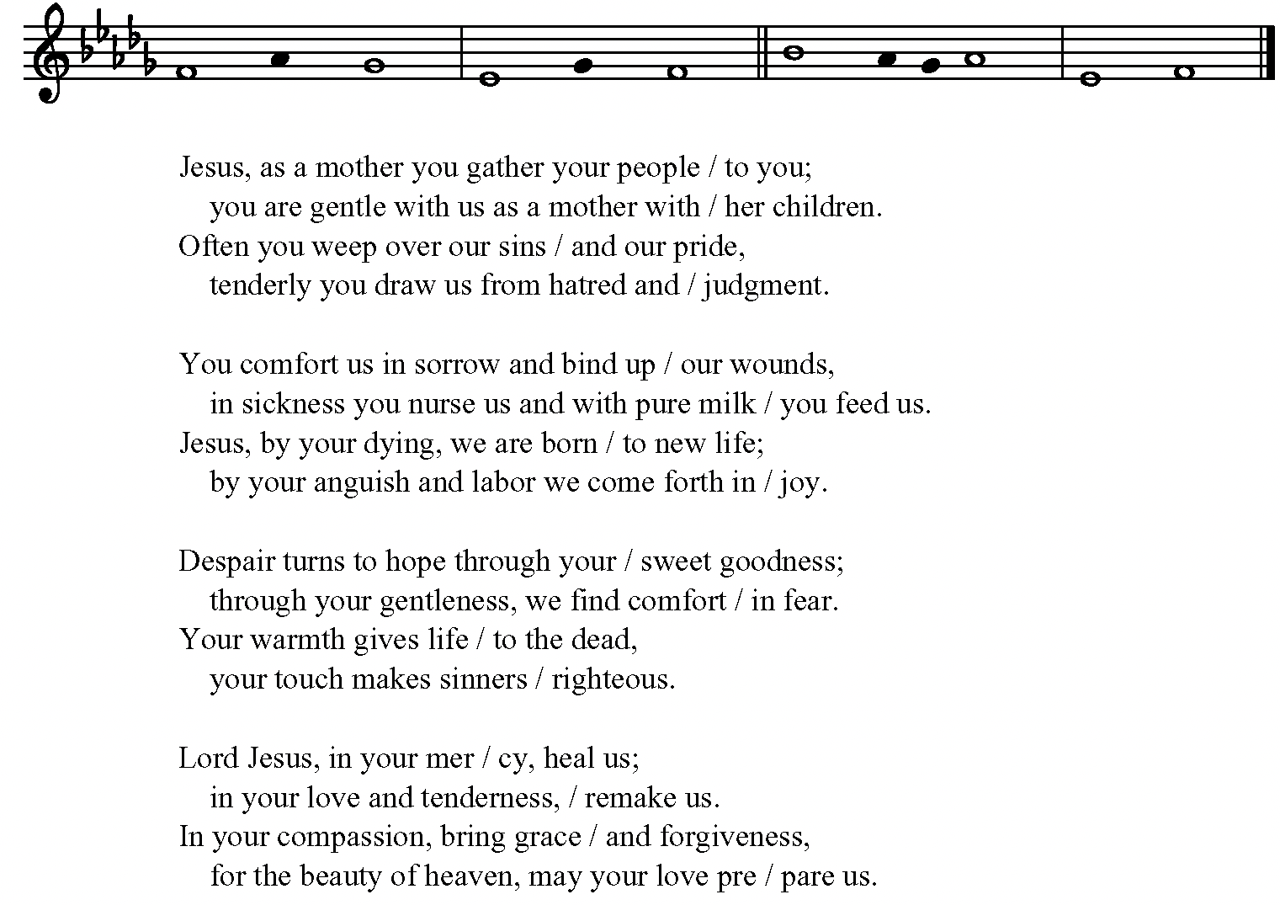

Glory to the Father and to / the Son,

and to the Ho- / ly Spirit;

As it was in the begin- / ning, is now,

and will be for ever. A- /men.



|  |  |
| --- | --- |
| **The Apostles' Creed pg.120**  I believe in God,  the Father almighty,  creator of heaven and earth.  I believe in Jesus Christ,  his only Son, our Lord,  He was conceived by the power of the Holy Spirit,  and born of the Virgin Mary,  He suffered under Pontius Pilate,  was crucified, died, and was buried.  He descended to the dead.  On the third day he rose again.  He ascended into heaven,  and is seated at the right hand of the Father.  He will come again  to judge the living and the dead.  I believe in the Holy Spirit,  the holy catholic Church,  the communion of saints,  the forgiveness of sins,  the resurrection of the body,  and the life everlasting. Amen | **The Prayers**  *The People stand or kneel*  *Officiant* The Lord be with you.  ***People* And also with you.**  *Officiant* Let us pray.  **The Lord’s Prayer**  Our Father who art in heaven,      hallowed be thy Name,      thy kingdom come,      thy will be done,          on earth as it is in heaven.  Give us this day our daily bread.  And forgive us our trespasses,      as we forgive those          who trespass against us.  And lead us not into temptation,      but deliver us from evil.  For thine is the kingdom,  and the power,      and the glory,      for ever and ever. Amen. |
| **Suffrages A**  V.    Show us your mercy, O Lord;  **R.    And grant us your salvation.**  V.    Clothe your ministers with righteousness;  **R.    Let your people sing with joy.**  V.    Give peace, O Lord, in all the world;  **R.    For only in you can we live in safety.**  V.    Lord, keep this nation under your care;  **R.    And guide us in the way of justice and truth.**  V.    Let your way be known upon earth;  **R.    Your saving health among all nations.**  V.    Let not the needy, O Lord, be forgotten;  **R.    Nor the hope of the poor be taken away.**  V.    Create in us clean hearts, O God;  **R.    And sustain us by your Holy Spirit.** |  |

**Suffrages B**

That this evening may be holy, good, and peaceful,  
**We entreat you, O Lord**.

That your holy angels may lead us in paths of peace and goodwill,  
**We entreat you, O Lord**. 

That we may be pardoned and forgiven for our sins and offenses,  
**We entreat you, O Lord.**

That there may be peace to your Church and to the whole world,  
**We entreat you, O Lord.** 

That we may depart this life in your faith and fear, and not be condemned before the great judgment seat of Christ,  
**We entreat you, O Lord.** 

That we may be bound together by your Holy Spirit in the communion of [________ and] all your saints, entrusting one another and all our life to Christ,  
**We entreat you, O Lord.**

**Suffrages A**

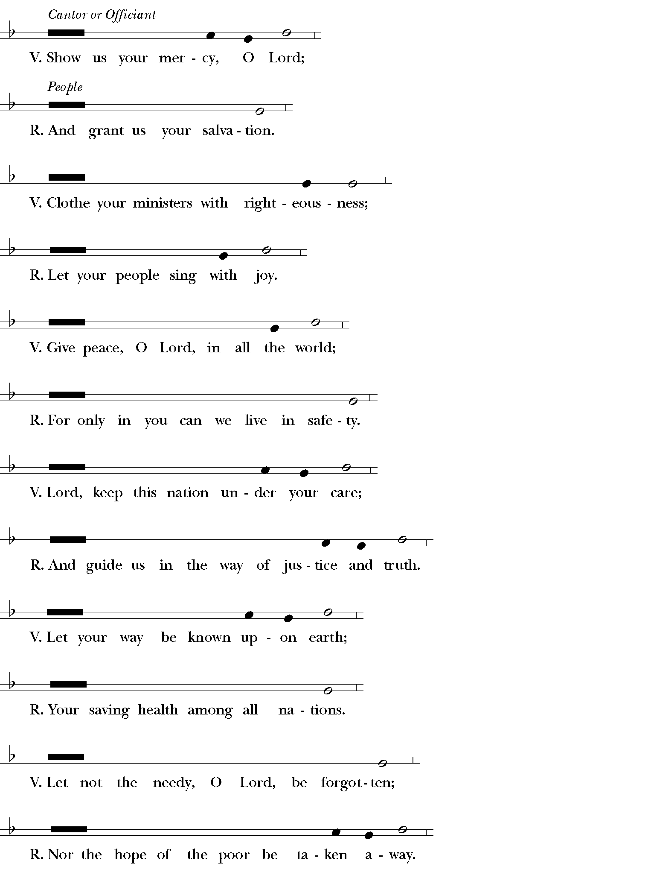

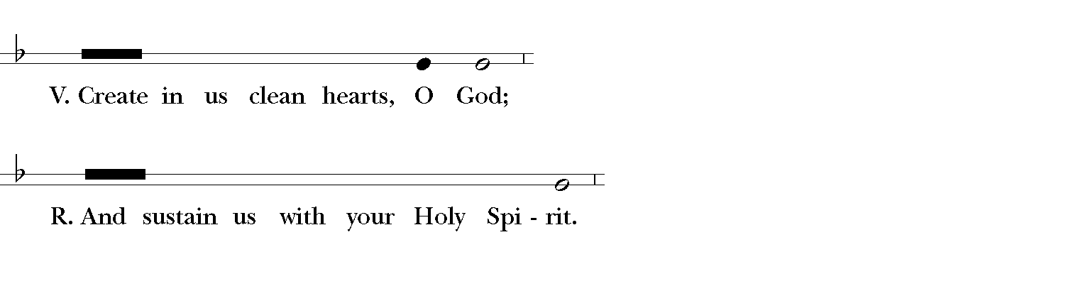

**Suffrages B**



Proper Collects for Lent

Ash Wednesday (February 17-20)

Almighty and everlasting God, you hate nothing you have made and forgive the sins of all who are penitent: Create and make in us new and contrite hearts, that we, worthily lamenting our sins and acknowledging our wretchedness, may obtain of you, the God of all mercy, perfect remission  
and forgiveness; through Jesus Christ our Lord, who lives and reigns with you and the Holy Spirit, one God, for ever and ever. **Amen**.

Lent I (Week of February 21)

Almighty God, whose blessed Son was led by the Spirit to be tempted by Satan: Come quickly to help us who are assaulted by many temptations; and, as you know the weaknesses of each of us, let each one find you mighty to save; through Jesus Christ your Son our Lord, who lives and reigns with you and the Holy Spirit, one God, now and for ever. **Amen**.

Lent II (Week of February 28)

O God, whose glory it is always to have mercy: Be gracious to all who have gone astray from your ways, and bring them again with penitent hearts and steadfast faith to embrace and hold fast the unchangeable truth of your Word, Jesus Christ your Son; who with you and the Holy Spirit lives and reigns, one God, for ever and ever. **Amen**.

Lent III (Week of March 7)

Almighty God, you know that we have no power in ourselves to help ourselves: Keep us both outwardly in our bodies and inwardly in our souls, that we may be defended from all adversities which may happen to the body, and from all evil thoughts which may assault and hurt the soul; through Jesus Christ our Lord, who lives and reigns with you and the Holy Spirit, one God, for ever and ever. **Amen**.

Lent IV (Week of March 14)

Gracious Father, whose blessed Son Jesus Christ came down from heaven to be the true bread which gives life to the world: Evermore give us this bread, that he may live in us, and we in him; who lives and reigns with you and the Holy Spirit, one God, now and for ever. **Amen**.

Lent V (Week of March 21)

Almighty God, you alone can bring into order the unruly wills and affections of sinners: Grant your people grace to love what you command and desire what you promise; that, among the swift and varied changes of the world, our hearts may surely there be fixed where true joys are to be found; through Jesus Christ our Lord, who lives and reigns with you and the Holy Spirit, one God, now and for ever. **Amen**.

Tuesday in Holy Week (March 30)

O God, by the passion of your blessed Son you made an instrument of shameful death to be for us the means of life: Grant us so to glory in the cross of Christ, that we may gladly suffer shame and loss for the sake of your Son our Savior Jesus Christ; who lives and reigns with you and the Holy Spirit, one God, for ever and ever. **Amen**.

**Other Collects**

*A Collect for Peace*

Most holy God, the source of all good desires, all right judgments, and all just works: Give to us your servants, that peace which the world cannot give, so that our minds may be fixed on the doing of your will, and that we, being delivered from the fear of all enemies, may live in peace and quietness; through the mercies of Christ Jesus our Savior. Amen.

A Collect for Fridays   
Lord Jesus Christ, by your death you took away the sting of death: Grant to us your servants so to follow in faith where you have led the way, that we may at length fall asleep peacefully in you and wake up in your likeness; for your tender mercies' sake. Amen.

A Collect for Saturdays   
O God, the source of eternal light: Shed forth your unending day upon us who watch for you, that our lips may praise you, our lives may bless you, and our worship on the morrow give   
you glory; through Jesus Christ our Lord. Amen.

*A Collect for Aid against Perils*

Be our light in the darkness, O Lord, and in your great mercy defend us from all perils and dangers of this night; for the love of your only Son, our Savior Jesus Christ. Amen.

*A Collect for Protection*

O God, the life of all who live, the light of the faithful, the strength of those who labor, and the repose of the dead: We thank you for the blessings of the day that is past, and humbly ask for your protection through the coming night. Bring us in safety to the morning hours; through him who died and rose again for us, your Son our Savior Jesus Christ. Amen.

*From the New Zealand Prayer Book*

Lord,

it is night.

The night is for stillness.

Let us be still in the presence of God.

It is night after a long day.

What has been done has been done;

what has not been done has not been done;

let it be.

The night is dark.

Let our fears of the darkness of the world and of our own lives

rest in you.

The night is quiet.

Let the quietness of your peace enfold us,

all dear to us,

and all who have no peace.

The night heralds the dawn.

Let us look expectantly to a new day,

new joys,

new possibilities.

In your name we pray.

Amen.

*A Collect for the Presence of Christ*

Lord Jesus, stay with us, for evening is at hand and the day is past; be our companion in the way, kindle our hearts, and awaken hope, that we may know you as you are revealed in Scripture and the breaking of bread. Grant this for the sake of your love. Amen.

*Then, unless the Eucharist or a form of general intercession is to follow, one of these prayers for mission is added*

O God and Father of all, whom the whole heavens adore: Let the whole earth also worship you, all nations obey you, all tongues confess and bless you, and men and women everywhere love you and serve you in peace; through Jesus Christ our Lord. Amen.

*or this*

Keep watch, dear Lord, with those who work, or watch, or weep this night, and give your angels charge over those who sleep. Tend the sick, Lord Christ; give rest to the weary, bless the dying, soothe the suffering, pity the afflicted, shield the joyous; and all for your love’s sake. Amen.

*or the following*

O God, you manifest in your servants the signs of your presence: Send forth upon us the Spirit of love, that in companionship with one another your abounding grace may increase among us; through Jesus Christ our Lord. Amen.

*Authorized intercessions and thanksgivings may follow.*

*Before the close of the Office one or both of the following may be used.*

*The General Thanksgiving*

Almighty God, Father and Mother of all mercies,

we your unworthy servants give you humble thanks

for all your goodness and loving-kindness

to us and to all whom you have made.

We bless you for our creation, preservation,

and all the blessings of this life;

but above all for your immeasurable love

in the redemption of the world by our Lord Jesus Christ;

for the means of grace and for the hope of glory.

And, we pray, give us such an awareness of your mercies,

that with truly thankful hearts we may show forth your praise,

not only with our lips, but in our lives,

by giving up our selves to your service,

and by walking before you

in holiness and righteousness all our days;

through Jesus Christ our Lord,

to whom, with you and the Holy Spirit,

be honor and glory throughout all ages. Amen.

*A Prayer of St. Chrysostom*

Almighty God, you have given us grace at this time

with one accord to make our common supplication to you;

and you have promised through your well-beloved Son

that when two or three are gathered together in his Name

you will be in the midst of them:

Fulfill now, O Lord, our desires and petitions as may be best for us;

granting us in this world knowledge of your truth,

and in the age to come life everlasting. Amen.



*The Officiant may then conclude with one of the following*

The grace of our Lord Jesus Christ, and the love of God, and the fellowship of the Holy Spirit, be with us all evermore. Amen. *2 Corinthians 13:14*

May the God of hope fill us with all joy and peace in believing through the power of the Holy Spirit. Amen. *Romans 15:13*

Glory to God whose power, working in us, can do infinitely more than we can ask or imagine: Glory to God from generation to generation in the Church, and in Christ Jesus for ever and ever. Amen. *Ephesians 3:20, 21*