Morning Prayer Rite II
Sunday, July 26, 2020

Eighth Sunday after Pentecost

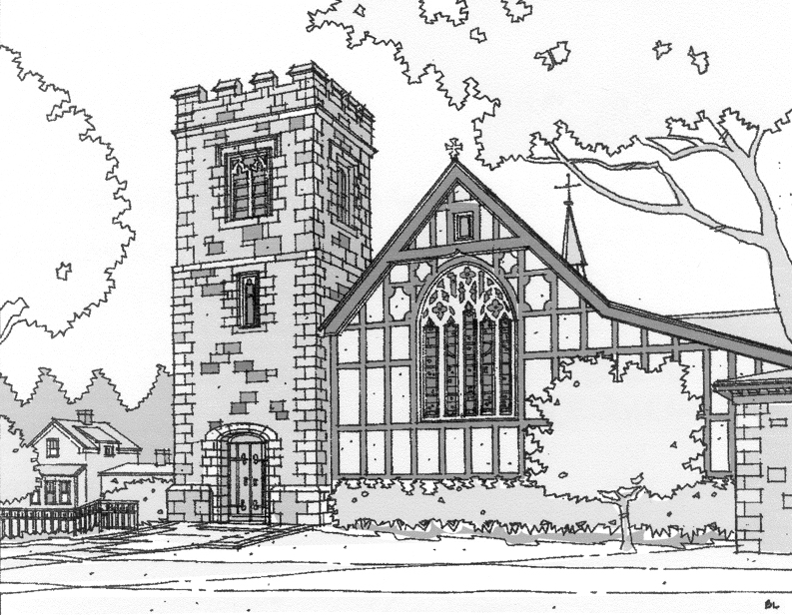

St. John’s Episcopal Church
Beverly Farms, MA

Opening Sentences
Grace to you and peace from God our Father and from the Lord Jesus Christ. Philippians 1:2

Confession of Sin from the Standing Commission on Liturgy and Music of the Episcopal Church

Officiant Let us confess our sins against God and one another.
All Almighty God, Source of all that is, Giver of every good gift:
You create all people in your image and call us to love one another as you love us. We confess that we have failed to honor you in the great diversity of the human family. We have desired to live in freedom, while building walls between ourselves and others. We have longed to be known and accepted for who we are, while making judgements of others based on the color of skin, or the shape of features, or the varieties of human experience. We have tried to love our neighbors individually while yet benefitting from systems that hold those same neighbors in oppression. Forgive us, Holy God. Give us eyes to see you as you are revealed in all people. Strengthen us for the work of reconciliation rooted in love. Restore us in your image, to be beloved community, united in our diversity, even as you are one with Christ and the Spirit. Holy and undivided Trinity, now and for ever. Amen.

Officiant Almighty God have mercy on us, forgive us all our sins through our Lord Jesus Christ, strengthen us in all goodness, and by the power of the Holy Spirit keep us in eternal life. Amen.

The Invitatory and Psalter
Officiant Lord, open our lips.
People And our mouth shall proclaim your praise.
All Glory to the Father, and to the Son, and to the Holy Spirit: as it was in the beginning, is now, and will be for ever. Amen. Alleluia.
Venite Psalm 95:1-7

Antiphon: The mercy of the Lord is everlasting: Come let us adore him.
Come, let us sing to the Lord; *
let us shout for joy to the Rock of our salvation.
Let us come before his presence with thanksgiving *
and raise a loud shout to him with psalms.
For the Lord is a great God, *
and a great King above all gods.
In his hand are the caverns of the earth, *
and the heights of the hills are his also.
The sea is his, for he made it, *
and his hands have molded the dry land.
Come, let us bow down, and bend the knee, *
and kneel before the Lord our Maker.
For he is our God, and we are the people of his pasture and the sheep of his hand, *
Oh, that today you would hearken to his voice!

Antiphon: The mercy of the Lord is everlasting: Come let us adore him.

The Psalm

Psalm 105:1-11, 45b
1 Give thanks to the Lord and call upon his Name; *
make known his deeds among the peoples.
2 Sing to him, sing praises to him, *
and speak of all his marvelous works.
3 Glory in his holy Name; *
let the hearts of those who seek the Lord rejoice.
4 Search for the Lord and his strength; *
continually seek his face.
5 Remember the marvels he has done, *
his wonders and the judgments of his mouth,
6 O offspring of Abraham his servant, *
O children of Jacob his chosen.
7 He is the Lord our God; *
his judgments prevail in all the world.
8 He has always been mindful of his covenant, *
the promise he made for a thousand generations:
9 The covenant he made with Abraham, *
the oath that he swore to Isaac,
10 Which he established as a statute for Jacob, *
an everlasting covenant for Israel,
11 Saying, "To you will I give the land of Canaan *
to be your allotted inheritance."
45b Hallelujah!

After the Psalm:

Glory to the Father, and to the Son, and to the Holy Spirit:

as it was in the beginning, is now, and will be forever. Amen.

The Lesson & Canticle

Each lesson is followed by a period of silence and a canticle

Matthew 13:31-33,44-52
Jesus put before the crowds another parable: “The kingdom of heaven is like a mustard seed that someone took and sowed in his field; it is the smallest of all the seeds, but when it has grown it is the greatest of shrubs and becomes a tree, so that the birds of the air come and make nests in its branches.”
He told them another parable: “The kingdom of heaven is like yeast that a woman took and mixed in with three measures of flour until all of it was leavened.”
“The kingdom of heaven is like treasure hidden in a field, which someone found and hid; then in his joy he goes and sells all that he has and buys that field.
“Again, the kingdom of heaven is like a merchant in search of fine pearls; on finding one pearl of great value, he went and sold all that he had and bought it.
“Again, the kingdom of heaven is like a net that was thrown into the sea and caught fish of every kind; when it was full, they drew it ashore, sat down, and put the good into baskets but threw out the bad. So it will be at the end of the age. The angels will come out and separate the evil from the righteous and throw them into the furnace of fire, where there will be weeping and gnashing of teeth.
“Have you understood all this?” They answered, “Yes.” And he said to them, “Therefore every scribe who has been trained for the kingdom of heaven is like the master of a household who brings out of his treasure what is new and what is old.”

Hear what the Spirit is saying to God’s people.
People Thanks be to God

Canticle The Song of Mary (The Magnificat) Luke 1:46-55
My soul proclaims the greatness of the Lord,
my spirit rejoices in God my Savior; *
for he has looked with favor on his lowly servant.
From this day all generations will call me blessed: *
the Almighty has done great things for me,
and holy is his Name.
He has mercy on those who fear him *
in every generation.
He has shown the strength of his arm, *
he has scattered the proud in their conceit.
He has cast down the mighty from their thrones, *
and has lifted up the lowly.
He has filled the hungry with good things, *
and the rich he has sent away empty.
He has come to the help of his servant Israel, *
for he has remembered his promise of mercy,
The promise he made to our fathers, *
to Abraham and his children for ever.

Glory to the Father, and to the Son, and to the Holy Spirit: *
as it was in the beginning, is now, and will be for ever. Amen.
The Apostles’ Creed  I believe in God,  the Father almighty,  creator of heaven and earth.  I believe in Jesus Christ,  his only Son, our Lord,  He was conceived by the power of the Holy Spirit,  and born of the Virgin Mary,  He suffered under Pontius Pilate,  was crucified, died, and was buried.  He descended to the dead.  On the third day he rose again.  He ascended into heaven,  and is seated at the right hand of the Father.  He will come again  to judge the living and the dead.  I believe in the Holy Spirit,  the holy catholic Church,  the communion of saints,  the forgiveness of sins,  the resurrection of the body,  and the life everlasting. Amen | The Prayers  The People stand or kneel  Officiant The Lord be with you.  People And also with you.  Officiant Let us pray.  The Lord’s Prayer  Our Father, who art in heaven,  hallowed be thy Name,  thy kingdom come,  thy will be done,  on earth as it is in heaven.  Give us this day our daily bread.  And forgive us our trespasses,  as we forgive those  who trespass against us.  And lead us not into temptation,  but deliver us from evil.  For thine is the kingdom,  and the power,  and the glory,  for ever and ever. Amen.
Sermon

Suffrages A
V. Show us your mercy, O Lord;
R. And grant us your salvation.
V. Clothe your ministers with righteousness;
R. Let your people sing with joy.
V. Give peace, O Lord, in all the world;
R. For only in you can we live in safety.
V. Lord, keep this nation under your care;
R. And guide us in the way of justice and truth.
V. Let your way be known upon earth;
R. Your saving health among all nations.
V. Let not the needy, O Lord, be forgotten;
R. Nor the hope of the poor be taken away.
V. Create in us clean hearts, O God;
R. And sustain us with your Holy Spirit.
The Collect of the Day
O God, the protector of all who trust in you, without whom nothing is strong, nothing is holy: Increase and multiply upon us your mercy; that, with you as our ruler and guide, we may so pass through things temporal, that we lose not the things eternal; through Jesus Christ our Lord, who lives and reigns with you and the Holy Spirit, one God, for ever and ever. Amen.
A Prayer for the Power of the Spirit among the People of God
Written by a team of Lutheran and Episcopal prayer leaders to unite us in common prayer and revive us for common mission
God of all power and love, we give thanks for your unfailing presence and the hope you provide in times of uncertainty and loss. Send your Holy Spirit to enkindle in us your holy fire. Revive us to live as Christ’s body in the world: a people who pray, worship, learn, break bread, share life, heal neighbors, bear good news, seek justice, rest and grow in the Spirit. Wherever and however we gather, unite us in common prayer and send us in common mission, that we and the whole creation might be restored and renewed, through Jesus Christ our Lord. Amen.
Prayer for Racial Justice From the Evangelical Lutheran Church in America
Save us, O God, from ourselves,
from racism often cloaked in pious words,
from the machinations of white supremacy hidden in calls for civility,
from micro aggressions thinly veiled in arrogance,
from apologies when they don’t give way to action,
from forgiveness without facing the truth,
from reconciliation without reparation.
Deliver us, O God, from expecting our siblings of color to continue to bear this emotional work, which is not theirs to do.
Grateful for the long arc that bends toward justice, we pray:
Grant us wisdom, give us courage for the facing of these days by the power of the Spirit, all for the sake of the kin-dom that we share in Christ Jesus. Amen.
A Prayer for the Sick
Heavenly Father, giver of life and health: Comfort and relieve your sick servants, and give your power of healing to those who minister to their needs, that those for whom our prayers are offered may be strengthened in their weakness and have confidence in your loving care; through Jesus Christ our Lord, who lives and reigns with you and the Holy Spirit, one God, now and for ever. Amen.
A Prayer for the Poor and the Neglected
Almighty and most merciful God, we remember before you all poor and neglected persons whom it would be easy for us to forget: the homeless and the destitute, the old and the sick, and all who have none to care for them. Help us to heal those who are broken in body or spirit, and to turn their sorrow into joy. Grant this, Father, for the love of your Son, who for our sake became poor, Jesus Christ our Lord. Amen.
A Prayer for in the Morning
This is another day, O Lord. I know not what it will bring forth, but make me ready, Lord, for whatever it may be. If I am to stand up, help me to stand bravely. If I am to sit still, help me to sit quietly. If I am to lie low, help me to do it patiently. And if I am to do nothing, let me do it gallantly. Make these words more than words, and give me the Spirit of Jesus. Amen.
A Prayer for Mission
Almighty and everlasting God, by whose Spirit the whole body of your faithful people is governed and sanctified: Receive our supplications and prayers which we offer before you for all members of your holy Church, that in their vocation and ministry they may truly and devoutly serve you; through our Lord and Savior Jesus Christ. Amen.

Authorized intercessions and thanksgivings may follow.

The General Thanksgiving
Almighty God, Father of all mercies,
we your unworthy servants give you humble thanks
for all your goodness and loving-kindness
to us and to all whom you have made.
We bless you for our creation, preservation,
and all the blessings of this life;
but above all for your immeasurable love
in the redemption of the world by our Lord Jesus Christ;
for the means of grace, and for the hope of glory.
And, we pray, give us such an awareness of your mercies,
that with truly thankful hearts we may show forth your praise,
not only with our lips, but in our lives,
by giving up our selves to your service,
and by walking before you
in holiness and righteousness all our days;
through Jesus Christ our Lord,
to whom, with you and the Holy Spirit,
be honor and glory throughout all ages. Amen.

Dismissal
Officiant: Let us bless the Lord.
People: Thanks be to God.

The Officiant may then conclude with the following:

The grace of our Lord Jesus Christ, and the love of God, and the fellowship of the Holy Spirit, be with us all evermore. Amen. 2 Corinthians 13:14

