Morning Prayer Rite II
Sunday, August 9, 2020

The Feast of the Transfiguration

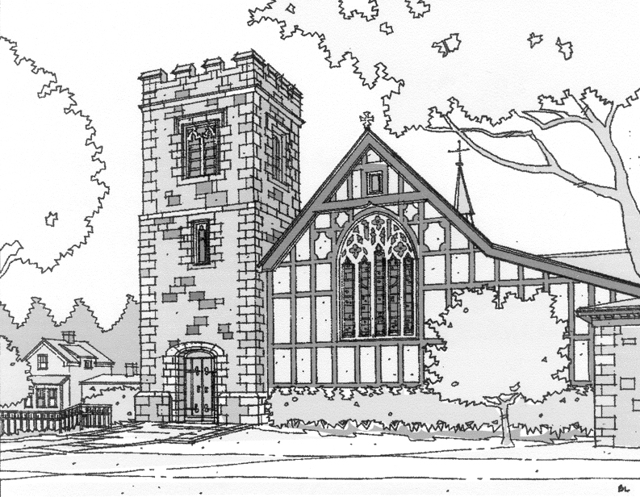

St. John’s Episcopal Church
Beverly Farms, MA

Opening Sentences
Send out your light and your truth, that they may lead me, and bring me to your holy hill and to your dwelling. Psalm 43:3

Confession of Sin from the Standing Commission on Liturgy and Music of the Episcopal Church

Officiant Let us confess our sins against God and one another.
All God of all mercy,
we confess that we have sinned against you,
opposing your will in our lives.
We have denied your goodness in each other,
in ourselves, and in the world you have created.
We repent of the evil that enslaves us,
the evil we have done,
and the evil done on our behalf.
Forgive, restore, and strengthen us
through our Savior Jesus Christ,
that we may abide in your love
and serve only your will. Amen.

Officiant Almighty God have mercy on us, forgive us all our sins through our Lord Jesus Christ, strengthen us in all goodness, and by the power of the Holy Spirit keep us in eternal life. Amen.

The Invitatory and Psalter
Officiant Lord, open our lips.
People And our mouth shall proclaim your praise.
All Glory to the Father, and to the Son, and to the Holy Spirit: as it was in the beginning, is now, and will be for ever. Amen. Alleluia.

Jubilate Psalm 100

Antiphon: Worship the Lord in the beauty of holiness: Come let us adore him.
Be joyful in the Lord, all you lands; *
serve the Lord with gladness
and come before his presence with a song.
Know this: The Lord himself is God; *
he himself has made us, and we are his;
we are his people and the sheep of his pasture.
Enter his gates with thanksgiving;
go into his courts with praise; *
give thanks to him and call upon his Name.
For the Lord is good;
his mercy is everlasting; *
and his faithfulness endures from age to age. [Antiphon]

The Psalm

Psalm 99
1 The Lord is King;
let the people tremble; *
he is enthroned upon the cherubim;
let the earth shake.
2 The Lord is great in Zion; *
he is high above all peoples.
3 Let them confess his Name, which is great and awesome; *
he is the Holy One.
4 "O mighty King, lover of justice,
you have established equity; *
you have executed justice and righteousness in Jacob."
5 Proclaim the greatness of the Lord our God
and fall down before his footstool; *
he is the Holy One.
6 Moses and Aaron among his priests,
and Samuel among those who call upon his Name, *
they called upon the Lord, and he answered them.
7 He spoke to them out of the pillar of cloud; *
they kept his testimonies and the decree that he gave them.
8 O Lord our God, you answered them indeed; *
you were a God who forgave them,
yet punished them for their evil deeds.
9 Proclaim the greatness of the Lord our God
and worship him upon his holy hill; *
for the Lord our God is the Holy One.

After the Psalm:

Glory to the Father, and to the Son, and to the Holy Spirit:

as it was in the beginning, is now, and will be forever. Amen.

The Lesson & Canticle

Each lesson is followed by a period of silence and a canticle

Luke 9:28-36
Jesus took with him Peter and John and James, and went up on the mountain to pray. And while he was praying, the appearance of his face changed, and his clothes became dazzling white. Suddenly they saw two men, Moses and Elijah, talking to him. They appeared in glory and were speaking of his departure, which he was about to accomplish at Jerusalem. Now Peter and his companions were weighed down with sleep; but since they had stayed awake, they saw his glory and the two men who stood with him. Just as they were leaving him, Peter said to Jesus, “Master, it is good for us to be here; let us make three dwellings, one for you, one for Moses, and one for Elijah” —not knowing what he said. While he was saying this, a cloud came and overshadowed them; and they were terrified as they entered the cloud. Then from the cloud came a voice that said, “This is my Son, my Chosen; listen to him!” When the voice had spoken, Jesus was found alone. And they kept silent and in those days told no one any of the things they had seen.

Hear what the Spirit is saying to God’s people.
People Thanks be to God

Canticle The Third Song of Isaiah Isaiah 60:1-3, 11a, 14c, 18-19
Arise, shine, for your light has come, *
and the glory of the Lord has dawned upon you.
For behold, darkness covers the land; *
deep gloom enshrouds the peoples.
But over you the Lord will rise, *
and his glory will appear upon you.
Nations will stream to your light, *
and kings to the brightness of your dawning.
Your gates will always be open; *
by day or night they will never be shut.
They will call you, The City of the Lord, *
The Zion of the Holy One of Israel.
Violence will no more be heard in your land, *
ruin or destruction within your borders.
You will call your walls, Salvation, *
and all your portals, Praise.
The sun will no more be your light by day; *
by night you will not need the brightness of the moon.
Glory to the Father, and to the Son, and to the Holy Spirit: *
as it was in the beginning, is now, and will be for ever. Amen.

Sermon

The Apostles’ Creed  I believe in God,  the Father almighty,  creator of heaven and earth.  I believe in Jesus Christ,  his only Son, our Lord,  He was conceived by the power of the Holy Spirit,  and born of the Virgin Mary,  He suffered under Pontius Pilate,  was crucified, died, and was buried.  He descended to the dead.  On the third day he rose again.  He ascended into heaven,  and is seated at the right hand of the Father.  He will come again  to judge the living and the dead.  I believe in the Holy Spirit,  the holy catholic Church,  the communion of saints,  the forgiveness of sins,  the resurrection of the body,  and the life everlasting. Amen | The Prayers  The People stand or kneel  Officiant The Lord be with you.  People And also with you.  Officiant Let us pray.  The Lord’s Prayer  Our Father, who art in heaven,  hallowed be thy Name,  thy kingdom come,  thy will be done,  on earth as it is in heaven.  Give us this day our daily bread.  And forgive us our trespasses,  as we forgive those  who trespass against us.  And lead us not into temptation,  but deliver us from evil.  For thine is the kingdom,  and the power,  and the glory,  for ever and ever. Amen.

Suffrages A
V. Show us your mercy, O Lord;
R. And grant us your salvation.
V. Clothe your ministers with righteousness;
R. Let your people sing with joy.
V. Give peace, O Lord, in all the world;
R. For only in you can we live in safety.
V. Lord, keep this nation under your care;
R. And guide us in the way of justice and truth.
V. Let your way be known upon earth;
R. Your saving health among all nations.
V. Let not the needy, O Lord, be forgotten;
R. Nor the hope of the poor be taken away.
V. Create in us clean hearts, O God;
R. And sustain us with your Holy Spirit.
The Collect of the Day
O God, who on the holy mount revealed to chosen witnesses your well-beloved Son, wonderfully transfigured, in raiment white and glistening: Mercifully grant that we, being delivered from the disquietude of this world, may by faith behold the King in his beauty; who with you, O Father, and you, O Holy Spirit, lives and reigns, one God, for ever and ever. Amen.
A Prayer for the Power of the Spirit among the People of God
Written by a team of Lutheran and Episcopal prayer leaders to unite us in common prayer and revive us for common mission
God of all power and love, we give thanks for your unfailing presence and the hope you provide in times of uncertainty and loss. Send your Holy Spirit to enkindle in us your holy fire. Revive us to live as Christ’s body in the world: a people who pray, worship, learn, break bread, share life, heal neighbors, bear good news, seek justice, rest and grow in the Spirit. Wherever and however we gather, unite us in common prayer and send us in common mission, that we and the whole creation might be restored and renewed, through Jesus Christ our Lord. Amen.
A Prayer for Social Justice
Almighty God, who created us in your own image: Grant us grace fearlessly to contend against evil and to make no peace with oppression; and, that we may reverently use our freedom, help us to employ it in the maintenance of justice in our communities and among the nations, to the glory of your holy Name; through Jesus Christ our Lord, who lives and reigns with you and the Holy Spirit, one God, now and for ever. Amen.

A Prayer for the Poor and the Neglected
Almighty and most merciful God, we remember before you all poor and neglected persons whom it would be easy for us to forget: the homeless and the destitute, the old and the sick, and all who have none to care for them. Help us to heal those who are broken in body or spirit, and to turn their sorrow into joy. Grant this, Father, for the love of your Son, who for our sake became poor, Jesus Christ our Lord. Amen.
A Prayer from Thomas Merton
My Lord God, I have no idea where I am going. I do not see the road ahead of me. I cannot know for certain where it will end. Nor do I really know myself, and the fact that I think I am following your will does not mean that I am actually doing so. But I believe that the desire to please you does in fact please you. And I hope I have that desire in all that I am doing. I hope that I will never do anything apart from that desire. And I know that if I do this you will lead me by the right road, though I may know nothing about it. Therefore will I trust you always though I may seem to be lost and in the shadow of death. I will not fear, for you are ever with me, and you will never leave me to face my perils alone. Amen.
A Prayer for the Future of the Human Race
O God our heavenly Father, you have blessed us and given us dominion over all the earth: Increase our reverence before the mystery of life; and give us new insight into your purposes for the human race, and new wisdom and determination in making provision for its future in accordance with your will; through Jesus Christ our Lord. Amen.
A Prayer for Mission
Almighty and everlasting God, by whose Spirit the whole body of your faithful people is governed and sanctified: Receive our supplications and prayers which we offer before you for all members of your holy Church, that in their vocation and ministry they may truly and devoutly serve you; through our Lord and Savior Jesus Christ. Amen.

Authorized intercessions and thanksgivings may follow.

The General Thanksgiving
Almighty God, Father of all mercies,
we your unworthy servants give you humble thanks
for all your goodness and loving-kindness
to us and to all whom you have made.
We bless you for our creation, preservation,
and all the blessings of this life;
but above all for your immeasurable love
in the redemption of the world by our Lord Jesus Christ;
for the means of grace, and for the hope of glory.
And, we pray, give us such an awareness of your mercies,
that with truly thankful hearts we may show forth your praise,
not only with our lips, but in our lives,
by giving up our selves to your service,
and by walking before you
in holiness and righteousness all our days;
through Jesus Christ our Lord,
to whom, with you and the Holy Spirit,
be honor and glory throughout all ages. Amen.

Dismissal
Officiant: Let us bless the Lord.
People: Thanks be to God.

The Officiant may then conclude with the following:

May the God of hope fill us with all joy and peace in believing through the power of the Holy Spirit. Amen. Romans 15:13

