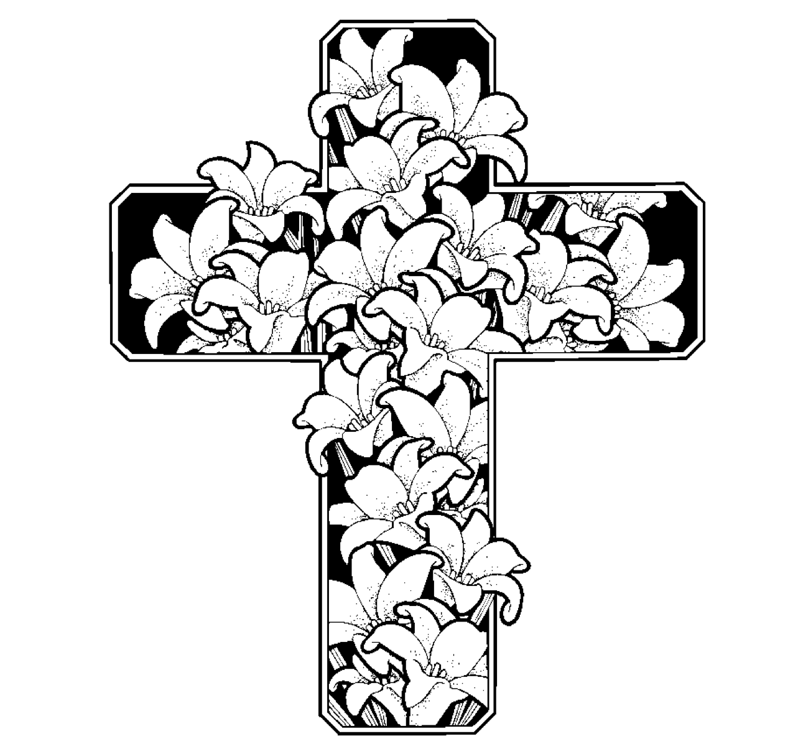

An Order for Compline

St. John’s Church, Beverly Farms

The Office continues with “O God, make speed to save us” or with the following Confession of Sin.
Officiant
Let us confess our sins to God.
Silence may be kept.
Officiant and People
Almighty God, our heavenly Father:
We have sinned against you,
through our own fault,
in thought, and word, and deed,
and in what we have left undone.
For the sake of your Son our Lord Jesus Christ,
forgive us all our offenses;
and grant that we may serve you
in newness of life,
to the glory of your Name. Amen.

Officiant
May the Almighty God grant us forgiveness of all our sins, and the grace and comfort of the Holy Spirit. Amen.

One or more of the following Psalms are sung or said.
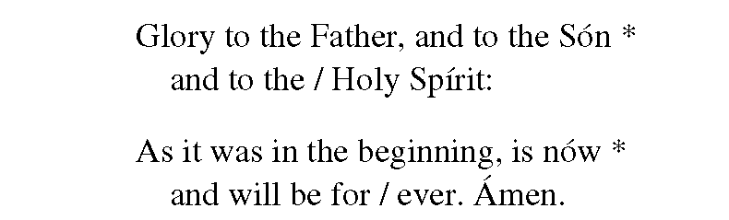

One of the following, or some other suitable passage of Scripture, is read
Lord, you are in the midst of us, and we are called by your Name: Do not forsake us, O Lord our God. Jeremiah 14:9, 22
Thanks be to God.
or this
Come to me, all who labor and are heavy-laden, and I will give you rest. Take my yoke upon you, and learn from me; for I am gentle and lowly in heart, and you will find rest for your souls. For my yoke is easy, and my burden is light. Matthew 11:28-30
Thanks be to God.
or the following
May the God of peace, who brought again from the dead our Lord Jesus, the great shepherd of the sheep, by the blood of the eternal covenant, equip you with everything good that you may do his will, working in you that which is pleasing in his sight, through Jesus Christ; to whom be glory for ever and ever. Hebrews 13:20-21
Thanks be to God.
or this
Be sober, be watchful. Your adversary the devil prowls around like a roaring lion, seeking someone to devour. Resist him, firm in your faith. I Peter 5:8-9a
Thanks be to God.
A hymn suitable for the evening may be sung.

Then follows

The Lord’s Prayer
Our Father who art in heaven,
hallowed be thy Name,
thy kingdom come,
thy will be done,
on earth as it is in heaven.
Give us this day our daily bread.
And forgive us our trespasses,
as we forgive those who trespass against us.
And lead us not into temptation,
but deliver us from evil.

The Officiant then says one of the following Collects
Be our light in the darkness, O Lord, and in your great mercy defend us from all perils and dangers of this night; for the love of your only Son, our Savior Jesus Christ. Amen.
Be present, O merciful God, and protect us through the hours of this night, so that we who are wearied by the changes and chances of this life may rest in your eternal changelessness; through Jesus Christ our Lord. Amen.
Look down, O Lord, from your heavenly throne, and illumine this night with your celestial brightness; that by night as by day your people may glorify your holy Name; through Jesus Christ our Lord. Amen.
Visit this place, O Lord, and drive far from it all snares of the enemy; let your holy angels dwell with us to preserve us in peace; and let your blessing be upon us always; through Jesus Christ our Lord. Amen.
From the New Zealand Prayer Book
Lord,
it is night.
The night is for stillness.
Let us be still in the presence of God.
It is night after a long day.
What has been done has been done;
what has not been done has not been done;
let it be.
The night is dark.
Let our fears of the darkness of the world and of our own lives
rest in you.
The night is quiet.
Let the quietness of your peace enfold us,
all dear to us,
and all who have no peace.
The night heralds the dawn.
Let us look expectantly to a new day,
new joys,
new possibilities.
In your name we pray.
Amen.

One of the following prayers may be added
Keep watch, dear Lord, with those who work, or watch, or weep this night, and give your angels charge over those who sleep. Tend the sick, Lord Christ; give rest to the weary, bless the dying, soothe the suffering, pity the afflicted, shield the joyous; and all for your love’s sake. Amen.

or this
O God, your unfailing providence sustains the world we live in and the life we live: Watch over those, both night and day, who work while others sleep, and grant that we may never forget that our common life depends upon each other’s toil; through Jesus Christ our Lord. Amen.
Silence may be kept, and free intercessions and thanksgivings may be offered.
The service concludes with the Song of Simeon with this Antiphon, which is sung or said by all.

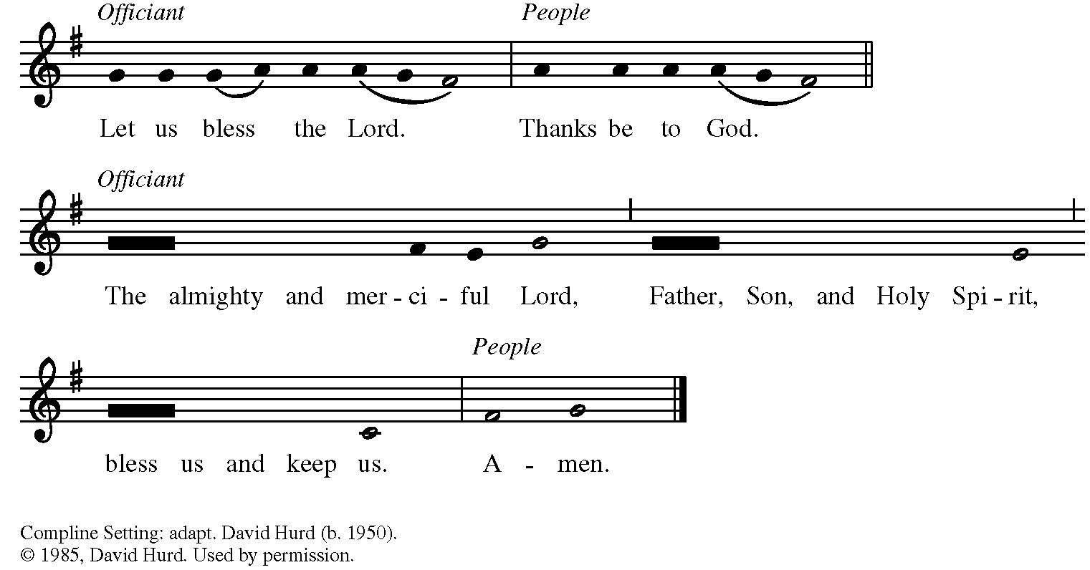

Text comes from the Book of Common Prayer. Music from Church Publishing Inc. is reproduced from the RiteSong.org music library.

Cover image from www.getcoloringpages.com.

