Choral Evensong – Saturday, May 30, 2020

PRECES: Officiant - Giovanni; People – Catherine

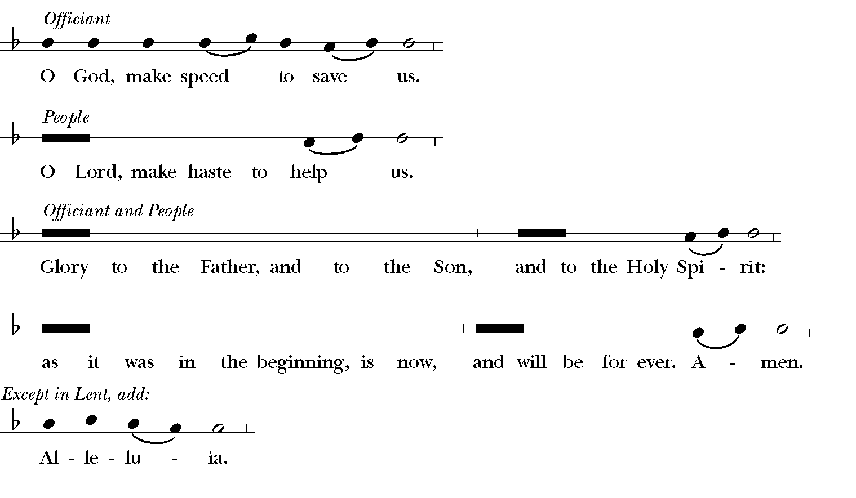

PHOS HILARON – sung by Catherine
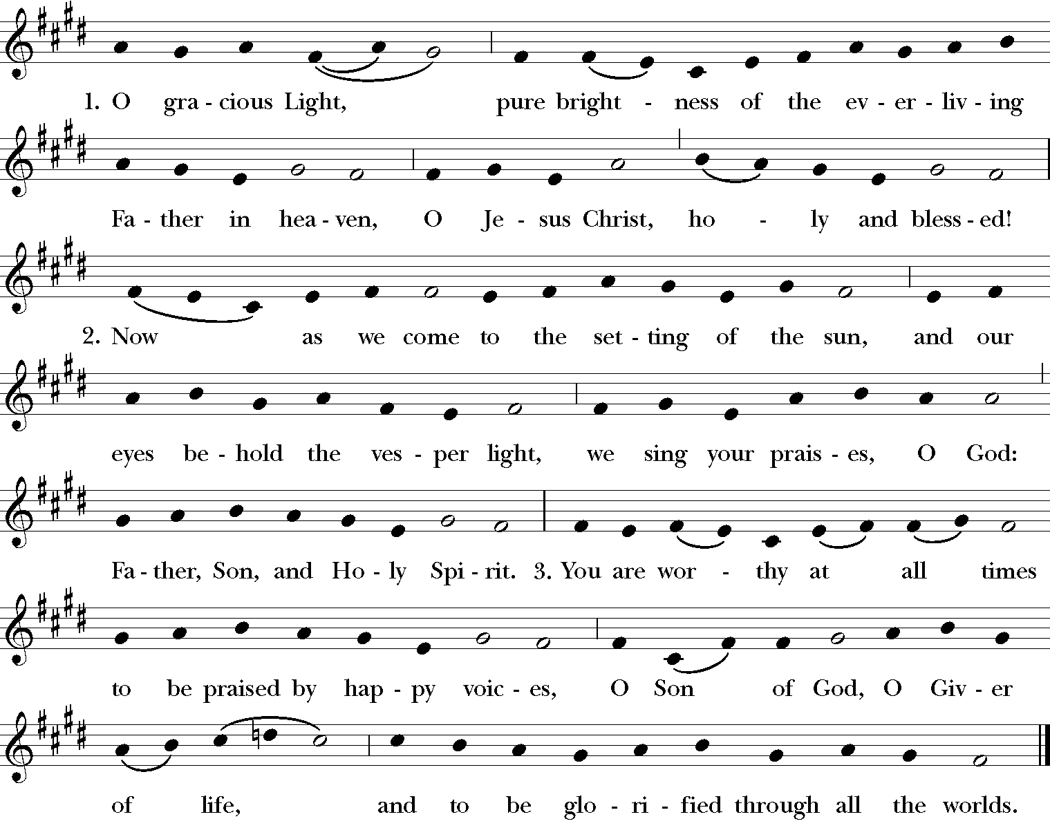

PSALM 33:12-22 – sung by Peter
Glory to the Father and to the Son, and to the / Holy Spi-rit;*
As it was in the beginning, is now and will be for-/e-ver, Ä-mën.

FIRST LESSON: Exodus 20:1-21 – read by Giovanni

20 Then God spoke all these words:
² I am the Lord your God, who brought you out of the land of Egypt, out of the house of slavery; ³ you shall have no other gods before^{[a]} me.
⁴ You shall not make for yourself an idol, whether in the form of anything that is in heaven above, or that is on the earth beneath, or that is in the water under the earth. ⁵ You shall not bow down to them or worship them; for I the Lord your God am a jealous God, punishing children for the iniquity of parents, to the third and the fourth generation of those who reject me, ⁶ but showing steadfast love to the thousandth generation^{[b]} of those who love me and keep my commandments.
⁷ You shall not make wrongful use of the name of the Lord your God, for the Lord will not acquit anyone who misuses his name.
⁸ Remember the sabbath day and keep it holy. ⁹ Six days you shall labor and do all your work. ¹⁰ But the seventh day is a sabbath to the Lord your God; you shall not do any work—you, your son or your daughter, your male or female slave, your livestock, or the alien resident in your towns. ¹¹ For in six days the Lord made heaven and earth, the sea, and all that is in them, but rested the seventh day; therefore the Lord blessed the sabbath day and consecrated it.
¹² Honor your father and your mother, so that your days may be long in the land that the Lord your God is giving you.
¹³ You shall not murder.^{[c]}
¹⁴ You shall not commit adultery.
¹⁵ You shall not steal.
¹⁶ You shall not bear false witness against your neighbor.
¹⁷ You shall not covet your neighbor’s house; you shall not covet your neighbor’s wife, or male or female slave, or ox, or donkey, or anything that belongs to your neighbor.
¹⁸ When all the people witnessed the thunder and lightning, the sound of the trumpet, and the mountain smoking, they were afraid^{[d]} and trembled and stood at a distance, ¹⁹ and said to Moses, “You speak to us, and we will listen; but do not let God speak to us, or we will die.” ²⁰ Moses said to the people, “Do not be afraid; for God has come only to test you and to put the fear of him upon you so that you do not sin.” ²¹ Then the people stood at a distance, while Moses drew near to the thick darkness where God was.

MAGNIFICAT: VF-152 – sung and played by FCF

SECOND LESSON: Romans 8:14-17 – read by FCF
¹⁴ For all who are led by the Spirit of God are children of God. ¹⁵ For you did not receive a spirit of slavery to fall back into fear, but you have received a spirit of adoption. When we cry, “Abba!^{[a]} Father!” ¹⁶ it is that very Spirit bearing witness^{[b]} with our spirit that we are children of God, ¹⁷ and if children, then heirs, heirs of God and joint heirs with Christ—if, in fact, we suffer with him so that we may also be glorified with him.

NUNC DIMITTIS: S 336 – sung by Matthew

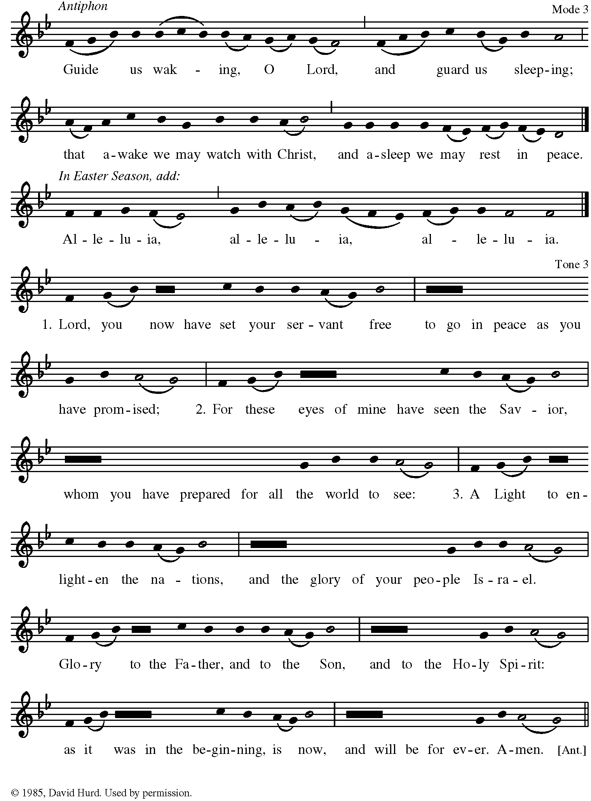
THE APOSTLES’ CREED – led by Matthew (spoken)

I believe in God the Father Almighty,
creator of heaven and earth:
And in Jesus Christ, his only Son, our Lord,
who was conceived by the power of the Holy Spirit
and born of the Virgin Mary.
He suffered under Pontius Pilate,
was crucified, died, and was buried.
He descended to the dead.
On the third day he rose again.
He ascended into heaven,
and is seated at the right hand of the Father.
He will come again to judge the living and the dead.
I believe in the Holy Spirit, the holy catholic Church,
the communion of saints, the forgiveness of sins;
the resurrection of the body, and the life everlasting.
Amen.

Officiant The Lord be with you. – Matthew, monotone
Choir And also with you. - Catherine
Officiant Let us pray. – Matthew

SUFFRAGES – sung by Catherine and Giovanni in alternation
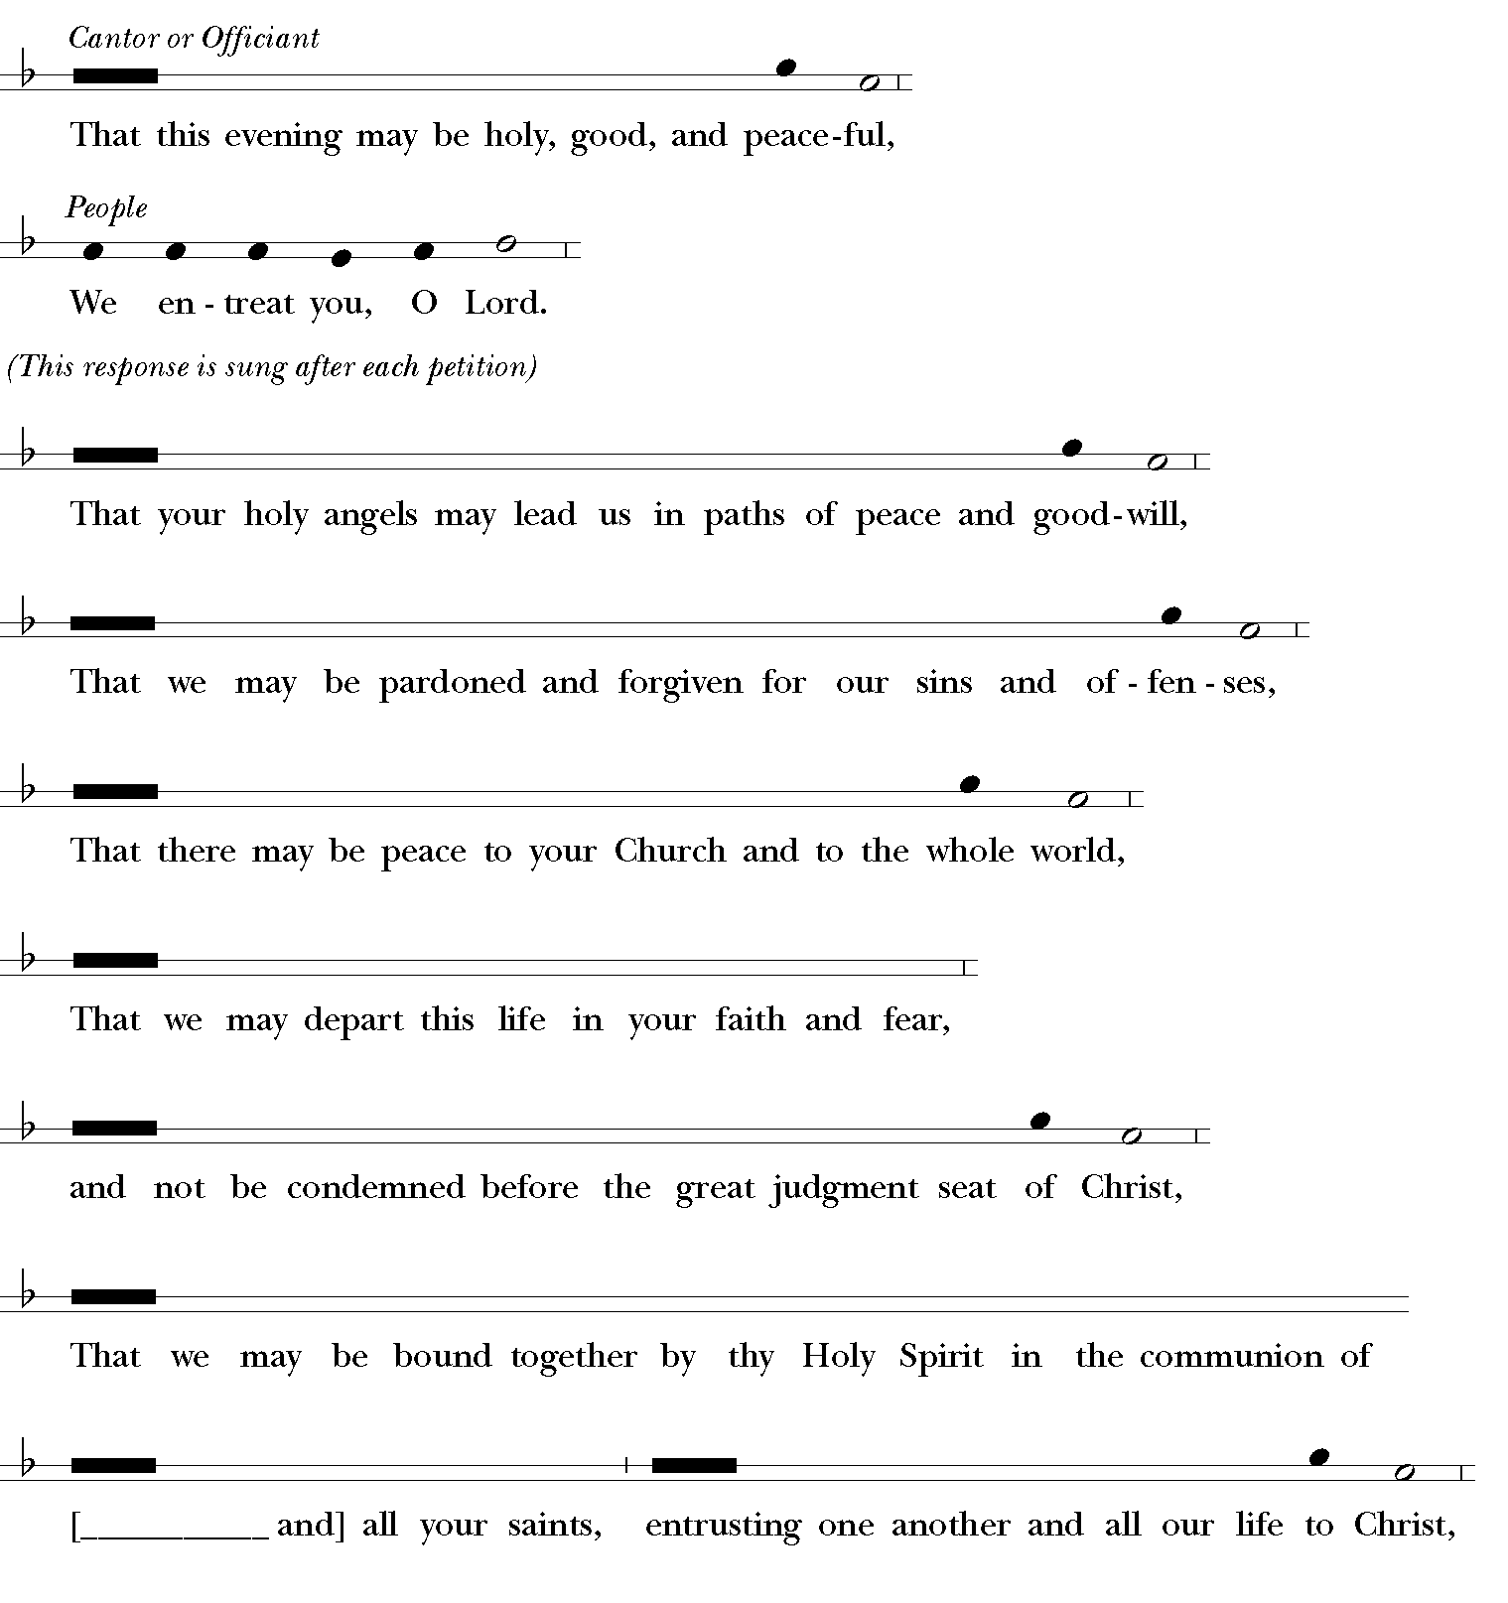

Then these Collects are sung – Giovanni and Catherine alternating, singing “Amen” for each other.

The Collect for Saturdays
O God, the source of eternal light: Shed forth your unending
day upon us who watch for you, that our lips may praise you,
our lives may bless you, and our worship on the morrow give
you glory; through Jesus Christ our Lord. Amen.

A Collect for Aid against Perils
Be our light in the darkness, O Lord, and in your great mercy
defend us from all perils and dangers of this night; for the love
of your only Son, our Savior Jesus Christ. Amen.

A Collect for Protection
O God, the life of all who live, the light of the faithful, the
strength of those who labor, and the repose of the dead: We
thank you for the blessings of the day that is past, and
humbly ask for your protection through the coming night.
Bring us in safety to the morning hours; through him who
died and rose again for us, your Son our Savior Jesus Christ.
Amen.

Keep watch, dear Lord, with those who work, or watch, or
weep this night, and give your angels charge over those who
sleep. Tend the sick, Lord Christ; give rest to the weary, bless
the dying, soothe the suffering, pity the afflicted, shield the
joyous; and all for your love's sake. Amen.

The General Thanksgiving – led by Peter (spoken)
Almighty God, Father of all mercies,
we your unworthy servants give you humble thanks
for all your goodness and loving-kindness
to us and to all whom you have made.
We bless you for our creation, preservation,
and all the blessings of this life;
but above all for your immeasurable love
in the redemption of the world by our Lord Jesus Christ;
for the means of grace, and for the hope of glory.
And, we pray, give us such an awareness of your mercies,
that with truly thankful hearts we may show forth your praise,
not only with our lips, but in our lives,
by giving up our selves to your service,
and by walking before you
in holiness and righteousness all our days;
through Jesus Christ our Lord,
to whom, with you and the Holy Spirit,
be honor and glory throughout all ages. Amen.
A Prayer of St. Chrysostom – led by Matt
Almighty God, you have given us grace at this time with one
accord to make our common supplication to you; and you
have promised through your well-beloved Son that when two
or three are gathered together in his Name you will be in the
midst of them: Fulfill now, O Lord, our desires and petitions
as may be best for us; granting us in this world knowledge of
your truth, and in the age to come life everlasting. Amen.

Officiant Let us bless the Lord. - Giovanni
All Thanks be to God. – Catherine

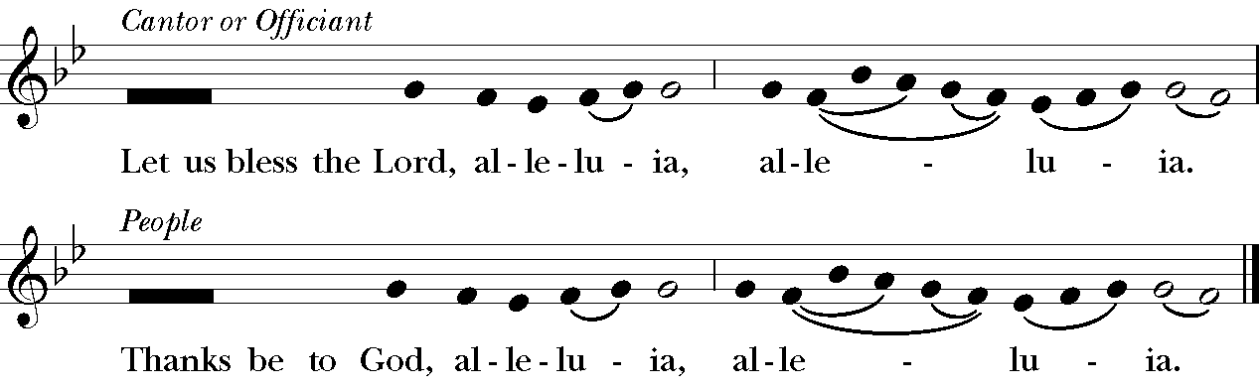

THE GRACE – FCF (spoken)
The grace of our Lord Jesus Christ, and the love of God, and
the fellowship of the Holy Spirit, be with us all evermore.
Amen. 2 Corinthians 13:14

