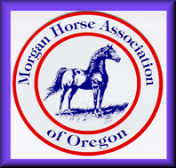
Morgan Horse Association of Oregon
2020 Membership Form
Membership types
- Individual $30: One adult and all children age 21 and under as of October 31, 2020. Includes 1 vote.
- Family $35: Two adults in the same household and all children age 21 and under as of October 31, 2020. Includes 2 votes.
Member Name(s)
Second Adult Name
Business/Stable Name
Street Address
City, State ZIP
Telephone
Email
Website
MHAO member since:
Membership Type:

Youth Member | Birthday | Email | Include Name in MHAO Directory?

Morgan Horse Information
$ | Horse Name | Sire | Dam | Color | Sex | YOB
$: Indicate For Sale YOB: Year of Birth
Sex: (S) Stallion, (M) Mare, (G) Gelding
Color Key
Color | Description |  | Color | Description |  | Color | Description |  | Color | Description
Bay | Bay |  | Buck | Buckskin |  | Crem | Cremello |  | SBl | Smoky Black
Blk | Black |  | Ch | Chestnut |  | Pal | Palomino |  | SCr | Smoky Cream
Brn | Brown |  |  |  |  | Perl | Perlino

Individual Memberships are $30.  Family Memberships are $35.  Payment can be made by check or online.  Please return this form to the  address to the right.  Remember to update  your horse information.  Thank You! | Please mail renewal & check to:  Kathy Christensen  MHAO Membership  1010 Rainbow Hills Ln SE  Salem, OR 97306  Mike-kak@Q.com  (503) 391-9047 | To Pay by Credit Card  Credit Card #:  Name on Card:  Exp. Date: 3 Digit Code:  Billing address if different:

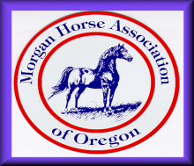
Morgan Horse Association of Oregon
2019 Membership Form
Page 2 for additional horse information

Member Name(s)

Morgan Horse Information
$ | Horse Name | Sire | Dam | Color | Sex | YOB
$: Indicate For Sale YOB: Year of Birth
Sex: (S) Stallion, (M) Mare, (G) Gelding
Color Key
Color | Description |  | Color | Description |  | Color | Description |  | Color | Description
Bay | Bay |  | Buck | Buckskin |  | Crem | Cremello |  | SBl | Smoky Black
Blk | Black |  | Ch | Chestnut |  | Pal | Palomino |  | SCr | Smoky Cream
Brn | Brown |  |  |  |  | Perl | Perlino

