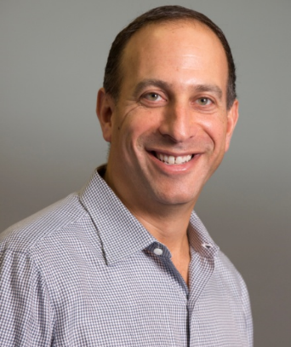
Andrew Hirsch
Chief Financial Officer and Head of Corporate Development
Agios Pharmaceuticals

Andrew Hirsch joined Agios as chief financial officer in September 2016. He has more than 20 years of experience in a range of strategic and operating roles in business, including over 15 years in the biotech industry, most recently having served as president and chief executive officer of BIND Therapeutics. Prior to joining BIND, Mr. Hirsch was chief financial officer at Avila Therapeutics until its acquisition by Celgene. Prior to that, he held roles of increasing responsibility during his nearly 10-year tenure at Biogen, including vice president of Corporate Strategy and M&A and program executive for the Tecfidera development team. He currently serves on the board of directors at Editas Medicine. Mr. Hirsch holds an MBA from the Tuck School at Dartmouth College and a Bachelor of Arts in Economics from the University of Pennsylvania.

