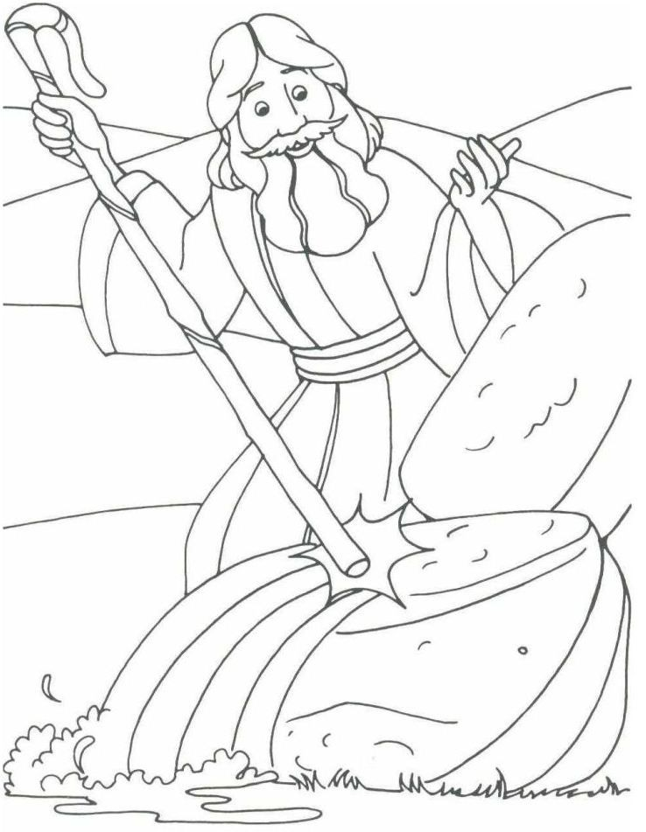
Moses had shepherd’s staff that was sometimes called the Staff of God. A good shepherd uses his staff to guide, protect, and rescue the sheep, never to harm them. Moses used his staff to demonstrate signs of God’s power to Pharaoh, to part the Red Sea so that they could escape and to get water in the wilderness. Moses was a good shepherd to God’s people and his staff became a sign of God’s presence.

