Step One: Restart PC
Step Two: Open an internet browser such as Internet Explorer or Google Chrome and navigate to https://Resetme.Mclaren.org/PMUser or from the login screen, go to the bottom of the page and choose “Forgot Password/Unlock Account”.
Step Three: Enter your Mclaren AD username in the first box and enter the verification code in the second field.
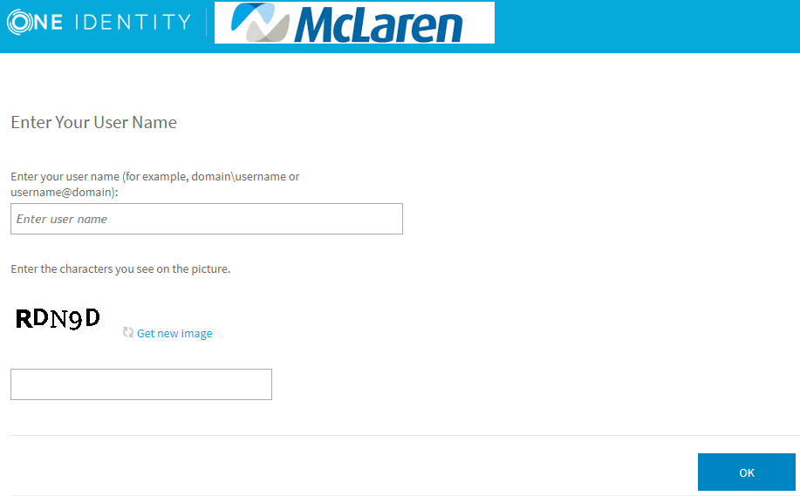
Step Four: Click on “Forgot My Password” from the home screen
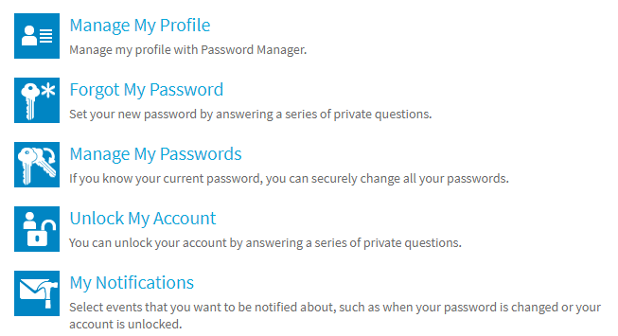
Step Five: Enter your Security Questions that you setup when logging into Resetme for the first time. If you are unable to remember your security questions please call the service desk.
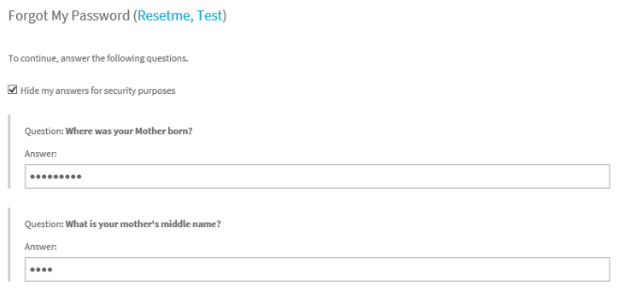
Step Six: Enter your new password following the new password requirements and hit next. You have now reset your McLaren AD password.
