Step One: Open an internet browser such as Internet Explorer or Google Chrome and navigate to https://Resetme.Mclaren.org/PMUser
Step Two: Enter your MclarenAD username in the first box and enter the verification code in the second field.
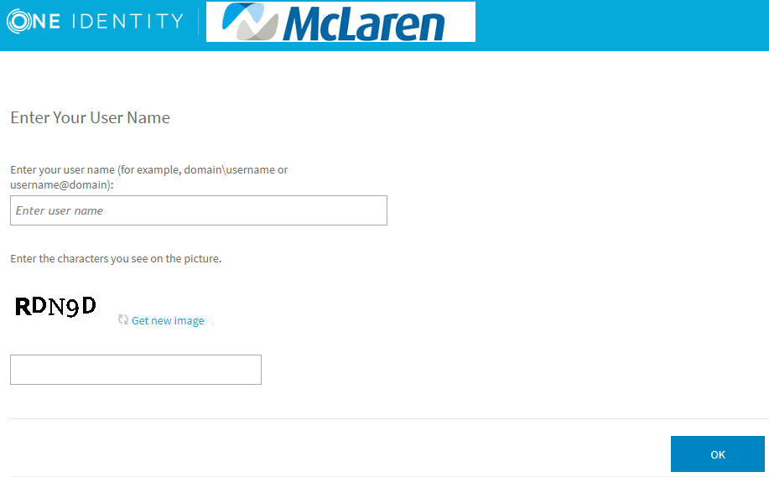
Step Three: Click on “Manage my Passwords” from the home screen
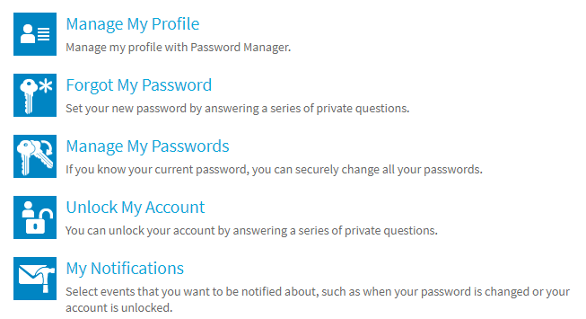
Step Four: Enter your Security Questions that you setup when logging into Resetme for the first time. If you are unable to remember your security questions please call the service desk.
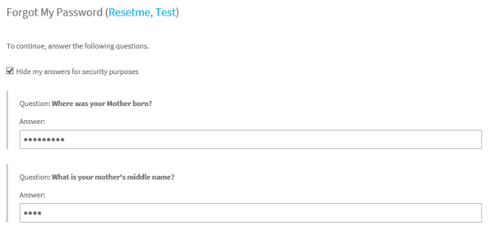
Step Five: Enter your new password following the new password requirements and hit next. You have now reset your McLaren AD password.
