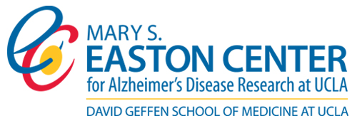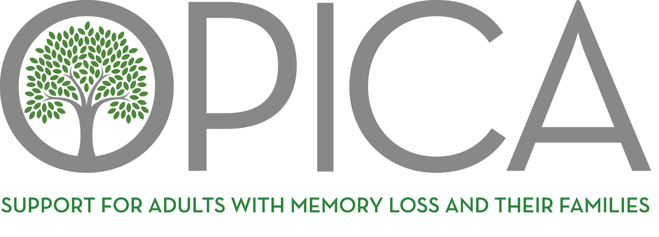

Free Virtual Education Event:
Caring for the Caregiver

Monday, September 19, 10:30- 11:30am

Caring for a friend or family member with dementia is often something people do without preparation. This presentation will provide the tools and education needed to for this journey and will focus on practical tips to sustain and care for the caregiver.



Free Seminar - Registration Required
https://uclahs.zoom.us/meeting/register/tJwsce2gqDMuG9Z3UO-vlCEaRQc4pBQbbLpn

If you have, any questions please contact
Pam Schwimmer, OPICA Community Outreach Associate pam@opica.org

OPICA Adult Day Program & Counseling Center
11759 Missouri Ave.
Los Angeles, CA 90025 310-478-0226 www.opica.org

