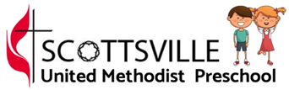
Reminders
- There will be no school on Friday, Oct. 29 and Monday, Nov. 1. Friday will be a teacher work day, and Monday will be set aside for parent/teacher conferences. If you are interested in having a conference with me, please return the attached sign-up sheet as soon as possible.
Upcoming Events
We will have fun celebrating Halloween next week, with some not-too-scary games and projects. We will continue working on the 2 letters we have learned so far this month, A and P. On Wednesday, the kids are welcome to wear costumes to school.
Questions to Ask Your Child
- What are some changes we see in Fall?
- What color apple was your favorite?
- What are some words you can use to describe your pumpkin?
What We Did This Week
We have had a great two weeks learning about Fall! We made paintings of Fall trees and did a concept sort of things we do/wear in Fall vs. Summer. We talked about how apples and pumpkins are two things that we see a lot of in Fall. We had an apple taste test and graphed our favorites. We made paper bag pumpkins, as well as painting real ones, and the kids worked together to write a story about a scary pumpkin! They have had fun learning seasonal rhymes and songs. The unanimous favorite activity we did was making and using pumpkin scented play dough!

